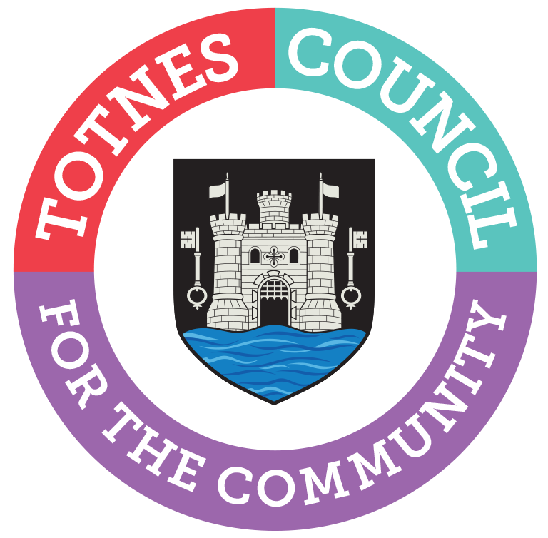

MINUTES FOR THE MEETING OF TOTNES TOWN COUNCIL
MONDAY 4TH NOVEMBER 2019 AT THE GUILDHALL TOTNES

Present: Cllr J Hodgson (Chair), Cllr Paine, Cllr Luker, Cllr Allen, Cllr Price, Cllr Allford, Cllr Vint and Cllr Trow
Apologies: Cllr Webberley, Cllr Hendriksen, Cllr Matthews, Cllr Simms, Cllr Adams, Cllr Piper, Cllr Perkins and Cllr Skinner
In Attendance: Catherine Marlton (Town Clerk), Christina Bewley (minutes), Peter Bethel (Town Sergeant), Soundart Radio x 1, D.Cllr Birch, D.Cllr Sweett and 3 members of the public.

No | Subject | Comments
1 | To receive apologies and vote on whether to agree. | Cllr Webberley, Cllr Hendriksen, Cllr Matthews, Cllr Simms, Cllr Adams, Cllr Piper, Cllr Perkins and Cllr Skinner  It was RESOLVED to accept the apologies from Cllr Webberley, Cllr Hendriksen, Cllr Matthews, Cllr Adams, Cllr Perkins and Cllr Skinner.
2 | The Mayor will request confirmation that all Members have completed or made any necessary amendments to their Declaration of Interests. | Confirmed.
3 | The Council will adjourn for the following items:  Reports from County and District Councillors | It was RESOLVED to suspend standing orders  a) C.Cllr Hodgson provided a written report.  b) D.Cllr Birch provided a written report. Cllr Vint asked for feedback on the open letter he handed into the Executive from a group of climate activists regarding the lack of progress with the SHDC climate emergency action plan. Cllr Birch will be asking for the issue to be included on the agenda at the next Overview & Scrutiny Committee meeting. Cllr Allen asked Cllr Birch to ask how the Neighbourhood Plan can be adapted to fit with the Climate Emergency Plan as they do not align at the moment. Cllr Allen also asked it to be noted that the carpark at the Brutus Centre development is in a listed archaeological zone and it is important that there is an exploratory dig before the carpark is built on it. Cllr Birch felt it would be helpful if the Town Council made that clear to the conservation officer and planning officer at SHDC who are dealing with the pre-application.  Cllr Birch advised all Councillors to read the draft SPD and Cllr Hodgson offered to send out notes she produced on it. Cllr Allen suggested it should be considered at the next Planning Committee meeting.  c) D.Cllr Sweett provided a written report. She highlighted concerns over increasing anti-social behaviour and drug dealing at the skate park. As it important to keep the community on board with the skate park project she asked that anyone noticing any problems there should call 111 to report it. The proposed total spend for the skate park project is £200k. Cllr Sweett also reported that she has met with the planning officer and developer at Great Court Farm because a devon bank has been removed in error and it now has to be re-instated.  The Council reconvened.
4 | To approve and sign the Minutes of the following Meetings:  (Please note confidential minutes can be agreed but any discussion must be held in Part 2):  - Full Council 7th October 2019  - Council Matters 14th October 2019  - Planning 24th October 2019 | It was RESOLVED to approve and sign the Minutes of the following meetings :  - Full Council 7th October 2019  - Council Matters 14th October 2019  - Planning 24th October 2019
5 | To consider any matters arising from the Minutes and to approve any recommendations from Committees  (Please note confidential recommendations can be agreed but any discussion must be held in Part 2):  - Full Council 7th October 2019  - Council Matters 14th October 2019  - Planning 24th October 2019 | The following matters arose:  - Full Council 7th October 2019  Item 4 – Cllr Luker raised concerns about losing the £1000 funding if the project is not approved soon. The Clerk explained that she has met with A.Price & K.Rennells and is going to ask the Town Matters Committee to give permission for the initial phase of the scheme to go ahead and for the £1000 donation to be given direct to them. The only involvement then required from the Council is as landowners to given permission for the work to take place.  Item 9 – Cllr Hodgson advised that the action planning is taking place this week.  Item 10 – Cllr Vint offered to draft the required letters. The Clerk confirmed she would check on what action has been taken.  Item 12 – the survey is out with the public.  Item 13 – the Clerk asked Councillors for input to the Directory entry. Suggestions made were: public realm update, Cemetery wildflower scheme, Christmas market dates, fun facts and information about events in the town, planters.  - Council Matters 14th October 2019  None.  - Planning 24th October 2019  Item 2 – the Clerk will check if the invitation has gone out yet.  Item 3 – It was RESOLVED to accept the recommendation.  Item 10 - It was RESOLVED to accept the recommendation.
6 | To note the date of 12th December 2019 for a general election and the purdah guidance that must be followed. | Noted.  The Clerk advised that an e-mail has been sent to all Councillors providing guidance. Purdah rules apply immediately.
7 | It is proposed by Cllr Luker that the resolution made by Full Council previously in relation to 5G was revisited as an exception to the usual 6 month rule outlined in Standing Orders. The background and the proposed amended resolution is as follows:  Original August 2019 Planning recommendation  To RECOMMEND to Full Council that Totnes Town Council makes a statement on its website that on the precautionary principle, Totnes Town Council is concerned about potential health risks caused by 5G based on a lack of scientific research into the issue.  From September 2019 Council minutes:  Totnes Town Council will issue a statement on its website issuing a moratorium on the installation of any 5G equipment (including phone masts and street lighting) into the public realm due to the significant health and safety concerns raised. All applications will be met with refusal until the safety of the effects of electromagnetic radiation is demonstrably proven.  Amended resolution put forward:  Totnes Town Council will issue a statement on its website and Facebook page stating that We object to the proposed reforms to permitted development rights. In particular as it currently relates to support the deployment of 5G and extend mobile coverage until we have sound scientific information with regard to the health impact on local residents. | Following a discussion the proposal was amended to say:  Totnes Town Council will issue a statement on its website and Facebook page stating that we object to the proposed reforms to permitted development rights, in particular as it currently relates to support for the deployment of 5G and extended mobile coverage, until we have sound scientific information with regard to the health impact on local residents and wildlife.  it was RESOLVED to accept the amended proposal.
8 | It is proposed by Cllr Hodgson that Totnes becomes an Earth Protector Town and uphold our Council duties and support and endorse the principle of making a stand and speaking out for the protection of the planet, but that does not imply that and nor will we be supporting breaches of the peace or advocating public protest as that is a matter for individual citizens over which we have no jurisdiction. | It was RESOLVED to accept the proposal.
9 | To note an update on the Neighbourhood Plan (standing item) | Cllr Luker advised that the schedule for the public consultation is to be agreed at the next meeting on Wednesday. The consultation period will run from November to Christmas. It is all progressing well and in budget.  Cllr Hodgson pointed out that the JLP conflicts with our Emergency Declaration.
10 | To note an update on the Christmas Festival nights (standing item) | The Clerk informed Councillors that the event is still predicted to come in under budget at the moment.  Hi-Viz jackets are being purchased for the stewards and Councillors.
11 | To note that the 11th November Council Matters committee will start at the earlier time of 6.30pm and all Councillors are encouraged to attend to discuss the draft budget for 2020/21 | Noted.
12 | To consider a request from Cllr Luker to join the Council Matters committee. | It was RESOLVED to approve the request.
The Council did not asked to RESOLVE to exclude the press and public “by reason of the confidential nature of the business” to be discussed and in accordance with the Public Bodies (Admission to Meetings) Act 1960.
13 | To discuss any confidential items from the Council Matters minutes. | None.
14 | To note the date and time of the next meeting: Monday 2nd December 2019. Public session from 6.30pm in The Guildhall. | Noted.  Cllr Hodgson reminded Councillors about the Remembrance Sunday event and the event in the Guildhall the next day.

Ended 8.20pm

Catherine Marlton
Town Clerk

