Climate Emergency Action Group

20 Apr 2021
Present

Cllr Jacqi Hodgson
Sylvia Dell (minutes)
David Cutting (environmentalist)
Sue Misselbrook (Bridgetown, Berry Pomeroy counsellor)
Ian Bright (TRESOC)
Richard O’Connell (recycling)
John Cummings
Mirella (Shareshed)
Cllr Georgina Allen (planning)
Cllr Victoria Trow
Leslie Nel
Chris Watson
Barbara Philips
Cllr Sarah Collinson
Diana Brown (designer)

Future Forum
Preparing med and long term plan for the town of Totnes. Aiming to engage a facilitator and looking for representatives from the CEWG. Currently preparing a mission statement.

Updates from current projects

Tree planting
- Baltic Wharf zig zag path - planted 24 cherry trees. Well attended
- Cemetary 6 white flowering cherry trees
- Plans to plant oak trees on parish boundary
- Action - send photos of tree planting - Clare Alford has Tree Planting Facebook page

Local water and energy consumption data
- These measure water consumption within the town - still awaiting Mar figures
  - Malt Mill
  - True Street
- Energy consumption - Feb - Mar 2021
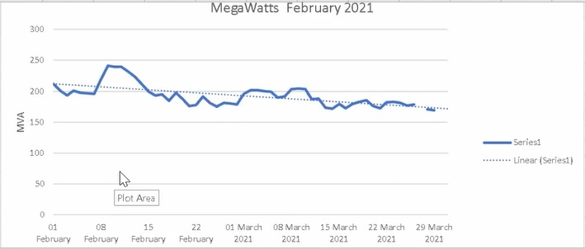

- New carbon footprint tool - Impact Community Carbon Calculator https://impact-tool.org.uk/footprint/footprint?parishId=E04003183&footprintType=territorial&scale=per-household
- 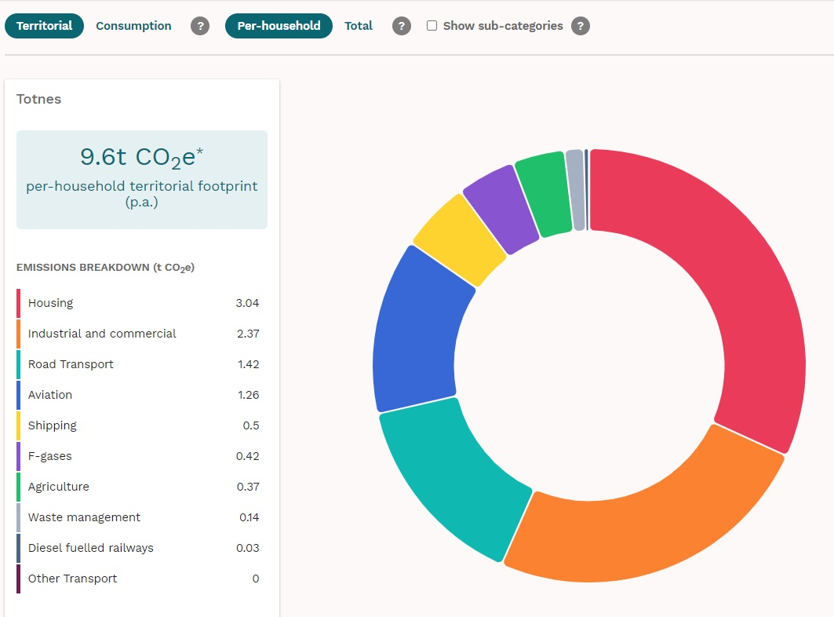

Our Place Our Planet
Progressing slowly
- Energy - Catherine Munrow (TRESOC minutes) offering energy advice South Devon Group in totnes

Sustainable South Hams
They have set up a FB page
We also have a climate emergency FB page - anybody can share their projects and news updates

Shareshed
- Library of Things - over 350 items
- Reopened last week - every Thursday 1-5 pm is in Civic Square
- Looking for funding and volunteers, and also repair cafes
- They are looking for funding - suggest you contact SHDC counsellors for locality funding (after May elections)
- Action - Leslie and Mirella to talk funding

Measuring Air Quality
- Mobile air quality monitors - we have 2 already and are looking to extend these, taking advantage of short term discounts
- However these are not necessarily appropriate for measuring
  - NOx
  - SO2
  - CO2
  - Particulates 2.5 and 10 ppm
- What is the purpose of these - awareness raising or something more?
  - Problem that we need someone with appropriate skills to use the data
  - Also they cannot be used for decision making as the data does not conform to statutory requirements
  - Possibly used to put pressure on SHDC to fulfill their legal requirements
- CW put forward information about the data collection monitors which SHDC should be using. SHDC have a climate emergency budget of £500k
  - Action - CW provide a document about the air quality monitors which can be discussed at Green Travel Steering Group
- Action - invite Sarah Harcombe, environmental health officer to explain what SHDC are currently doing

Renewable energy at the Pavilions
- TRESOC approached Tadpool, running the Pavilions, 6 years ago
- SHDC has freehold of the property and they have to sign the lease - they appeared to be interested but nothing has happened for 2 years
- Action - Totnes Town Councillors are invited to support the proposal with SHDC - take proposal to Full Council
- Action - IB write to our MP (who speaks with SHDC chief exec each week)
- Action - contact Adam Williams - this project ticks every box - IB to contact him

Wildflower Verges
- Action - look out for verges that could be managed as wildflower areas
- Action - “Please don’t cut - managed for wildflowers and insects”

Climate Emergency Hub
- Action - link Becca with Mirella and Shareshed - engage with them in the Civic Sq on Thursday (JH)

Cumulative impacts on wildlife
Deferred to next meeting

CEE Bill
DCC officers have expressed support

