Marketing Report Jan - April 2021
Samantha Branch, Marketing & Communications Manager
Marketing
Visit Devon
Visit South Devon sent an enewsletter out to their database of just under 5,000 subscribers and posted it to their blog/news pages in March with a Spotlight feature on Totnes - for free. The same enews featured The Bull Inn as well (arranged by them direct) offering good exposure for the town.
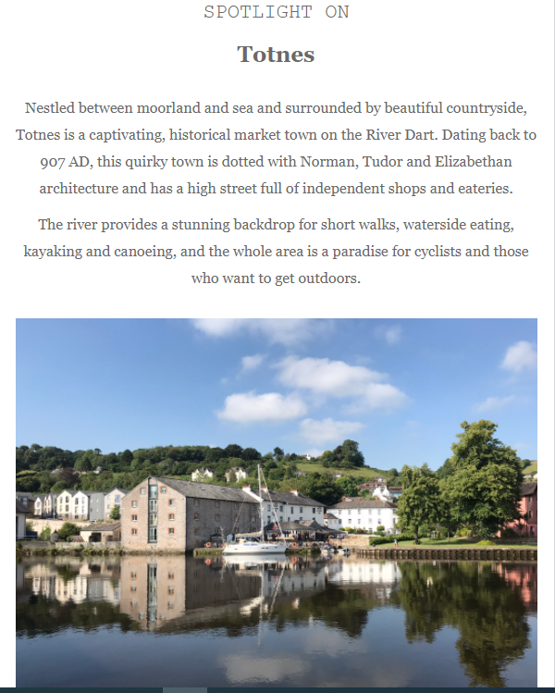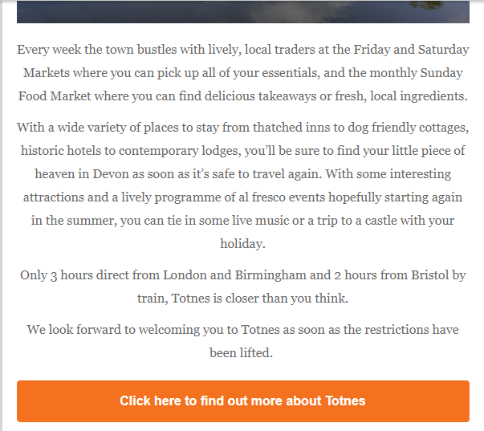
The newsletter caused a slight spike in the number of visits to the website based on our Google Analytics. In February as a whole and on the days previous to the enews being sent out at 5pm on 2nd March the daily average visitors to the site was approximately 160 a day. On 3rd March this increased to 452.
OS / Secret Stories
We have the potential opportunity to work with Ordnance Survey as part of their new Secret Stories app where we can upload a walk from Totnes which needs to include various stories about the town. Sam Branch is currently seeking help from Councillors to gather some of the relevant information. We would need to upload the walk by the summer holidays - all for free.

2021 Visit Totnes Leaflet and Guide Distribution
We have just over 5,000 2020 guides left at the TIC now. This year St Mary’s Church will help to distribute them for us and we can deliver them to any accommodation providers who require them when they’re open so we should get through this amount easily throughout the season.

Glide Media have started distributing their batch of 10,000 2020 guides and the new DL leaflets to various locations across Devon and nationwide as well. They were due to start in January but they started later this year due to the national lockdown. We’re awaiting a report from them.

The updated 2021 guide is now on the website for people to download with a new front cover and updated details - https://www.visittotnes.co.uk/see-and-do/attractions/download/

Planters

I’ve started selling the blackboards as advertising space and have currently sold at least 10 sides with expressions of interest from some other businesses as well.

The reaction to the posts on social media were positive when we posted the photos with the plants in them with the following being posted on the TTC pages and receiving 67 likes on FB & a reach of 6856 people:

Website
We have given all of our existing advertisers a free page on the website this year and we have given as many shops and eateries in town a FREE basic web listing as well. We’re continuing to add more as and when new places open.

PR
Julia Bradbury - Walks in Devon
We were really fortunate because Julia Bradbury featured Totnes and the Dart Valley Trail in her primetime ITV program on 17th February where she featured Sharpham Estate, Sharpham Cheese & Wine and Conker Shoes. She was walking part of the Dart Valley Trail from Totnes to Dartmouth.
Conker Shoes said their website crashed as a result of the number of people who visited their website during and after the show, and The Old Forge has reported that they have had a lot more bookings from people visiting for walking and cycling holidays who have cited the show as the reason. We had a lot of engagement on social media surrounding the show as well:
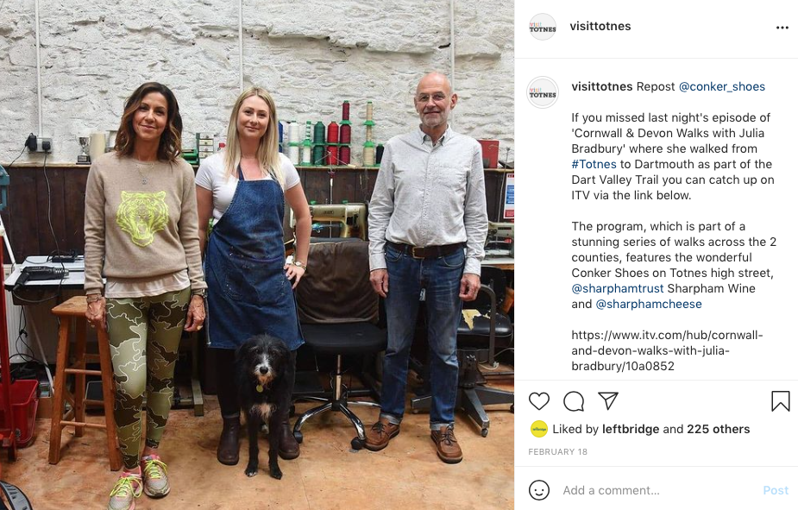
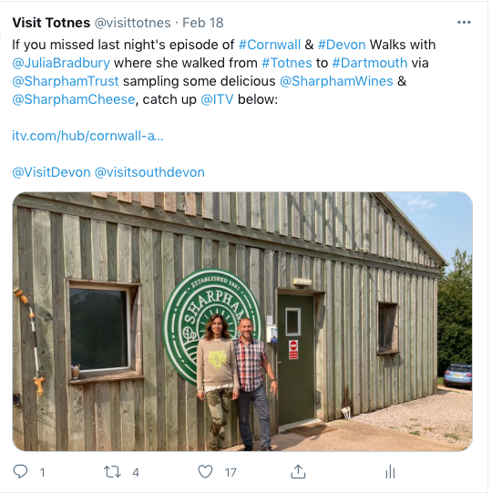
Digital
Social Media Stats 2020/21
As always Facebook & Instagram are continuing to grow really well organically however Twitter has always been a lot slower, however FB and Instagram are much more valuable to the VT brand therefore it’s not worth investing too much time, effort or money into Twitter.
I will do some more research into the demographics of our FB & Instagram users soon to see if we need to attract more from London and other key target areas.
Followers | July 2020 | August 2020 | April 2021
Instagram | 2262 | 2347 | 2993
FB | 2522 | 2596 | 3295
Twitter | 1576 | 1598 | 1708
Website Stats
The website stats for 2020 were down considerably due to the lockdowns and uncertainty with coronavirus and the start of 2021 looked the same.
The February stats were only saved because of the Julia Bradbury ITV program which aired on 17th which caused a huge uplift in traffic on 17th & 18th - otherwise this month would have been really down again. The month as a whole actually had a 48% increase in the number of unique visitors to the site based on last year. However the dwell time went from 2 minutes in Feb 2020 to 1 minute 4 seconds this year which is because those who were on the site during & after the program aired were only on the site for about 40 seconds which shows they were having a quick look rather than doing any serious planning at this stage.
The site has started to pick up again from March and is starting to become more in line with the normal figures rather than last March when the site took a hit because we were in lockdown.
2020 | Jan | Feb | March | April | May | June | July | Aug | Dec | Avg
Users | 4027 | 4074 | 2402 | 1361 | 2138 | 3425 | 6881 | 10706 |  | 4363
yr-on-yr change | 28% | 19% | -50% | -80% | -66% | -46% | -14% | 17.4% |  | -24%
Unique | 3867 | 3902 | 2268 | 1298 | 2057 | 3315 | 6792 | 10550 |  | 4400
yr-on-yr change | 31% | 21% | -50% | -81% | -66% | -45% | -12% | 16% |  | -22%
Pageviews | 14419 | 13717 | 7701 | 4354 | 6234 | 8683 | 21418 | 34152 |  | 14131
yr-on-yr change | 21% | 4.9% | -54% | -80% | -73% | -60% | -25% | 4.6% |  | -33%
Duration | 2:11 | 2:00 | 2:09 | 2:33 | 1:55 | 1:21 | 1:52 | 2:00 |  | 1:54

2021 | Jan | Feb | March | April | May | June | July | Aug | Sept | Nov | Dec | Avg
Users | 2579 | 5849 | 4738 |  |  |  |  |  |  |  |  | 4377
yr-on-yr change | -36% | 44% | 97% |  |  |  |  |  |  |  |  | -24%
Unique | 2492 | 5764 | 4608 |  |  |  |  |  |  |  |  | 4256
yr-on-yr change | -35% | 48% | 103% |  |  |  |  |  |  |  |  | -25%
Pageviews | 6516 | 11778 | 12992 |  |  |  |  |  |  |  |  | 13835
yr-on-yr change | -55% | -14% | 69% |  |  |  |  |  |  |  |  | -35%
Duration | 1:31 | 1:04 | 1:34 |  |  |  |  |  |  |  |  | 1:58

Demographics – Country
Due to coronavirus we’ve seen another decrease in the number of visitors from overseas and more from the UK due to the lockdowns, lack of international travel and more staycations. There has been another big decline in the number of people visiting the site from America for the same reasons. in 2019 we had 5802 visit the site from America but in 2020 we only had 1551. The same trend is continuing for the first part of this year.
Country Demographics
Country | Jan - Dec ‘19 | Country | Jan - Dec ‘20 | Country | Jan - Apr ‘21
UK | 85% (58,690) | UK | 91% (48,151) | UK | 91% 11,816
USA | 8.42% (5802) | USA | 2.95% (1551) | USA | 293
Germany | 0.77% (533) | France | 247 | China | 107
France | 0.57% (395) | Australia | 198 | Germany | 46
Spain | 0.48% (328) | Germany | 196 | France | 46
Australia | 0.45% (307) | Canada | 186 | Australia | 44
Netherlands | 0.44% (302) | S. Korea | 175 | Spain | 40
Canada | 0.29% (203) | China | 156 | Canada | 33
Switzerland | 0.32% (176) | Spain | 141 | Switzerland | 30
Canada | 0.29% (159) | Turkey | 110 | India | 30
Demographics – City
Historically we have always had the largest percentage of visitors from London and then the rest of the top ten are mainly from the surrounding towns and cities.
However when considering the figures of visitors who view the site from all of the surrounding areas collectively (Totnes, Newton, Torquay, Paignton, Exeter & Plymouth) it makes up the majority. Again in 2020 this number increased which would be because of the lockdowns:
2019: a minimum of 24,095 visitors from the local areas (over 35% of all visitors)
2020: a minimum of 21,701 from the local areas (over 41% of all visitors)
City Demographics
City | Jan - Dec ‘19 | City | Jan - Dec ‘20 | City | Jan - Apr ‘21
London | 15.5% (11,203) | London | 18% (10,228) | Totnes | 15% (2056)
Not set (likely Totnes) | 8797 | Totnes | 8928 | London | 13% (1703)
Exeter | 6162 | Exeter | 4655 | Exeter | 781
Chicago | 4739 | Plymouth | 3085 | Plymouth | 530
Plymouth | 3643 | Bristol | 2769 | Torquay | 452
Bristol | 3612 | Torquay | 2223 | Bristol | 423
Torquay | 3081 | Paignton | 1030 | Birmingham | 227
Newton Abbot | 1229 | Newton Abbot | 905 | Newton Abbot | 190
Southampton | 1227 | Kingsbridge | 875 | Paignton | 142
Paignton | 1183 | Chicago | 662 | Taunton | 101

Latest Blogs
https://www.visittotnes.co.uk/celebrate-valentines/
https://www.visittotnes.co.uk/the-sharpham-trust-receives-lifeline-grant-from-governments-1-57bn-culture-recovery-fund/
https://www.visittotnes.co.uk/a-new-fish-finger-takeaway-in-town/
https://www.visittotnes.co.uk/re-opening-at-last-and-on-the-rails-to-recovery/
https://www.visittotnes.co.uk/charity-invests-1-6million-in-a-new-retreat-venue-at-sharpham/
https://www.visittotnes.co.uk/totnes-update/
https://www.visittotnes.co.uk/share-shed-mobile/
https://www.visittotnes.co.uk/south-devon-rail-secure-funding/

