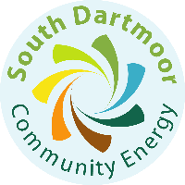
Worried about increasing energy bills?

We are here to help

South Dartmoor Community Energy is a local not-for-profit organisation set up to help people in our community make their homes more energy efficient so we can all afford to keep warm and healthy at home.

Since 2016 our qualified and friendly advisors have helped thousands of people in the South Hams to save money and use less energy at home.

We can provide advice over the phone or we can visit you at home. We will help with:
- High energy bills
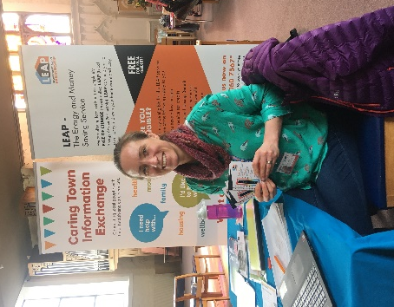
- Cold at home
- Damp or mould problems
- Confusing heating controls
- Complicated bills
- Fuel debt or problems with suppliers
- Switching tariffs
- Insulation or heating grants
- Energy bills becoming unaffordable
- Extra support you may be entitled to

All our advice is completely FREE and impartial, we receive grant funding so we can help home owners and people who are renting privately or from a housing association. If you’d like to book a visit, or just chat to an advisor, please get in touch.
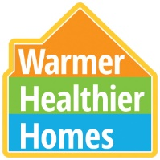
0800 112 3044
advice@sdce.org.uk

www.sdce.org.uk/energy-advice

