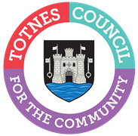

GENERAL DATA PROTECTION REGULATIONS – SUBJECT ACCESS REQUEST FORM
Any individual is entitled to obtain from Totnes Town Council:
- Confirmation as to whether Totnes Town Council is processing any personal data about you;
- Access to that personal data;
- Any related information.
To make a request please specify in the box below the information that you would like to obtain. Please bring this form to the Council for your identity to be verified.

Name……………………………………………………………………………………………………….
Address……………………………………………………………………………………………………

Please sign here …………………………………………………Date………………………….
In order to release any information Totnes Town Council will need to see two documents giving evidence of your identity, one in the form of a current passport or driving licence or other photo identification, and the other a utility bill, vehicle registration document, bank statement or rent book.
Totnes Town Council is required to respond to you within 30 days of the above date.
Totnes Town Council, The Guildhall Offices, 5 Ramparts Walk, Totnes, Devon, TQ9 5QH
Tel 01803 862147, administrator@totnestowncouncil.gov.uk , www.totnestowncouncil.gov.uk

