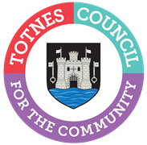

WAYFINDING PROJECT – TOTNES TOWN COUNCIL

Location of contract
Totnes Town

Value of contract
Unknown

Procurement reference
Totnes Town Council Wayfinding Phase 1

Published date
11th March 2022

Closing date
31st March 2022

Closing time
1pm

Contract start date
Mid April 2022

Contract end date
31st July 2022

DESCRIPTION
Totnes Town Council is looking for a suitably competent supplier to supply and deliver the first phase of signage that will be installed in and around the town centre.
A total of 4 finger posts, 4 totem style signs and 1 landscape information board are required.
The supplier is to provide the boards with all the artwork content applied and the fixings to allow installation should also be included.
The artwork will be provided in a digital format to the successful supplier.
Please refer to the specification for the detailed requirement. The map detailing the initial phase is below:

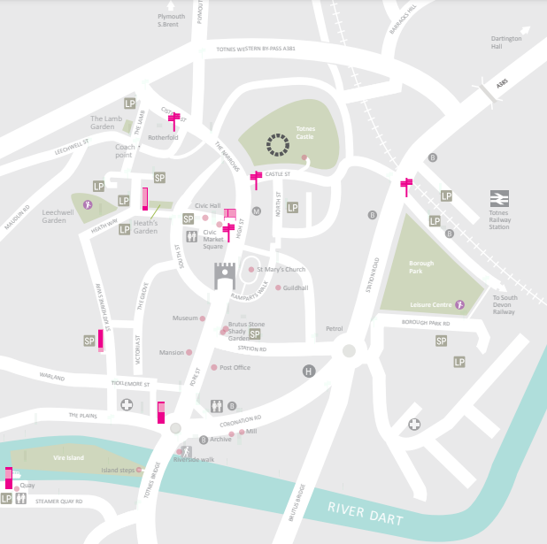

BEFORE COMMENCEMENT
Contractor to provide written risk assessments, methods statements, evidence of public liability insurance and other industry specific paperwork which is acceptable to the Council.
THE WORKS
To source materials and fabricate the first phase of new signage as outlined below and in the attached technical specification.

TENDER BREAKDOWN

The Contractor is asked to breakdown the cost by each individual signage unit.

If the Contractor has experience of signage installation in the public realm projects they are invited to contact the Town Clerk separately regarding quoting for that future phase of the project.
_____________
Tenders are invited by 31st March 2022
It is anticipated fabrication work should start in mid April with a view to completion (and starting of installation) in mid June 2022.
All queries relating to the tender process and specification should be addressed to :-
Lucy Ferrier
Communications and Marketing Manager
Totnes Town Council
5 Ramparts Walk
Totnes
TQ9 5QH
reception@totnestowncouncil.gov.uk

