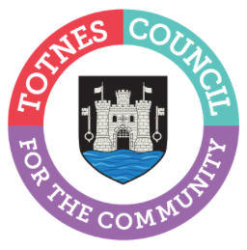

24 August 2022
£25,000 Funding Available To Build Community Resilience
Totnes Town Council is inviting local community groups to apply for a grant to support projects that make positive changes in the town. Over £25,000 is available. Grant applications open on the council’s website at www.totnestowncouncil.gov.uk/your-community/community-grants/ on 1 September 2022. Groups have until 5pm on 30 September 2022 to submit their application.
Totnes Town Council’s Mayor, Cllr Emily Price, said: “Our community groups do an amazing job making a positive difference to Totnes. We know that this is going to be a tough winter for many residents and businesses but I’m reassured that we have dedicated organisations in our town helping people of all ages and needs. I’m delighted that through these grants the Town Council can support the vital work these groups carry out to build community resilience.”
To apply for a grant, community organisations need to complete the simple form on the council’s website, which asks for details on how the funds will be spent. Projects that help deal with the current cost of living crisis or building resilience in the community will be viewed favourably. Councillors will allocate the available funding at the Council Matters meeting on 10 October 2022 and successful applicants will be informed after this date.
The grant funding is the latest round of financial support provided by the Town Council for local organisations. In April 2022, Totnes Town Council allocated grants worth a total of £24,000 to a diverse range of community groups including Totnes Caring, South Hams Citizens Advice, Totnes Bike Hub, St John’s Church, Inclusive Totnes and Bridgetown Alive!
Totnes Town Council has also supported projects across Totnes to access funding worth over £545,000 from government grant schemes and other sources in the last year. If you’d like to find out more, please email: community@totnestowncouncil.gov.uk
To apply for a grant from 1 September 2022, go to www.totnestowncouncil.gov.uk/your-community/community-grants/

- Ends

Note to Editors
For more information, please contact Lucy Ferrier, Marketing & Communications Manager at info@visittotnes.co.uk

