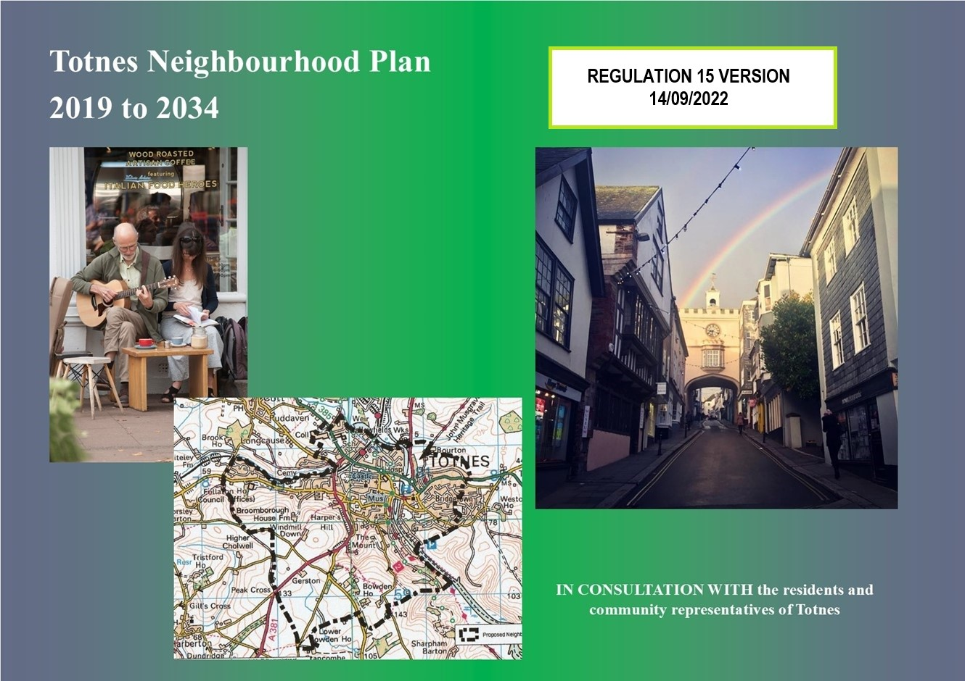
CONTENTS Page

Foreword 6
Have your say 6

Introduction
1.1 What is a NP and why is it important to the Totnes community? 8
1.2 What area does the NP cover? 8
1.3 How does the NP relate to other neighbourhood plans and what period does it cover? 10
1.4 How has the NP been prepared? 10
1.5 Are there any limits on the NP? 12
1.6 How will the plan be used and who is it for? 12

Vision and Objectives
  - Vision 13
  - Objectives 15
  - Local Identity 19
2.4 Health and Wellbeing 20

What Makes Totnes Special? 21

Environment
4.1 Sustainable Development and the Settlement Boundary 24
4.2 Development and Design 26
4.3 Historic and Built Character 28
4.4 Landscape Setting of Totnes 29
4.5 The River Dart 30
4.6 Enhancing Local Environmental Capacity 31
4.7 Renewable Energy Generation 32
4.8 Domestic and Small-Scale Waste Management 32
4.9 Local Food Growing 33
4.10 Mitigation and Adaption to Climate Change 34

Economy
5.1 The Local Economy 36
5.2 The Town Centre 39
5.3 Training and Education 41
5.4 Totnes Industrial Estate – Babbage Road 41
5.5 The Green Economy 42
5.6 Sustainable Transport 43
5.7 Walking and Cycling 47
5.8 Public and Community Transport 48
5.9 Car Parking Opportunities 49

Community
6.1 The Public Realm 52
6.2 Open Spaces 53
6.3 Local Green Spaces 55
6.4 Housing 57
6.5 Services and Facilities 59
6.6 King Edward VI Community College 60
6.7 Steamer Quay 62
6.8 Market Square and Civic Hall 63
6.9 Former Dairy Crest 65

Delivery and Monitoring 68

Maps
Totnes Neighbourhood Plan Designated Area (page 9)
Figure 1 – Proposals Map (page 16)
Environment Proposals Map (page 17)
Economy Proposals Map (page 17)
Community Proposals Map (page 18)
Figure 2 – Public Open Spaces and Local Green Spaces Map (page 56)
Figure 3 – Former Dairy Crest site policy area (page 66)

Appendices
A. Totnes and its Four Neighbourhoods
B. Local Green Spaces
C. Non-Designated Heritage Asset List
D. Detailed Designated Heritage List
E. Former Dairy Crest Site Development Brief

Photograph Acknowledgements:
Jacqi Hodgson, Colin Luker, Georgina Allen
The Totnes Map on p67 is reproduced by kind permission of the St Mary’s Totnes Heritage Trust

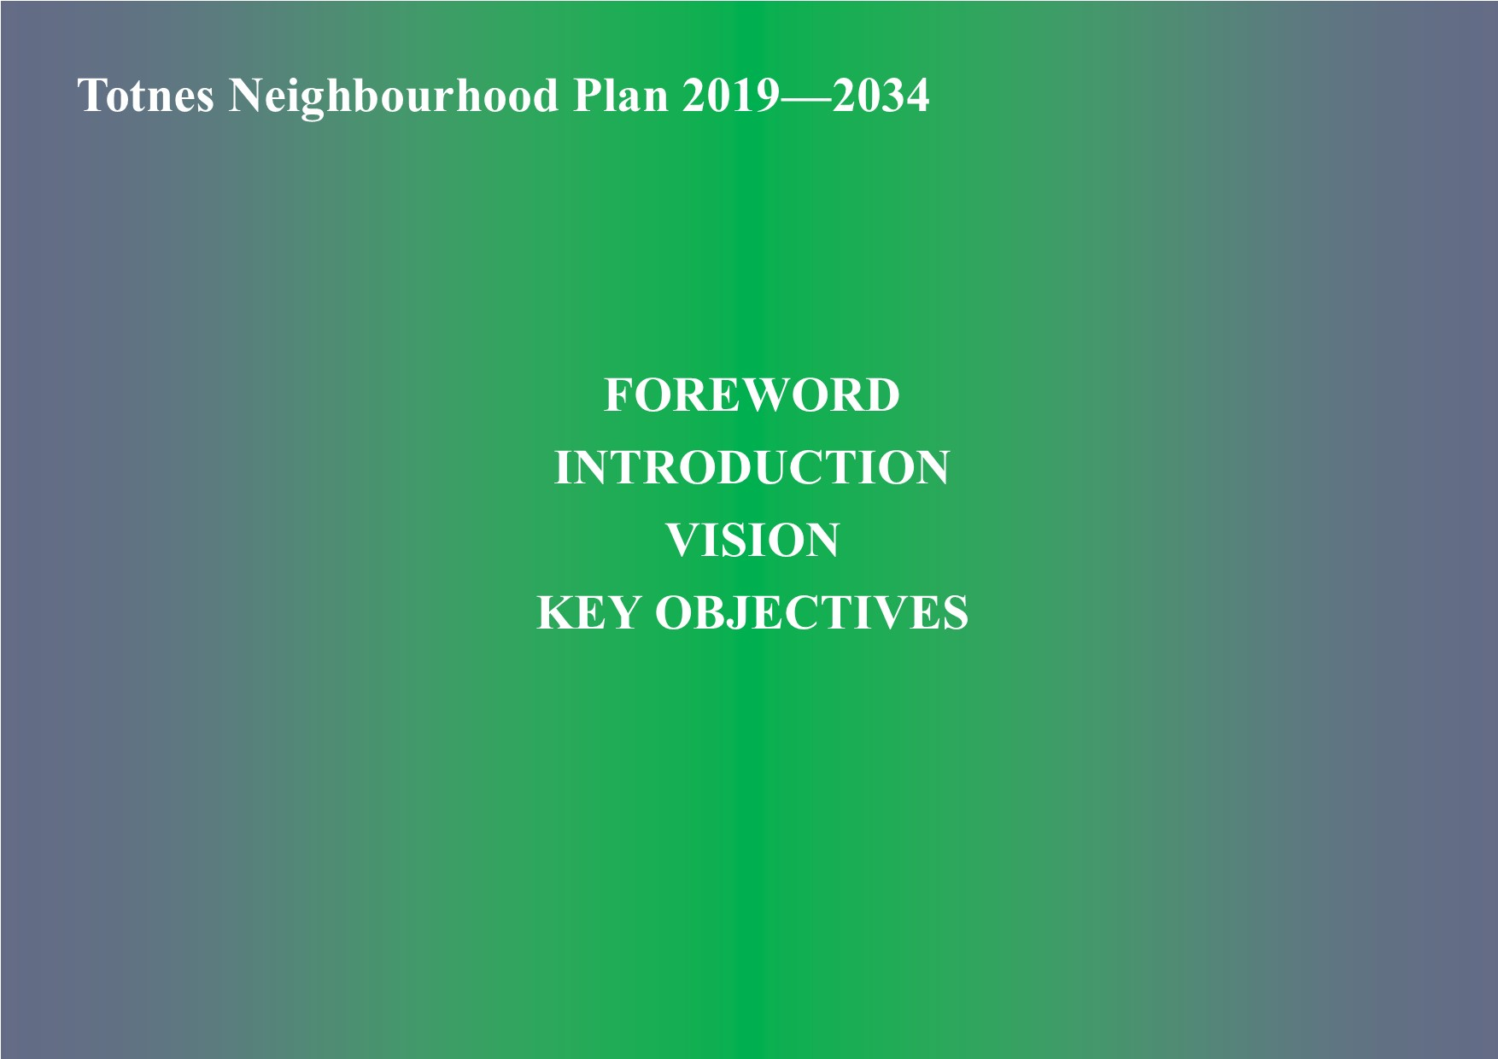

Foreword

Welcome to the plan for the future of Totnes. Inspired and made by the local community and covering the whole of the town inside the parish boundary, this is your plan.

Totnes is steeped in history going back to prehistoric times and its future development must respect that archaeological heritage. The local community is also determined that development in Totnes shall contribute towards a sustainable future. The plan aims to protect and nurture the town's precious heritage whilst adapting to the needs of a changing world, particularly recognising the ‘climate emergency’ and the way we act to protect Totnes for future generations.

The Neighbourhood Plan’s (NP) authors, consisting of Town Councillors and a wide variety of public working groups and public consultation events, have created this document to encompass the aspirations and hopes of the community for the next 14 years and beyond.

The vision for Totnes is that:
a. As Totnes changes and develops over the coming decades its identity must not be lost;
b. It will continue to be a model of sustainability, innovation, inclusivity and creativity; and
c. It will become an even better place for residents of all ages, visitors and businesses.

Have your say

The community will have the final say on the adoption of the NP, following its independent examination, through a public referendum. How you vote will determine whether the NP will be adopted.

The NP has been amended following a six week public consultation carried out in November/December 2019 and in the light of comments received from South Hams District Council as the local planning authority.

This is the final document approved by Totnes Town Council for submission to South Hams District Council who will make it available for another six weeks for any further public comments to be made, before arranging for an Independent Examination to take place.

Provided the plan passes examination South Hams District Council will organise a Referendum, which will give the people of Totnes the final say on whether they think the Neighbourhood Plan should be adopted through a simple ‘Yes/No’ vote. The referendum will be open to all those on the electoral register for Totnes. For the plan to be accepted at least 50% of those voting must say ‘yes’. Due to the current Covid-19 situation the referendum is currently planned for no earlier than May 2021.

If it is approved by referendum this neighbourhood plan will come into force immediately and will be referred to by planners in making decisions about development in the town.

This is your plan. Please let us know what you think of it.

Approved by Totnes Town Council, 7th September 2020 and updated for policy C12 on 28th July 2022.

1. Introduction

1.1 What is a NP and why is it important to the Totnes community?

Neighbourhood Planning gives communities direct power to develop a shared vision for their neighbourhood and shape the development and growth of their local area. They are able to choose where they want new homes, shops and offices to be built, have their say on what those new buildings should look like, what infrastructure should be provided and grant planning permission. Neighbourhood planning provides a powerful set of tools for local people to plan for the types of development to meet their community’s needs and where the ambition of the neighbourhood is aligned with the strategic needs and priorities of the wider local area.

(source https://www.gov.uk/guidance/neighbourhood-planning--2#what-is-neighbourhood-planning)

1.1.1 A Neighbourhood Plan (NP) enables Totnes as a community to have a much greater say in shaping the areas in which we live and work and in supporting new development proposals in the future. This NP forms part of the development plan and sits alongside the Plymouth and South West Devon Joint Local Plan (JLP) which has been prepared by the local planning authorities.

1.1.2 Decisions on planning applications will be made using both the JLP and the NP, and any other material considerations. The NP means that planning decisions will be based on better informed and more detailed policies than if Totnes were only covered by the JLP.

1.1.3 The NP reflects local ideas and opinions, aiming to ensure that the town's identity is protected and that it will have a sustainable, healthy and prosperous future.

1.2 What area does the NP cover?

1.2.1 The NP covers the administrative area of Totnes as detailed in the Notice of Designation 2/2013. The NP’s policies can apply only within that area, but in order to ensure that the plan looks at the whole community regard has also been paid to those parts of the built-up area of Totnes or existing development proposals which lie inside adjacent parishes.
1.2.2 In the future there will be further growth outside the administrative boundary of Totnes which will result in impacting the residents of Totnes in all the areas covered by this NP. The NP makes reference to this but cannot make proposals for change or development outside its area. The consultation with adjacent parishes** in the NP process has therefore been both welcome and essential. It is an aspiration that plans for those parishes will therefore contain proposals to complement and mirror this NP.

** Berry Pomeroy; Dartington; Harberton, Ashprington and Littlehempston.

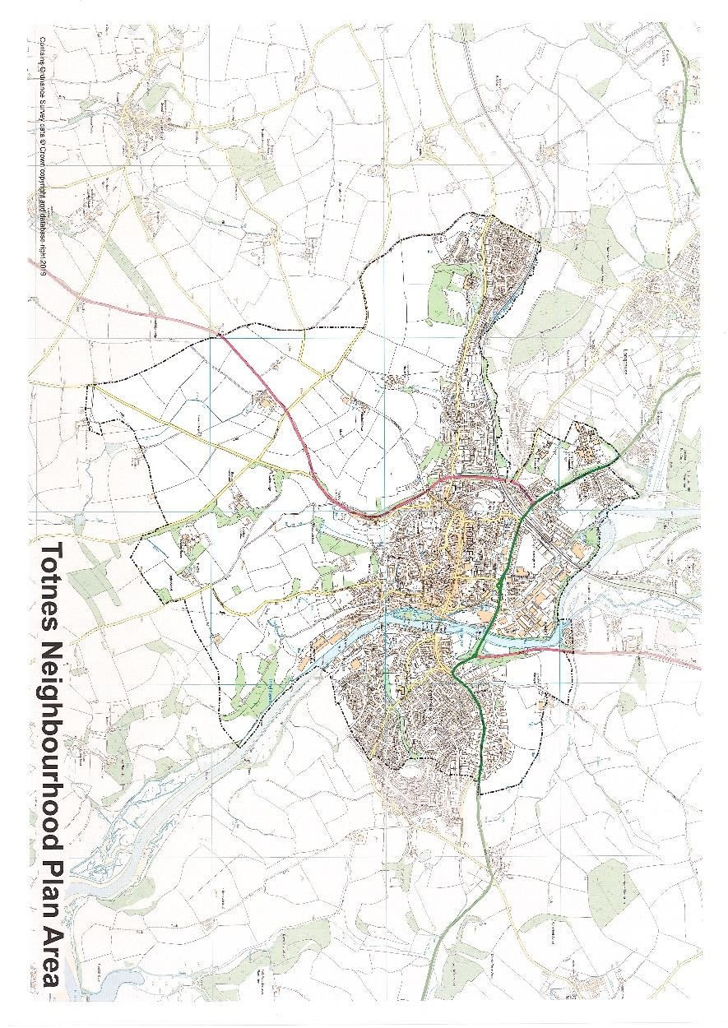

1.3 How does the NP relate to other plans and what period does it cover?

1.3.1 The NP complies with the National Planning Policy Framework (NPPF) and the adopted plans for the area. In particular it complies with the adopted Plymouth and South West Devon Joint Local Plan (the JLP) with which it shares the same time horizon (2034), and the Devon Waste Plan 2011-2031. The NP should also comply with the emerging Climate Emergency Plans being developed by Devon County Council and South Hams District Council, and the Dart Harbour Authority strategic plan. It formally covers the period to 2034, the same as that covered by the JLP. Specific development proposals in the NP relate to that period but its general policies, so long as they remain fit-for purpose, will continue to apply beyond that date.

1.3.2 There are also neighbourhood plans being prepared for parishes adjacent to Totnes. The plan aims to correlate with these, and in particular with the emerging neighbourhood plans for Dartington, Harberton and Berry Pomeroy.

1.4 How has the NP been prepared?

1.4.1 The NP process has been led by a steering group comprising representatives of the town council and volunteers from the local community and a variety of local organisations. The diagram below outlines the process. Widespread public consultation has been carried out as detailed in the Statement of Consultation which describes in more detail how the community has been involved throughout the process.

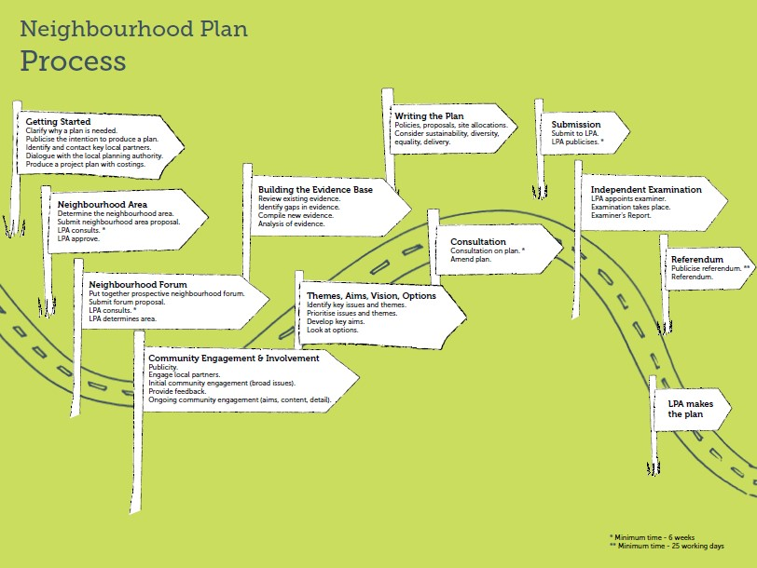

1.5 Are there any limits on the NP?

1.5.1 The NP must meet several basic conditions, which will be the principal basis of its examination. Those conditions are:

- Be appropriate - having regard to national policy;
- Contribute to the achievement of sustainable development;
- Be in general conformity with the strategic policies of the JLP; and
- Be compatible with human rights requirements and EU obligations.

1.6 How will the plan be used and who is it for?

1.6.1. The NP will be used by Totnes Town Council in its consideration of recommendations on planning applications as part of the consultation process, and by South Hams District Council (SHDC) to help guide its planning decisions for Totnes. It will be used by planning inspectors (or the Secretary of State) in relation to planning appeals in Totnes. It will be referred to by decision makers of all kinds – planners, investors, developers, funding bodies, community groups and existing and future residents.

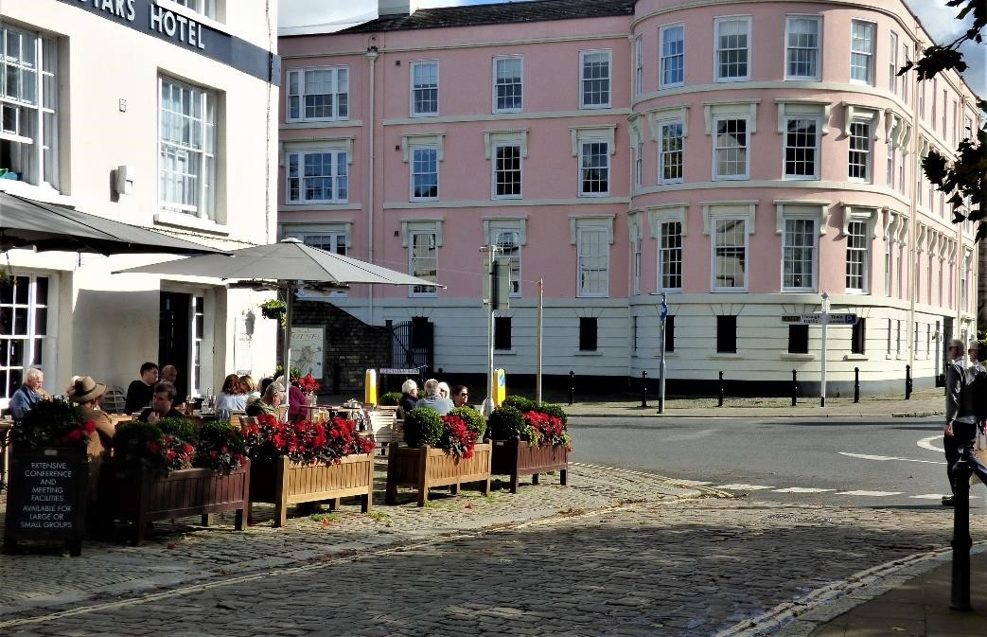

2. Vision and Objectives

2.1 Vision

As Totnes changes and develops over the coming decades its identity MUST not be lost.

The town will continue to be a model of sustainability, innovation, inclusivity and creativity, becoming an even better place for residents of all ages, visitors and businesses.

2.1.1 Totnes has seen continuous change over its history. From its origins as an early Saxon settlement, through being a fortified town, a wealthy trading centre, a thriving industrial hub based on timber, boat building, cider production, meat and milk processing, up to the current day when tourism and small/medium businesses dominate the local economy. Many buildings have changed their use over the centuries. Merchants’ houses are now shops and accommodation. The racecourse is now an industrial estate and the old manufacturing and commercial buildings and sites have been converted to apartments, a supermarket and housing. The landscape has changed with housing being built on what was open farmland. Churches are becoming community hubs. So, what will happen in the future as the needs of the community change and lifestyle moves on from where we are today?

2.1.2 The NP addresses the community’s aspirations for the future of Totnes, that it will be a sustainable place where:

- Suitable housing and local employment are available to all
- Air quality no longer creates the health risks presently encountered
- Leisure and open spaces are available to all
- The local green economy provides food, goods and services in a sustainable way which mitigates climate issues
- Totnes remains a local transport hub in the South Hams

2.1.3 Consultation has shown that the distinct identity of Totnes is something that is highly valued, and that there is a strong desire to ensure that development both recognises and enhances that identity. The NP attempts to fully capture the town's distinctive nature, and the proposed policies must ensure that all of Totnes's special qualities are maintained and enhanced.

2.1.4 Achieving sustainable development is a central objective for the planning system and for Totnes. This means that economic, social and environmental considerations must be well balanced. The planning system should deliver development that meets the needs of today without compromising the ability of future generations to meet their own needs, achieving economic, social and environmental gains. This approach is at the heart of the NP. Totnes already aspires to be a sustainable town and the NP’s provisions aim to help this.

The Vision is summarised in the diagram below.
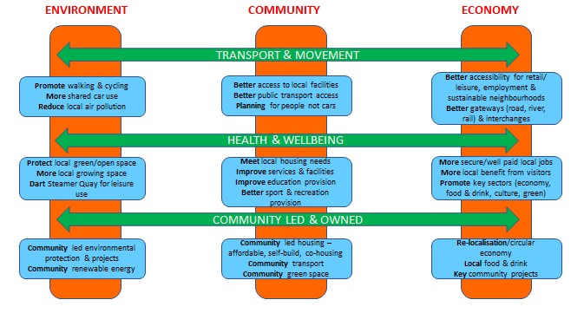

2.2 Objectives

2.2.1 The NP must support the vitality and diversity of the Totnes community, making sure that its needs are met and creating new opportunities to build on the strengths of the community. NP policies aim to maintain and enhance the well-being of all and to deliver the following objectives:

- Protect the distinctive historic character of Totnes and its many architecturally significant buildings, streets, squares, open spaces and the wider public realm for their vital importance to the identity and heritage of the town.
- Seek to ensure that all new housing developments, small or large, give priority to the needs of local people, with particular emphasis on social and affordable homes.
- Support community-led development and community asset ownership as ways of achieving sustainable development.
- Support and enhance the Totnes retail and service roles and the way they combine to create a place which is much more than just the sum of its physical attributes.
- Support and enhance the Totnes economic capability and its role as a visitor destination via the associated hospitality sector.
- Extend the strength, variety and distinctiveness which characterise the thriving local economy.
- Encourage and support 'green' and 'ethical' businesses and their local networks and clusters based on the existing strengths in this area of the town.
- Support the improvement of existing business space and expansion of new space to meet the needs of the local economy.
- Support and extend the Totnes pioneering approach to sustainable development and local resilience, seeking to reduce the environmental impacts of the town, and mitigate and adapt for climate change.
- Seek to create a more sustainable transport network for Totnes and its hinterland via transport development which reduces the need for travel by independent vehicle and makes the best use of more sustainable modes of travel, directly reducing the adverse impact of vehicular traffic on the environment and health.
- Enhance opportunities for open space and recreation facilities to be developed and contribute more to the community's active health and wellbeing.
- Eliminate discrimination, advance equality of opportunity and advance good relations between those sharing protected characteristics and those who do not.

2.2.2 The NP's policies, set out in the following chapters and shown on the proposals map at figure 1 below and one additional maps at the beginning of each section, together aim to deliver these objectives. However, there are aspects of the objectives which lie outside the remit of the NP, whose policies will guide and control development in the town but not all activities. The NP sets a course for Totnes and it is hoped that this will also be followed in many of the strategies, policies and practices of other bodies and organisations dealing with matters such as transport, schools and health.

Figure 1. Totnes Proposals Map

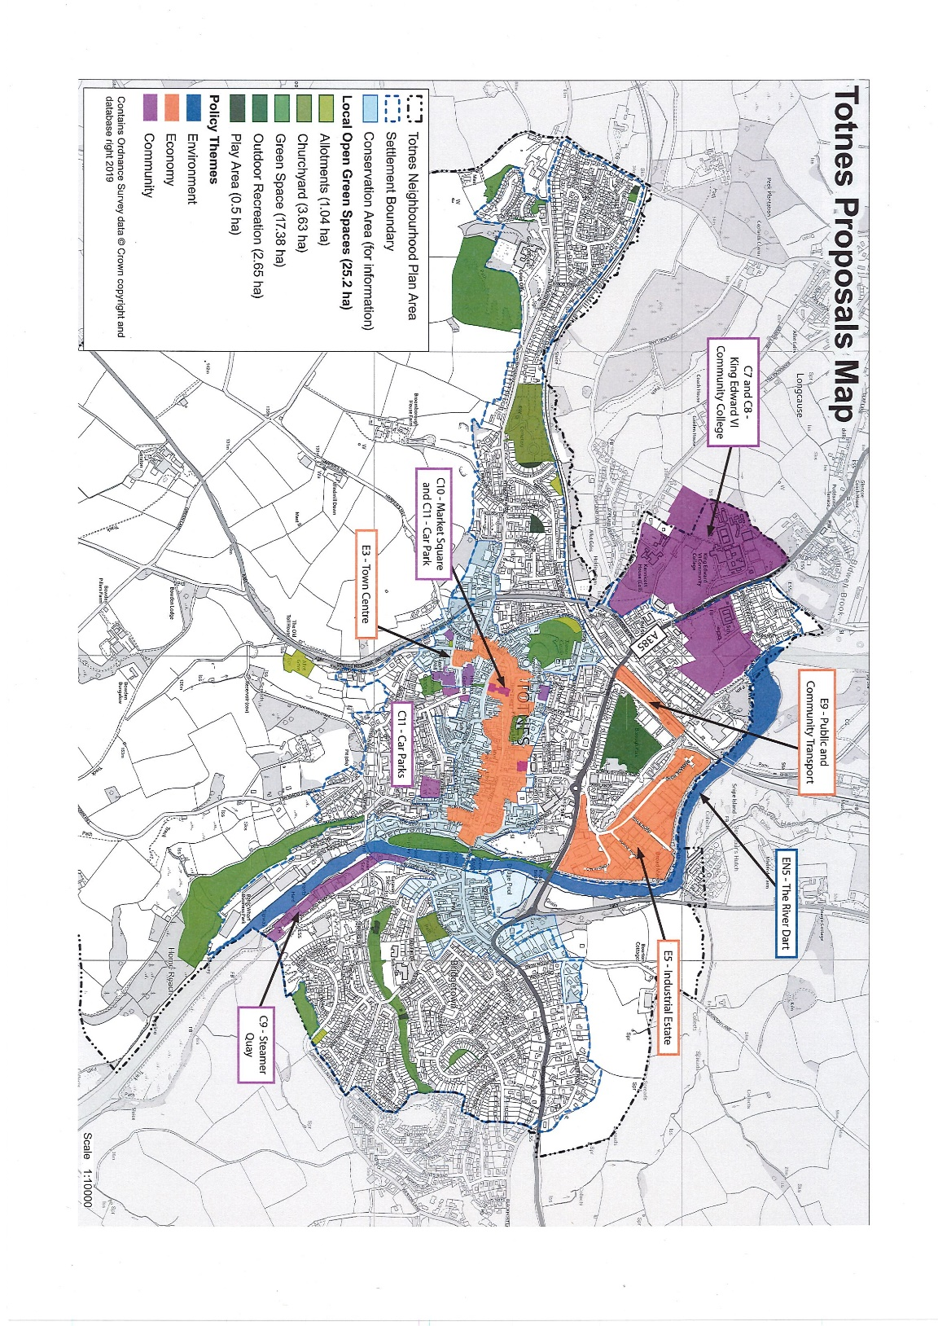

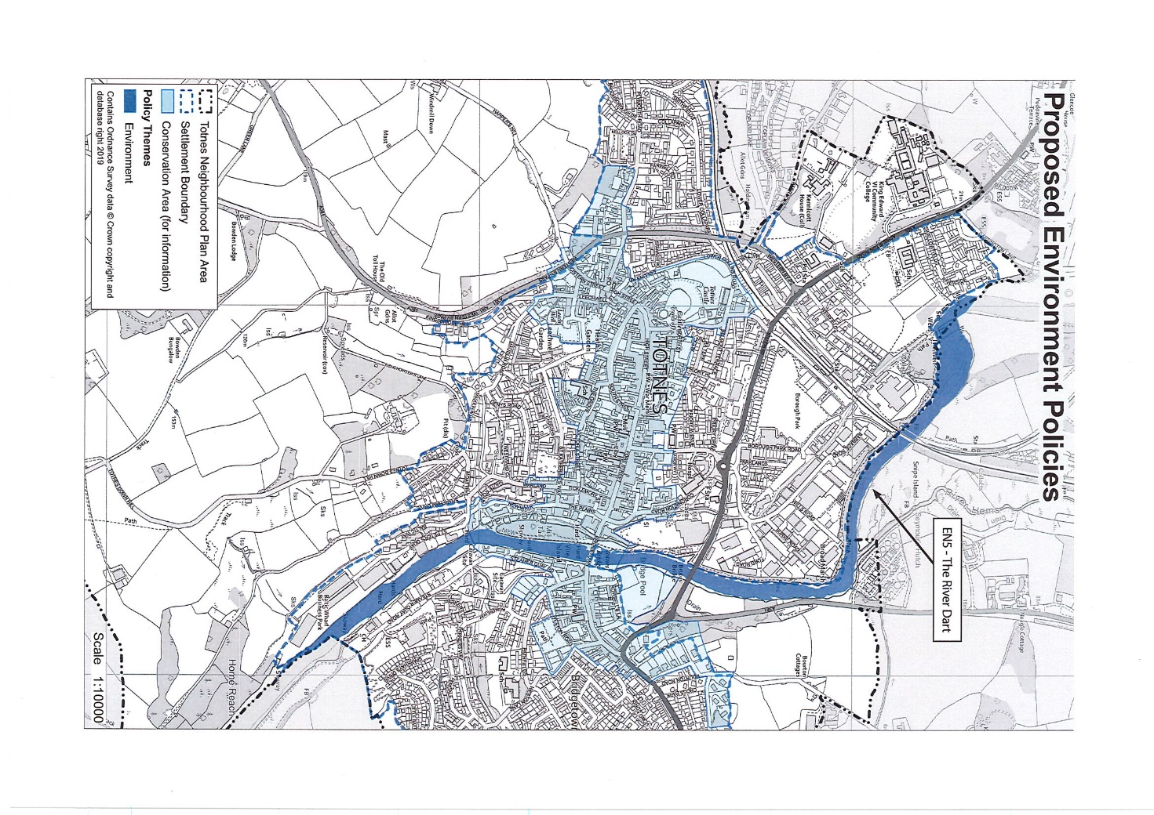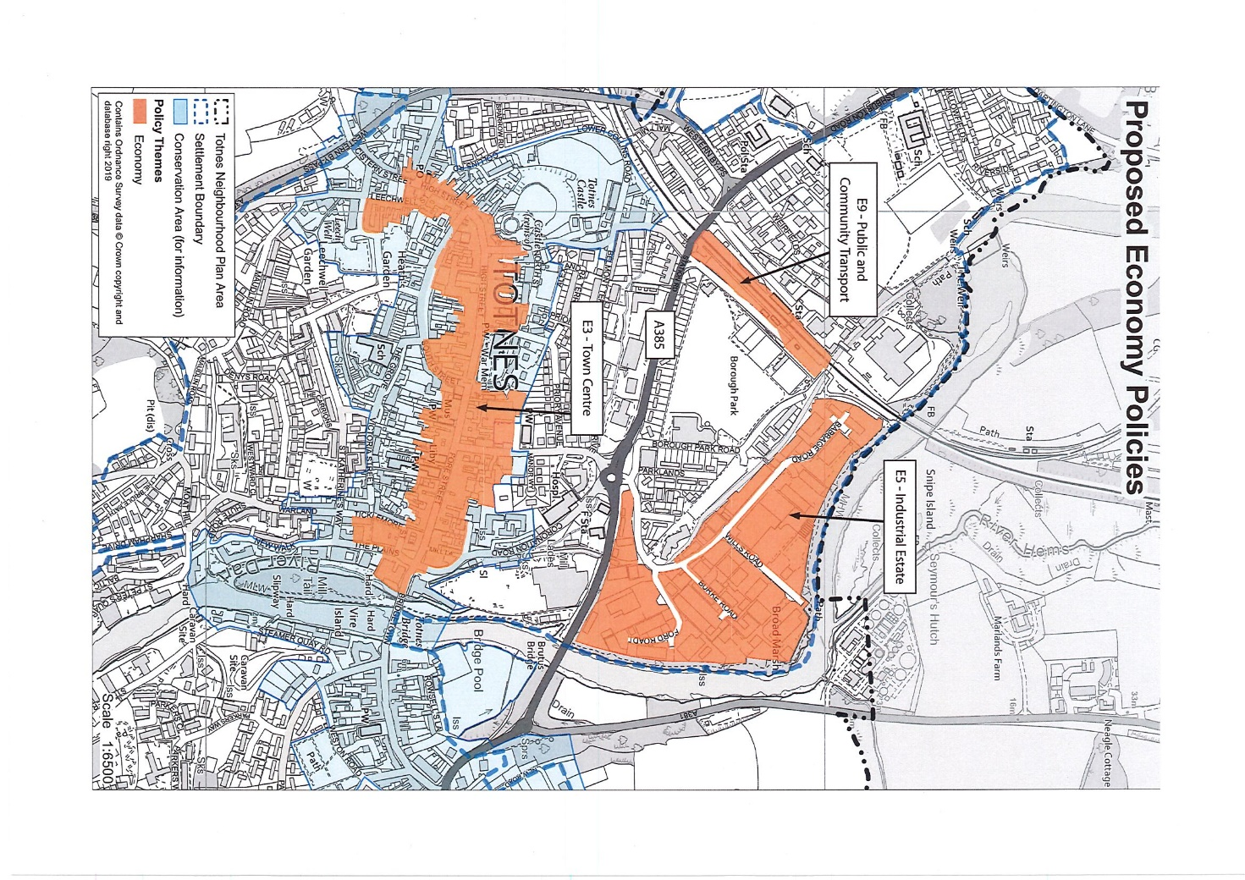
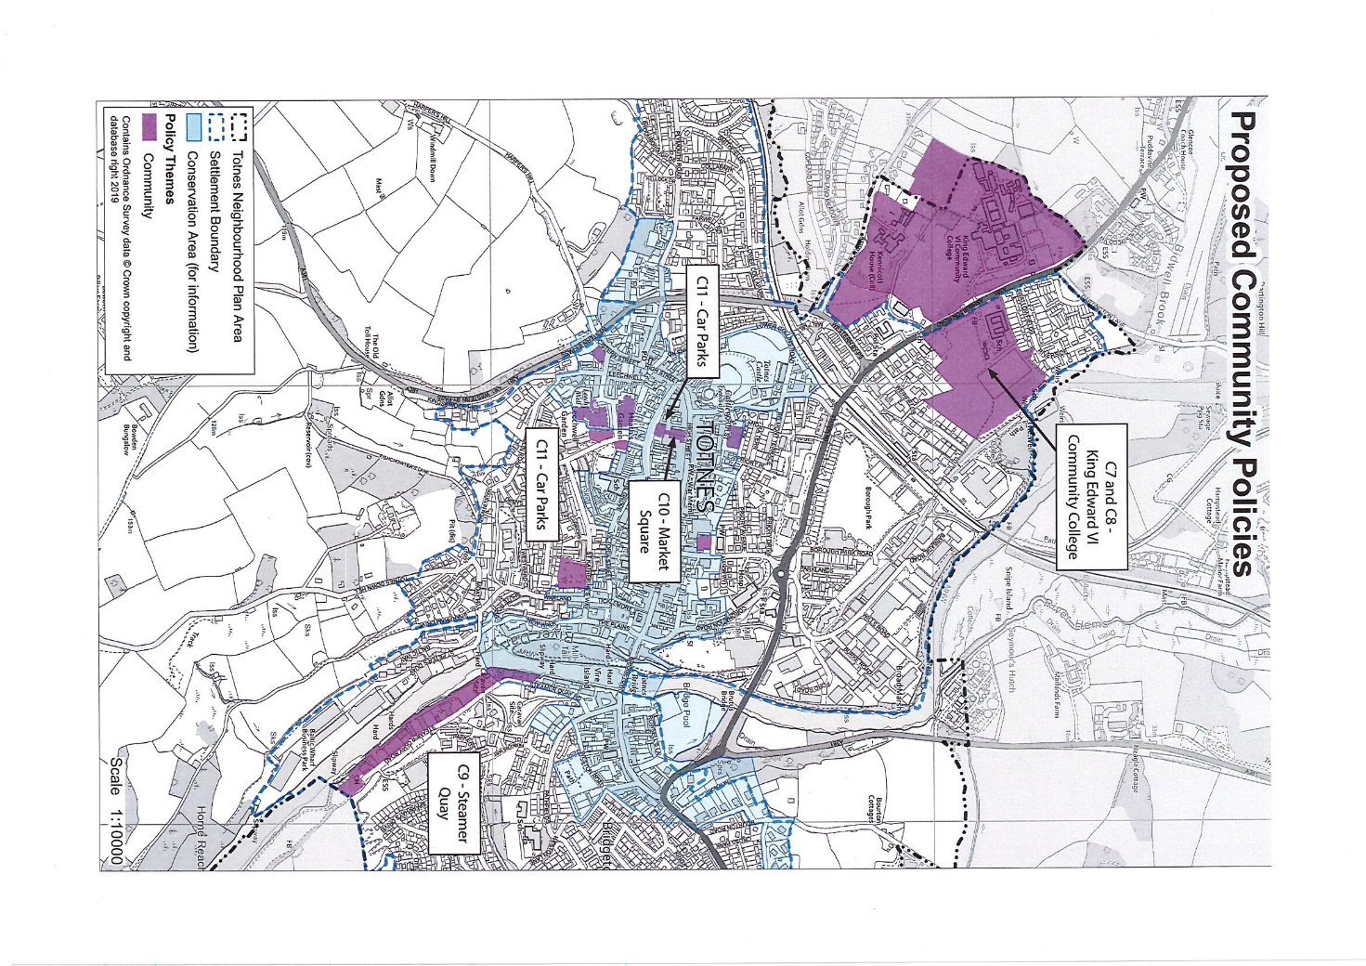

2.3 Local Identity

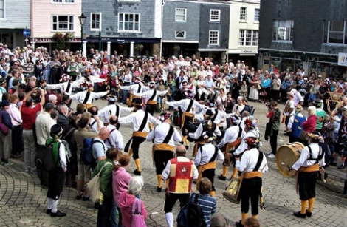
2.3.1 Totnes is home to a strong, diverse and vibrant community. In 2017 the population was estimated to be more than 8,400. Parts of the built-up extent lie beyond its administrative boundary in the adjoining parishes of Berry Pomeroy and Dartington, further increasing its functional population. It is estimated that the town's wider catchment population exceeds 23,000 and, particularly in summer, tourists and visitors further swell these numbers.

2.3.2 The historic character of Totnes, still so very evident today, combined with the unusually wide spectrum of local interests and activities, give the town a highly distinctive local identity and an 'edge' which it must not lose. The NP aims to support and strengthen this, with policies designed to enable local people, business and culture to flourish.

2.3.3 The community faces a variety of challenges. There is a lot of demand to live in Totnes. House prices are high, pressure for development is strong, and there is a large unmet need for affordable housing. This creates particular problems for younger people, families and older households, who can struggle to meet their housing needs either for affordable or open market housing. This, in turn, means that there is difficulty attracting young people and families to and retaining them in the town. It is vital therefore that any of the limited opportunities for new housing and business development in Totnes make the greatest possible contribution to meeting local needs.
2.3.4 Many local services and facilities are, without doubt, worth the protection that the NP provides. The town's educational facilities, however, need improvement, and the NP seeks to facilitate this.

POLICY V1 – LOCAL IDENTITY

Support will be given to new development in Totnes which conserves and enhances the town and its reputation by:

a. respecting local distinctiveness and historic character in land use, scale, form and appearance;

b. stimulating innovation and creativity in design and practice;

c. enriching culture and community wellbeing by providing facilities, services or amenities of local value; and/or

d. enhancing sustainability by promoting low carbon travel, employing low energy use materials and construction techniques and incorporating renewable energy generation.

2.4 Health and Wellbeing

2.4.1 The state of our built and natural environment is a key determinant of health and wellbeing. The design and social cohesion of neighbourhoods can influence physical activity levels, travel patterns, social connectivity and mental and physical wellbeing. Totnes has long recognised this and has built strong community infrastructure such as the “Caring Town Totnes” initiative. Measures to address health and wellbeing can be found throughout the NP, which will:

- Enhance the wellbeing of all, recognising that this is a distinctive positive feature of Totnes;
- Ensure equality of access, removing or minimising disadvantages and promoting equality, diversity, fairness and inclusion for all; and
- Support measures to increase walking and cycling and reduce the adverse impacts of vehicular traffic.

POLICY V2: HEALTH AND WELLBEING

Support will be given to new development which results in benefits to local community health and wellbeing through:

a. more opportunities for food to be grown and consumed locally;

b. new housing options for those excluded from the market;

c. new employment opportunities and raised job security and quality;

d. increased access to public green spaces and the river;

e. greater participation in culture, sport and recreation;

f. safe, convenient, comfortable movement without recourse to a car; and/or

g. equal accessibility and opportunity for all.

3. What Makes Totnes Special?

3.1 Totnes is a highly desirable place to live and work and has a well-deserved reputation as a special place attracting many visitors. It is proud of its distinctiveness and is well known for its commitment to sustainable development, although there is much concern that some past planning decisions have not supported this.
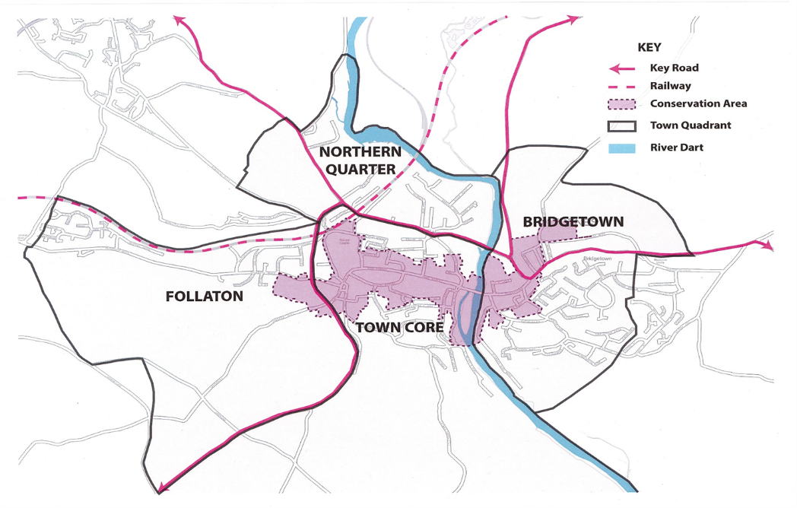
3.2 Totnes has high archaeological significance with its origins potentially rooted in a Saxon burh established at some time during the 10th century AD, and it is one of the few remaining burhs. The historic core of the town is probably its most valued feature with its medieval street pattern, castle, numerous listed buildings and other heritage features. The location of Totnes at the lowest bridging point on the River Dart has been a significant part of its success over the centuries, bringing people to and through the town. However, today this causes serious traffic congestion, which impacts the quality of the local environment for its residents. More information on Totnes and its four neighbourhoods – the Town core, Bridgetown, Follaton and northern quarter - can be found in Appendix A.

3.3 The River Dart is a huge asset to the town, although it is currently undervalued and underused. It contributes greatly to environmental quality, social, energy and water-based leisure facilities. There are great opportunities to make much more of this resource, as well as securing continuous riverside access in any future development of land.

3.4 The landscape setting of Totnes is also a critical dimension of its character. Totnes is surrounded by hills, creating an intimate setting. If development were to overrun these hills a central aspect of its identify would be lost. This emphasises the point that there are obvious environmental limits to the expansion of Totnes, so the limited development opportunities that exist must be used wisely, to the greatest benefit of the residents.

3.5 Totnes occupies a focal point on both road and rail networks, a synergy which adds to the town’s many attractions as a place to live and work but poses a growing challenge to the local environment, economy and quality of life. Developments both in Totnes and beyond are putting an ever-increasing strain on an already constrained road/rail/public transport network.

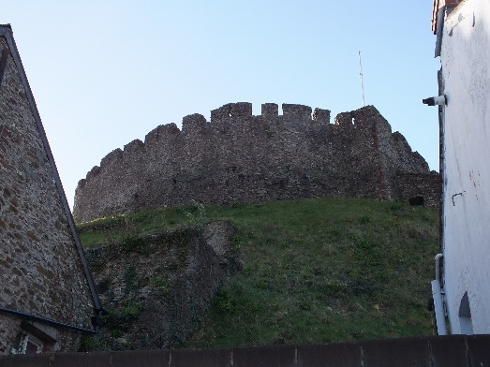
3.6 Totnes is a local employment centre with employment opportunities in several key sectors, including retail whose varied choice of independent shops, cafés and restaurants gives Totnes an edge. However, the number of workers travelling into the town outnumber its resident working population, many of whom commute to work elsewhere. This adds to congestion in Totnes at peak hours and the NP aims to increase the town's economic self-sufficiency.

3.7 Totnes has a well-deserved reputation as a cultural, education and environmental centre. Over the decades it has become a centre for arts and 'alternative' lifestyle activities, greatly helped by its proximity to Dartington Estate, Schumacher College and the Steiner School and by the Totnes Transition Town movement. These characteristics are fostered by a high level of engagement of residents in a wide spectrum of local activities and issues. All of this creates many opportunities for furthering these important aspects of local identity and is an important aspect of life in Totnes which it must not lose.

3.8 The attraction of Totnes creates challenges. House prices are high, shortage of affordable and social housing means that young people, families and older people can all struggle to meet their housing needs. The loss of retail sites to other types of development is a concern leading to problems accessing ‘everyday’ goods, services and facilities. Educational facilities need proper funding and improvement. Despite the strength of the local economy there are a high percentage of low wage and part time work. This adds to the housing issues already mentioned. Traffic congestion at peak times impairs the town's efficient functioning and causes air pollution.

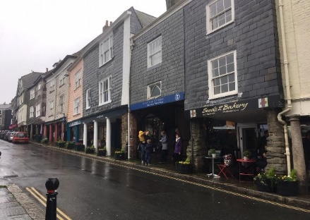
3.9 Totnes is seen as a different sort of place – unique not only in Devon but more widely, with a national and international reputation which residents, businesses and visitors cherish.

3.10 The central task for the NP is to make sure that future development does not diminish Totnes but strengthens it and enhances the reasons that people choose to come and make their lives in Totnes.

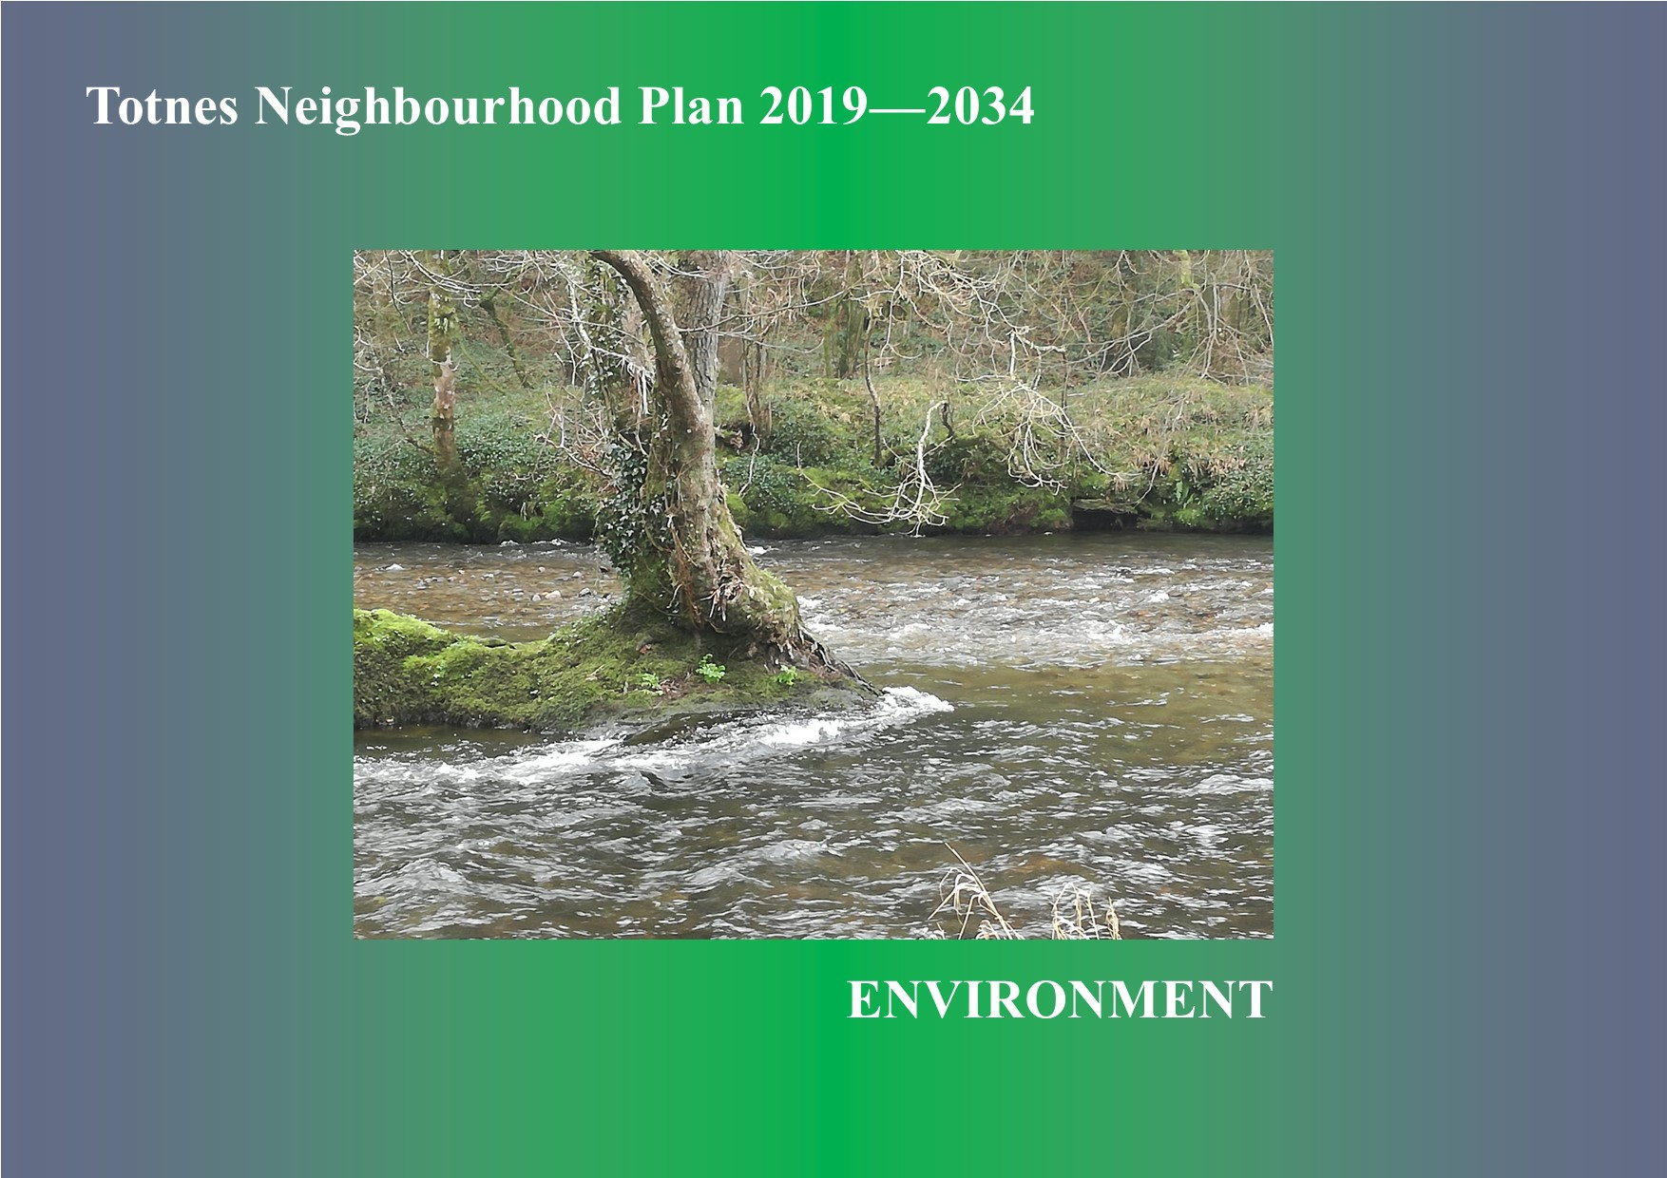

4. Environment

4.1 Sustainable Development and the Settlement Boundary

4.1.1 The NP seeks to ensure that development in Totnes meets local needs without damaging local character, heritage or the environment. To assist in this, it defines a settlement boundary within which development will be acceptable in principle providing it satisfies the policies of the NP.

4.1.2 The NP can only deal with matters inside Totnes’ administrative boundary. Parts of the built-up area of Totnes have extended into adjacent parishes and it is hoped that the settlement boundary established in this NP will be complemented by those shown in adjacent neighbourhood plans in order to guide and control the extent of the town's growth.

4.1.3 Totnes is a very environmentally active and aware town, and this is reflected in its NP. New development in Totnes should seek to minimise impacts on the global environment and bring the greatest possible benefits to the local environment.

4.1.4 Achieving sustainable development is at the heart of the National Planning Policy Framework and the NP aims to:

- Support and extend Totnes' pioneering approach to sustainable development and local resilience, reducing the environmental impacts of the town and adapting for climate change.
- Enable continual transition towards true sustainability, addressing issues including energy generation and use, resource consumption, waste production, and air and water pollution, taking every opportunity to mitigate and adapt for climate change and enhance local environmental capacity.

4.1.5 For Totnes, then, sustainability entails a strong focus on environmental sustainability, as without a strong environment a strong community and economy cannot be attained. This does not necessarily mean less development. Maintaining a strong environment may constrain some development but will also create opportunities for development which maintains or enhances the environment. The NP, therefore, is actively looking for development which will be good for the environment, community and economy.
4.1.6 The NP seeks to reduce the environmental impacts and increase the environmental benefits of new development, requiring that new development provides the greatest environmental benefits which can reasonably be achieved.

4.1.7 Planning applications must include a simple summary of relevant environmental impacts and benefits, including those addressed by specific policies in this NP:

- Mitigation of (by reducing greenhouse gas emissions) and adaptation to climate change
- Enhancing local environmental capacity
- Renewable energy generation
- Waste management
- Enhancing air quality
- Enhancing water quality
- Wildlife sensitive exterior lighting
- Landscaping
- Enhancing local environmental and ecological capacity.

4.1.8 It is imperative that new development does not make local air quality worse and if possible, makes it better. This is particularly important in the A385 Air Quality Management Area (AQMA). The main impact on local air quality is from traffic, which the location and size of new development can influence.

4.1.9 Major development sites in Totnes for the NP period are already identified in the JLP. New development on these and on other sites can help improve local air quality through suitable design to encourage dispersal of pollution and through landscaping to help manage local air quality, which may also support adaptation to climate change and enhance local environmental capacity. All such opportunities should be taken. Advances in vehicle technology through the NP period to 2034 and beyond may also help to reduce the levels of pollution emitted from vehicles.

4.1.10 In addition to respecting historic character national policy also encourages innovation in the design of new development and sustainability is a strong driver for innovative modern design.

4.1.11 The NP encourages design able to deliver greater global and local sustainability. A major part of this is that buildings should be low carbon in both their construction and use. Other aspects include designing to manage water and local pollution and designing buildings as integral elements of wider site design using approaches such as permaculture.

4.1.12 Totnes already has a number of high-quality, innovative modern buildings. Such buildings contribute towards a new generation of buildings of high-quality design in the town. Modern buildings not embodying this approach offer little and exacerbate worsening environmental conditions.

POLICY En1: SUSTAINABLE DEVELOPMENT AND THE SETTLEMENT BOUNDARY

1. Within the settlement boundary development will only be permitted provided:

a. it will help to meet local needs or enhance local services and facilities;

b. it will make efficient use of the site in terms of layout, density and mix of uses;

c. its scale and character will be in keeping with the site and surroundings;

d. it will maintain or enhance local identity and distinctiveness; and

e. it will incorporate all reasonable measures to reduce adverse impacts and deliver environmental benefits including improved access for all.

2. Outside the settlement boundary development will be permitted only where:

a. it meets the above criteria; and

b. it will meet a proven local need which is neither being nor likely to be met in the town, and cannot reasonably be met inside the boundary.

3. In all cases development should be of a high design quality, respecting and complementing the site and its setting, being of sustainable construction, promoting sustainable lifestyles and incorporating the latest energy efficiency measures.

4.2 Development and Design

4.2.1 The design of new development is of great significance, both to ensure that development is sustainably delivered and to preserve the town's distinctive and historic character. The NP aims to ensure sympathetic design in all new developments, particularly major developments for housing, retail, leisure, industrial and commercial uses. The design of minor development is also important but the NP acknowledges that in general its impact will be much less. Given Totnes’ historic past, the National Planning Policy Framework should be referred to in ensuring the protection of above and below ground archaeology as part of any development proposal.

4.2.2 Opportunities for development in Totnes are limited, and so it is important to make the best use of development land and existing buildings, ensuring that only that which can be sustainable to develop is used and that development takes place in a sustainable manner.

4.2.3 The NP does not set specific requirements for density and, in general, the community supports higher densities as a means of limiting green field development. Good design can deliver successful low-rise, high density building, as the historic town centre exemplifies. It can also provide amenity and food-growing spaces as part of development which this NP encourages. The density of each development should be determined in order to deliver the best possible and most sustainable design solution for the site.

POLICY En2: DEVELOPMENT AND DESIGN

All new development should display a high quality of design by meeting the following criteria:

a. maintaining and where possible enhancing local distinctiveness;

b. respecting historic character and interest above and below ground;

c. being in scale and keeping with its site and setting, protecting the local landscape and important views;

d. using appropriate materials not only for buildings but also for boundaries;

e. including where possible and practicable enough garden space to enable food growing;

f. incorporating meters, bin storage and other such features inconspicuously and so as to avoid street clutter;

g. being safe, attractive, inclusive and accessible for all, reducing opportunities for crime and the fear of crime;

h. being of sustainable construction, promoting sustainable lifestyles and incorporating the latest water and energy efficiency measures;

i. reducing the need to travel, causing no unnecessary noise, light, air or other pollution, safeguarding against risks of contamination, erosion or flooding, and ensuring satisfactory surface water drainage including Sustainable Urban Drainage Schemes (SUDS); and

j. providing safeguards during and after construction to protect against environmental damage, local nuisance, unnecessary noise, light, air or other pollution.

4.3 Historic and Built Character
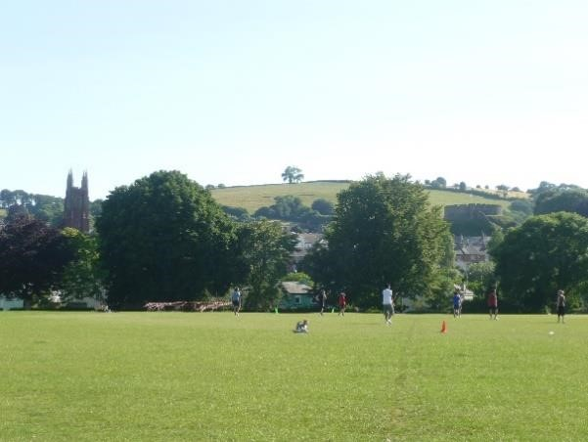
4.3.1 Totnes is justifiably well known for its historic character, which forms an essential part of the identity of the town. Much of the centre of the town is a Conservation Area and the town as a whole contains over 300 listed buildings and five Scheduled Ancient Monuments (including Totnes Castle and Totnes Priory).

4.3.2 Listed Buildings, Scheduled Monuments and Conservation Areas are national designations, protected by national and local policy. The NP reinforces this protection, addressing the locally distinctive historic character of the town as a whole, its buildings, streets and squares and the wider public realm.

BREAKDOWN OF THE HERITAGE ASSETS OF TOTNES – source www.historicengland.co.uk

Listed Buildings – total of 321, comprising:
Grade 1 – 7 (including St Mary’s Church classified as heritage at risk by Historic England)
Grade 2* - 27
Grade 2 – 282
Scheduled monuments – 5

4.3.3 New development is expected to maintain or enhance the historic and built character of the town. This does not mean that the NP is not open to change. Improvement and alteration of buildings can support wider heritage and cultural benefits, and new buildings and spaces can make positive contributions to the character and heritage of the town. New development should not, however, harm or dilute that character and heritage.

POLICY En3: HISTORIC AND BUILT CHARACTER

1. New development should:

a. respect the historic and built character of the town;

b. protect and where possible enhance heritage assets, both designated and non-designated; and

c. have regard to the Totnes Conservation Area Appraisal.

2. Good innovative design offering a fresh interpretation of local distinctiveness will be welcomed.

4.4 Landscape Setting of Totnes

4.4.1 The high quality, undeveloped landscape around Totnes frames the town as it nestles in the surrounding hills. The town's place in the wider landscape and the views of important buildings (the Castle and St Mary’s Church) within Totnes are both essential parts of local landscape character. This is particularly important at key ‘gateway’ sites to the town, for example: views descending Kingsbridge Hill and Bridgetown Hill; from boats approaching Totnes up the river; on the road approaches from Dartington and Newton Abbot; and from the railway lines. The NP therefore aims to protect both the landscape setting of the town and the town’s contribution to the wider local landscape.

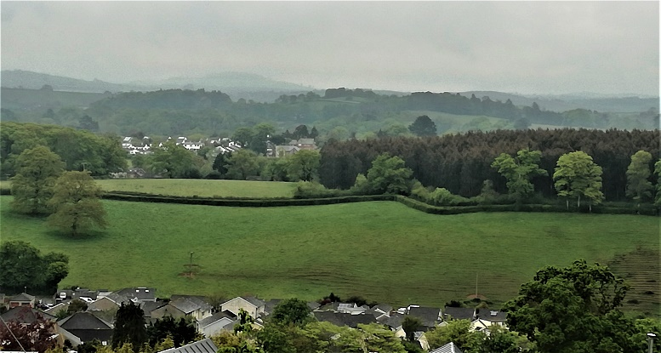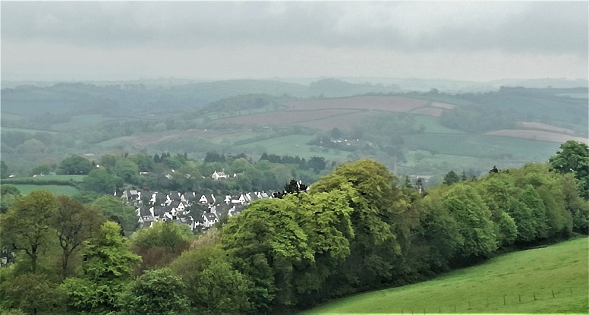

4.4.2 There is shared commitment between Totnes and the adjacent parishes of Dartington, Harberton, Ashprington and Berry Pomeroy to prevent coalescence between them. Totnes will seek to work with Dartington, Harberton, Ashprington and Berry Pomeroy to promote an effective green wedge between the settlements in which agriculture, landscape and nature conservation and public access is secured and the adverse impacts of traffic are minimised. The settlement boundaries established in this NP, the Dartington, Harberton and Berry Pomeroy Neighbourhood Plans will assist in ensuring this.

POLICY En4 – LANDSCAPE SETTING OF TOTNES

1. New development should have no adverse impact on the landscape setting of Totnes or on its historic landscape features.

2. New building should not be of a height or mass to obscure important views shown on the Proposals Map, nor of a height to break the historic skyline.

3. New development should not damage but enhance the contribution the town makes to the landscape character of the wider area.

4.5 The River Dart
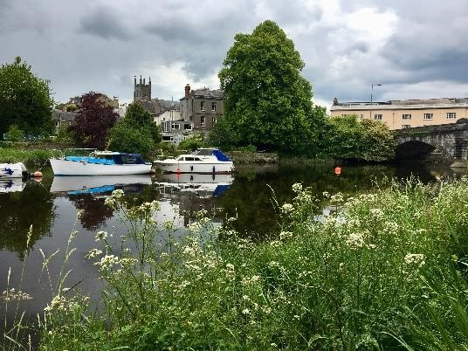
4.5.1 The River Dart is a key feature in the local landscape and the prime reason for the town's location. The Dart valley is Totnes' essential landscape feature, has been a mainstay of its economy and is an important resource for leisure and recreation. Recent residential development has taken place on both sides of the river with the Quayside and Baltic Wharf developments (the latter as set out in JLP TTV21).

4.5.2 Making more of the river is a priority for the NP, building on its existing roles and uses. Any development adjacent to the River Dart should be in accordance with Totnes’ inclusion in the Dart Estuary Maritime Conservation Zone which was designated in May 2019, and as set out in the Dart Harbour Authority Strategic Plan 2016-2026 and The Dart and Teign River Improvement Project.

4.5.3 Totnes marks the change of the River Dart from the river to the north of Totnes Bridge to the start of the tidal estuary. This results in the town being impacted by tidal as well as fluvial flooding. The convergence of the built-up areas creates a pinch point for the river and although the upper northern area of the flood zone is wider it overlaps the majority of the industrial area.

4.5.4 New development can help enhance local water quality through the way in which surface water is retained on site, through landscaping, and rain-water collection. This may also support adaptation to climate change and enhancing local environmental capacity. It is already a requirement of most new development that it effectively manages its surface water drainage. In addition, opportunities to simultaneously improve water quality should be taken.

4.5.5 The community highly values the access to the river and new development must not impinge on existing recreational and leisure uses such as: footpath and cycle provision; picnic areas; dog walking; water sports which need access into the river; educational information, riverbank/riparian maintenance; access for all; transport links to and from the town; and river taxi provision.

POLICY En5: THE RIVER DART

Development on or adjacent to the river should:

a. conserve or improve local identity and the appearance of the riverside;

b. maintain or enhance local biodiversity; and

c. create increased opportunities for improved public access for all, leisure and community use.

4.6 Enhancing Local Environmental Capacity

4.6.1 Environmental capacity is the capacity of the natural environment to support human activity. Reducing resource consumption is one way to try and address the imbalance between environmental capacity and human activity. Another is to increase local environmental capacity by requiring that new development should aim to enhance local environmental capacity, for example, by increasing biodiversity and bio-capacity, carbon sequestration, improving management of air and water pollution, and safeguarding soil quality.

4.6.2 Opportunities for increasing biodiversity and bio-capacity will vary. For larger developments appropriate landscaping can contribute, for smaller proposals such as domestic extensions more modest measures, such as the provision of bird, bat or insect boxes, or planting, can make a difference.

POLICY En6: ENHANCING LOCAL ENVIRONMENTAL CAPACITY

Development of new dwellings, employment, commercial or community buildings should provide an overall enhancement in local environmental capacity commensurate with the scale of the development. This should be demonstrated in terms of the current and proposed environmental capacity of the site.

4.7 Renewable Energy Generation

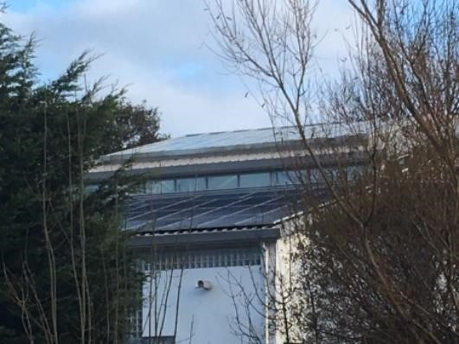
4.7.1 The generation of renewable energy on site is a direct way in which new development can support local and therefore global environmental sustainability. The effectiveness of renewable energy generation technologies has increased rapidly and this is likely to continue. Solar photovoltaics are likely to be the most common technology in use, but there may also be opportunities for micro wind and hydro generation.

4.7..2 In Totnes, we aim to be at the forefront of behavioural change and are willing to support the use of renewable energy, including roof solar, community scale solar and wind-turbines, battery store and hydro schemes, as a tangible means of reducing carbon footprint.

POLICY En7: RENEWABLE ENERGY GENERATION

New development should incorporate and maximize opportunities for on-site renewable energy generation and storage which will not negatively impact on local built character, landscape or amenity. Solar gain, through the orientation of new buildings and solar panels on south facing roofs will be supported.

4.8 Domestic and Small-Scale Waste Management

4.8.1 It is now common that new development should provide integrated facilities for the storage of recyclable and non-recyclable waste. New development can also reduce the amount of waste entering the waste stream by processing domestic waste on site wherever it is suitable to do so. The NP supports the expansion of community recycling activity and the creation of community composting facilities for domestic waste as the best way of composting waste locally on a small scale. It also supports on site composting of domestic putrescible waste where it can be undertaken without risk to residents or occupiers.

POLICY En8: DOMESTIC AND SMALL-SCALE WASTE MANAGEMENT

New development should make provision for waste to be processed on site wherever possible. Support will be given to:

a. on site processing of putrescible waste for small scale domestic, employment and community facilities;

b. the provision of community composting facilities; and

c. improvements to waste management and recycling, particularly in residential areas and the town centre.

4.9 Local Food Growing

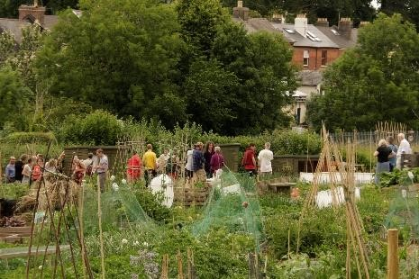
4.9.1 Buying food makes up around a quarter of the total ecological footprint of each person in the South West, primarily because of how food is packaged and transported to its end consumer. Food grown and consumed locally will directly benefit environmental sustainability. Growing food also better connects people to the natural environment and supports healthier lifestyles. New development therefore needs to maximise its contribution to space available to grow food locally.

POLICY En9: LOCAL FOOD GROWING

New development, where appropriate, is encouraged to take full advantage of and enable on-site potential to grow food for those living on or visiting the site, including on all land not built on, within and on the outside of buildings, and in public spaces.

4.10 Mitigation and Adaptation to Climate Change

4.10.1 Mitigation of climate change means tackling what is causing it, whereas adaptation means tackling the consequences of climate change. As the emerging Climate Emergency Plans being developed by Devon County Council and South Hams District Council come into use, this NP should draw on their content.

4.10.2 Climate change is a critical consideration for the NP. All new development will be required to minimise embodied energy and be carbon positive in use. Development should aim to be zero carbon in its construction and the embodied energy of construction materials should receive careful attention. Passive solar design and super-insulation are likely to be the most effective ways of achieving zero carbon development in its use. Off-site measures to achieve this will be acceptable only where they would provide greater all-round benefit than on-site measures.

4.10.3 The effects of climate change are likely to include rising and less stable temperatures, rising sea and tidal levels, and more extreme weather. New development is an opportunity to build in greater adaptation to such changes, both in the location and design of buildings and the space around them.

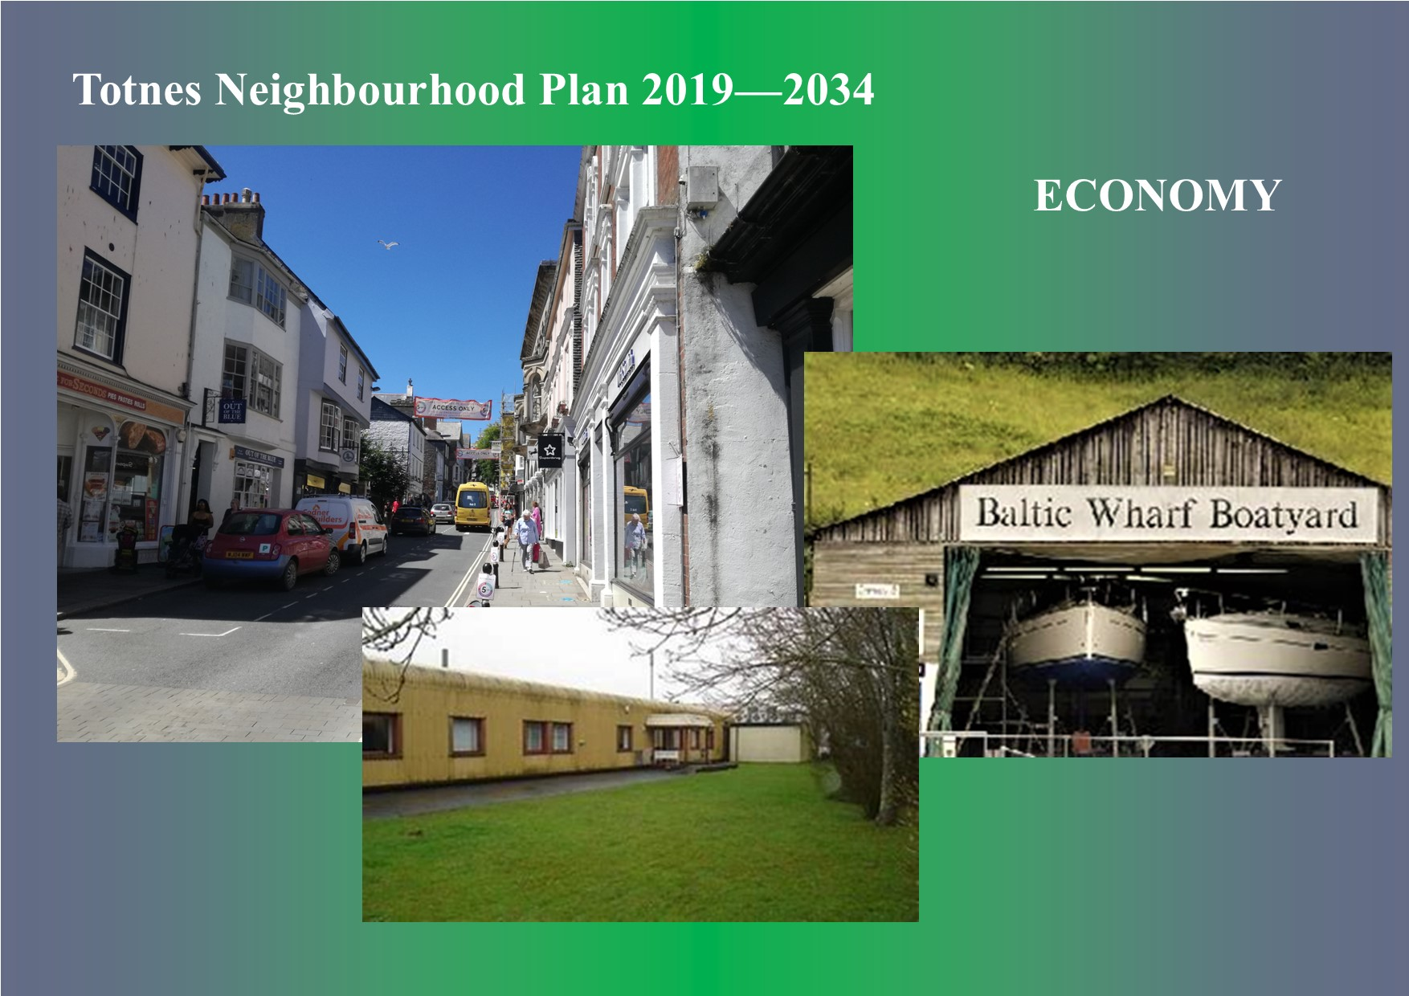

5. Economy

5.1 The Local Economy

5.1.1 Totnes is a thriving market town, drawing on a significant rural hinterland. It is economically much stronger than might be expected for a town of its size. It is a gateway for the surrounding area, particularly through its railway station, attracts many visitors and tourists, contains a wide range of businesses of all kinds and supports a strong service sector. The high-quality environment and strong community attract investors, businesses, the self-employed and home workers, supported by a wide variety of independent and shared working spaces and good rail links.

5.1.2 According to the 2011 Census 3,565 people living in Totnes were employed or self-employed, almost 50% of whom worked in Totnes (including working from home). Overall, 5,093 people were employed in Totnes, 1,528 more than the town's resident working population, giving a strong net employment balance of +43%. This is a powerful indicator of the town's economic health, showing a robust local economy, and the NP aims to maintain and develop that strength of character.

5.1.3 The Census also shows that over 60% of the town population are of working age (16-65) with 17% younger and 22% aged 65 and above. This is a healthy economic age structure and shows the potential for the community to make a strong contribution to the robustness of the local economy and community, including through volunteering.

5.1.4 Totnes still functions as a true employment centre, providing employment for people from a wide hinterland as well as a significant proportion of its own population. It is also highly attractive as a place to live for those working in larger centres such as Exeter, Plymouth and elsewhere. None of the other main towns in South Hams provide both of these things.

5.1.5 The good connections Totnes enjoys, by both road and rail, reinforce its economic strength. On the other hand, local prosperity is to some extent constrained by the congestion the town suffers, lying as it does at a nodal point for road and rail, with several key routes converging on the town at the lowest bridging point on the River Dart. Proposals for development which will create new employment likely to generate significant traffic movements must be supported by a travel plan and transport assessment to demonstrate how movements will be handled and why the development will be acceptable.

5.1.6 The availability of new office and employment space in Totnes is also somewhat constrained, with only 7,700 square metres of employment space allocated for the town in the JLP. This is a relatively small provision for a town with such economic strength and although not the smallest allocation to a main town in the JLP it is less than 10% of the largest such JLP allocation. New development which will strengthen the local economy without harming the town's social or environmental qualities will therefore be supported.

5.1.7 Existing employment space must also be safeguarded, and this is even more important in view of the difficulty in finding suitable sites for new employment development. The JLP protects existing employment land and premises, especially for sites which have potential to contribute towards the regeneration of the community, the expansion of existing businesses or with access to wharves or deep water. Each of these categories is relevant for Totnes, and this NP reinforces the JLP in requiring that existing employment land and premises be safeguarded.

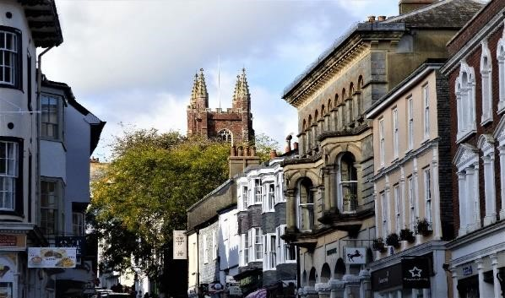
5.1.8 Retail, health and social care, education, and other public services make up some of the largest employment groups in Totnes. The importance of the public service sector is a common feature of many local economies.

5.1.9 Retail is the town's second largest employment sector, and the retail offer of the town, particularly its centre, is a vital component of its overall economic strength. The preponderance of independent shops, cafés and restaurants does much to give Totnes an edge over other centres, further enhanced by the tight knit historic core of the town. However, the rapidly changing face of high streets in the UK may have an impact on the types of retail and use of the properties over the coming years.

5.1.10 For a town of its size Totnes is also strong in manufacturing, science and technical activities, hospitality, the arts and entertainment. Such diversity and innovation are distinctive of the local economy, reflecting the cultural, environmental and alternative aspects of the town. New businesses which will reinforce the town's distinctive identity will be particularly welcomed.

5.1.11 The NP therefore gives specific support to economic innovation, company start-ups, fostering local economic clusters, and the infrastructure necessary to support healthy growth of the local economy such as superfast broadband and business meeting places.

POLICY E1: THE LOCAL ECONOMY

1. New employment and economic development should, without harming the town's social and environmental qualities:

a. reinforce the local economy and the function of Totnes as a market town;

b. enhance its reputation as a vibrant and distinctive place;

c. enable innovation and diversification in the local economy, including the formation of clusters and networks of local enterprises; and

d. enhance local employment opportunities and the trading experience of locals and visitors.

2. Businesses drawing on the town's distinctive character and identity will be particularly welcomed.

3. Development which will generate significant amounts of movement must be accompanied by a travel plan and transport assessment to demonstrate their acceptability.

5.1.12 It is considered that a minimum of two years of marketing empty premises needs to have taken place before a change of use is considered. Flexibility of approach, bearing in mind local requirements, when considering change of use needs to exist (for example retail to housing or leisure).

POLICY E2: EXISTING EMPLOYMENT LAND AND PREMISES

Existing employment land and premises will be safeguarded and kept available for such use unless it can be demonstrated that there is no reasonable prospect of their continued use for employment purposes.

5.2 The Town Centre
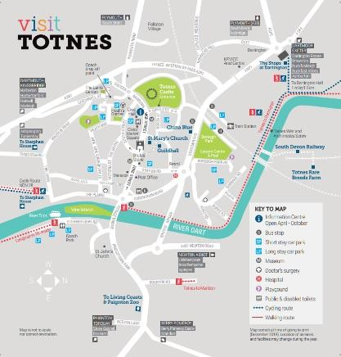
5.2.1 Retail offers in Totnes, particularly in its centre, are a vital component of its overall economic strength. The many independent shops, cafes and restaurants create a shopping experience refreshingly distinct and in marked contrast to typical town centres around the country today, most of which are dominated by a common pattern of mono-culture national chain outlets.

5.2.2 The NP seeks to ensure that the vitality and viability of the town centre is protected and enhanced, focussing new retail development and activity there and resisting it elsewhere. Town centre floorspace and shopping frontages ought also to remain predominantly in retail use.

5.2.3 The continuing demand for high street premises in Totnes and relatively low vacancy levels suggest that such an approach ought to succeed, despite the national trend for town centres to decline. It will also be important to
endeavour to maintain choice for convenience goods and everyday shopping alongside the growth of other independent businesses aligned to the town's thriving tourist and visitor role.

5.2.4 Markets and events contribute significantly to the town’s visitor economy, particularly the regular Friday and Saturday markets but also the summertime Elizabethan market, the monthly Sunday Good Food market and the Christmas late night shopping events. Protecting and enhancing such market activity and improving the operation and quality of outdoor trading spaces will be important and should be achieved through community consultation involving all key stakeholders.

5.2.5 The quality of the shopping experience, for residents and visitors alike, is key to Totnes' success. The NP aims to maintain that quality and to capture opportunities to enhance it still further. The steepness of town centre streets, narrowness of pavements, availability and cost of parking are issues for some. The number of visitors can mean congestion and inconvenience for locals. Improvements to streets, shops, signage, information and interpretation for visitors, car parking, open spaces, facilities and accommodation could help to make Totnes even more successful.

POLICY E3: THE TOWN CENTRE

1. Developments which promote the vitality, viability and retail health of the town centre area are encouraged and will be supported.

2. Proposals which reinforce the distinct character of Totnes as an independent market town focussed on its historic centre will be particularly welcomed.

3. Within the town centre’s primary shopping area, as defined in the JLP, ground floor space and shopping frontages should be retained predominantly in retail use.

4. Development which will maintain or enhance existing or new markets, community and arts events will be supported.

5. New development in the town centre will be required, where appropriate, to contribute, either through a Section 106 obligation or through CIL, towards the following priorities:

a. improved vehicle, bicycle and car parking provision;

b. enhancements to public squares and spaces and the public realm in general;

c. improvements to pedestrian safety and facilities;

d. improved signage, information and interpretation for visitors;

e. maintaining the offer for convenience and everyday goods;

f. support for local markets, community and arts events; and

g. monitoring and improving air quality.

6. Retail developments outside the town centre’s primary shopping area will be resisted unless:

a. they are minor and ancillary to an established business, or

b. it can be demonstrated that there is an operational need for them to be so located, there is no suitable central site available and they satisfy the requirements of the sequential test set out in the JLP.

5.3 Training and Education

5.3.1 Totnes has a broad range of educational and lifestyle offers, from language schools to courses and workshops about Health, Wellbeing, Transition Town, Arts and Culture. These provide employment and additional income streams for locals and have resulted in a wider range of accommodation.

5.3.2 The NP recognises the importance of the training and education sector and supports it as an integral part of the local economy.

5.3.3 The redevelopment of ‘brown field’ sites should be a priority over green field sites and enhancement of the Industrial estate and other such developments can all help to support this.

POLICY E4: TRAINING AND EDUCATION

1. New development which will support the provision of local training and education and, where possible, enhances the distinct cultural offer of Totnes will be supported.

2. New development which will support the provision of vocational training to meet the needs of local employees, young people and those seeking work will be supported.

5.4 Totnes Industrial Estate – Babbage Road

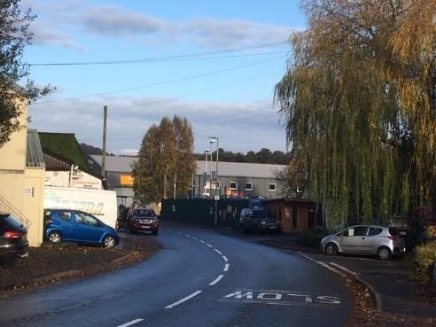
5.4.1 The industrial estate is an important element of the local economy and is estimated to provide between a quarter and a third of all the jobs in the town. Local and family businesses make up almost 70% of all businesses there and many are relatively long established. The estate is important for the employment of young people and for the provision of apprenticeships. It contains both traditional and high-tech enterprises, with the green economy making up 17% of 82 enterprises in 2017 and an expanding role in the local food economy.

5.4.2 It is important that the contributions the estate makes to the local economy are reinforced and the NP supports the provision of further floor space, improvement of existing premises and improvements to the overall quality of the estate, specifically its parking arrangements, riverside access and its accessibility for pedestrians and cyclists. The need for a retail element for some businesses on the estate is recognised but should remain ancillary and subsidiary to the business being carried out.

5.4.3 The diverse range of services include a growing Not for Profit sector including Refurnish, the Recycling centre, community groups, and new food enterprises. Such changes of use will be supported where impacts on the retail cohesion of the town and parking on the industrial estate can be demonstrated not to be detrimental.

POLICY E5: THE INDUSTRIAL ESTATE

1. New development increasing the amount and quality of industrial floor space on the industrial estate will be supported and must include adequate parking and servicing arrangements. Retail use will only be permitted where it is ancillary and subsidiary to the business.

2. Development should include improvements to the quality or function of the industrial estate wherever possible, including improved public transport, parking and pedestrian, cyclist and riverside access.

5.5 The Green Economy

5.5.1 The United Nations Environment Programme defines the green economy as follows:
“to be green, an economy must not only be efficient, but also fair. Fairness implies recognising global and country level equity dimensions, particularly in assuring a just transition to an economy that is low-carbon, resource efficient, and socially inclusive”. (UNEP 2011)

5.5.2 A green economy is one which therefore better serves the need of sustainable development, and specifically, environmental sustainability. The NP supports alternative economic models which are likely to produce more sustainable outcomes. These are the circular economy, re-localisation, the local food economy, and social and community-supported enterprise.

5.5.3 A circular economy aims to keep products, components and materials in circulation and always use at their highest value, so that the need for new products, components and materials is reduced. Reuse, repair and recycling are at its heart.

5.5.4 Re-localisation aims to ensure that a greater proportion of goods and services are sourced locally, benefiting local businesses, reducing environmental impacts and increasing the environmental benefits of local economic activity.

5.5.5 The local food economy encourages local production of food and local purchasing of that food. In addition to local economic and environmental benefits local health may also benefit from eating healthier food.

5.5.6 Social enterprises are businesses with primarily social objectives whose surpluses are principally reinvested for that purpose. A community supported enterprise is usually a specific type of social enterprise where members of the community invest in the enterprise and receive either a financial return or products and services in exchange. The most common type is community-supported agriculture where in exchange for a subscription to the business investors receive food from the farm.

5.5.7 Social and community-supported enterprises can offer goods and services at sub-market costs. Frequently this is achieved through not seeking a commercial return or using volunteer labour.

5.5.8 The NP supports the green economy, but it cannot create enterprises or the markets for them. Its role, therefore, is an enabling one. Development enabling the green economy may be acceptable in circumstances where other development would not be.

POLICY E6: THE GREEN ECONOMY

New development enabling the green economy in Totnes will be supported and encouraged. This includes development which enables circular economy, re-localisation, the local food economy, reducing waste, generating renewable energy, and social and community-supported enterprise.

5.6 Sustainable Transport

5.6.1 Several key routes converge on Totnes, which lies at the lowest bridging point of the River Dart. The town is a service centre for a large rural hinterland and hosts a mainline (London – Penzance, cross country routes direct to the Midlands and Scotland) railway station. Traffic congestion is common and has a significant adverse impact on the quality of life and environment in the town.

5.6.2 The Transition Town movement, which has a global reach, originated in Totnes and the town is committed to making the transition towards self-sufficiency and a stable local economy with reduced reliance on fossil fuels. Reducing travel and reducing the need to travel are a fundamental part of this impacting on all three dimensions of sustainable living – community, economy and environment.

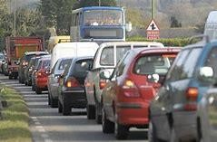
5.6.3 Around 70% of traffic on Station Road at peak periods is just passing through, and this proportion is likely to increase. Devon County Council recognise Totnes as the fourth most congested town in the administrative county, but physical, environmental and resource constraints limit the scope for large scale road building measures. While a northern by-pass was suggested in the 1970’s the prospects for any such scheme are now very remote, although public consultation has shown some support for the idea. The health and safety of pedestrians and road users in the town, and improving the air quality, are of paramount importance.

5.6.4 As a result the Devon and Torbay Local Transport Plan 3, 2011-2026 and the JLP focus on managing traffic flows in and around the town and promoting behavioural change to reduce the adverse impact of traffic on the environment. Elevated levels of air pollution have resulted in the designation of part of the A385 corridor as an Air Quality Management Area (AQMA). Despite these poor conditions a significant proportion of journeys to work in Totnes take place on foot or by cycle. The A381 also suffers from congestion and air pollution.

5.6.5 The railway station is immensely important for Totnes and its surrounding area. It is a gateway to the town, a transport hub and the railhead for the South Hams. Rail travel and passenger use of Totnes station is growing year on year for commuters, residents and visitors to the area. Passenger numbers were estimated at 0.628M in 2013/14 and had increased to 0.700M in 2018/19 (up by 11.5%).

5.6.6 Where new development has taken place, such as at Camomile Lawn, Baltic Wharf and Follaton Oak, developers have been required to contribute towards the cost of implementing traffic and transport improvements in the vicinity. Such new developments add to the levels of congestion, with the residents commuting to jobs outside of Totnes. Funding has also been provided for green travel advice and support. However public consultation for the plan has confirmed that for many the wider impact of traffic congestion across the town is their main concern.

5.6.7 Traffic management in the town centre has long been the subject of debate. Totnes and District Traffic & Transport Forum (an advisory body to the Town Council), has developed a Totnes Transport Strategy and policies with schemes for projects that has been adopted by the Town Council. This includes actions proposed by SHDC in the Air Quality Management Action Plan for Totnes. A ‘Shared Space’ programme of street based improvements that could provide an agreeable shopping and leisure environment and improved public safety whist supporting commercial activity and providing access for all is long overdue.

5.6.8 Elsewhere in the town, such as at Plymouth Road and old Bridgetown, there is scope to reduce the conflicts between traffic, pedestrians and cyclists, and opportunities exist to extend sustainable transport routes serving the town. Some such routes already exist, for example the National Cycle Route which links Totnes to Ashprington and Dartington. Work is also under way to promote new links to surrounding parishes such as Littlehempston and between the various parts of the town, including the development of a full riverside route. Where possible such opportunities should be enabled when relevant development proposals come forward.

5.6.9 There are concerns about the increasing development in surrounding towns and villages and the increase in traffic this generates, which in turn is showing a growing interest in exploring alternative approaches to managing the flow of traffic through Totnes. Measures might include the replacement of traffic signals controlling junctions with a more, free flowing approach operating at lower speeds (20mph). Experience from elsewhere suggest that this could help resolve some of the negative impacts which traffic has on the life of the town. While traffic management lies outside the scope of the NP there is scope for development to contribute towards the delivery of such measures.

5.6.10 Planning can help to reduce the environmental impacts of transport usage and it has long been a planning objective to reduce the need to travel. The NP seeks to reduce the likelihood of travel to and from new development by car and promotes the use of more sustainable modes of transport.

5.6.11 There are three main sustainability impacts of transport in Totnes:

- Motorised transport powered by fossil fuels contributes to carbon and particulate emissions;
- It also directly contributes to poor local air quality and congestion; and
- High levels of mobility can erode community cohesion and identity, as people’s lives are spread out rather than localised.
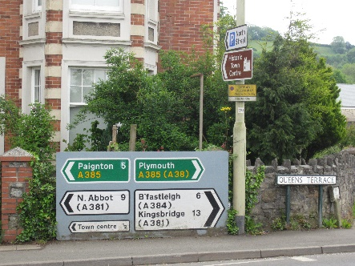
5.6.12 70% of peak hour traffic on Station Road is through traffic, giving rise to significant problems such as reducing local environmental quality, dividing neighbourhoods, ‘rat running’ through the town centre and deterring some from visiting the town thus undermining its retail and service roles.

5.6.13 New development in Totnes should therefore be located and designed to reduce the likelihood of motorised travel, make best use of more sustainable modes, and contribute to a more sustainable and effective local transport network for the town as a whole.

5.6.14 Rail is a growing and relatively sustainable form of transport, benefitting the local economy and reducing road journeys. Planning decisions need to prioritise the role of the railway station and the potential for its development as a transport hub with improved provision for bus links on both sides of the station, taxis and car parking.

5.6.15 Proposals for new development should be accompanied by whatever measures are necessary to ensure that it can be delivered and used sustainably and a statement explaining how it will seek to improve the local transport network by measures such as:

a. Reducing the likelihood of car travel through both the mix of the development itself and its relationship to surrounding development;
b. Facilitating and promoting the use of more sustainable transport modes; and
c. Ensuring that new development does not make congestion and air quality in the town worse.

POLICY E7: SUSTAINABLE TRANSPORT

1. New development should be designed to reduce the likelihood of travel by car and support a more sustainable local transport network. This means that it should:

a. prioritise walking and cycling as the most favoured modes of transport;

b. prioritise public and community transport as the next most favoured modes of transport; and

c. take all available and reasonable steps to reduce use of cars, local road congestion and air pollution.

2. Development which would prioritise travel by car will not be supported.

3. Development will be expected to contribute, either through on-site works or by way of a S106 agreement, towards whatever traffic and transport measures may be required to enable that development to be delivered and used sustainably. Such measures may include:

a. green travel plans, information points and signposting;

b. provision of safe and convenient footpaths, cycle lanes, cycle racks and storage;

c. subsidising public and community transport;

d. local collection points to support green deliveries; and

e. provision of charging points for electric vehicles.

5.7 Walking and Cycling

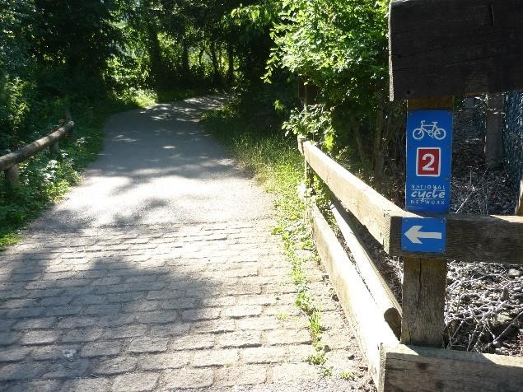
5.7.1 Walking and cycling are the most sustainable forms of transport, being zero carbon, and are ideally suited to a town as small as Totnes though difficult on hilly outskirts. To maximise use there needs to be a good walking and cycling network which is also safe and pleasant to use. In the past patterns of development in the town have sometimes not allowed selective permeability for pedestrians and cyclists – new development should enhance this permeability.
Totnes Town Council’s adoption of the Ramblers ‘Charter for Walking Neighbourhoods‘ reinforces the importance of walking within the Town for health and as a mode of transport.

5.7.2 Opportunities exist for new and improved connections and facilities for walkers and cyclists, both for recreational use and work, within the town and adjoining parishes (such as Littlehempston) and also over longer distances including as part of the national cycle network. New development should take up these opportunities and seek to enhance them.

POLICY E8: WALKING AND CYCLING

1. New development must be well connected to, maintain and seek to improve the functionality and quality of the walking and cycling network in and beyond the town.

2. Good connections to the walking and cycling network must be a design priority, taking up opportunities to improve freedom of use and road safety for pedestrians and cyclists.

3. Good provision for safe cycle storage, parking, charging and changing facilities for cyclists and motorcyclists should be designed into development proposals.

5.8 Public and Community Transport

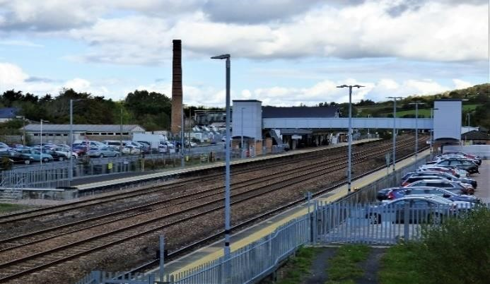
5.8.1 Most forms of public and community transport have a much-reduced carbon impact in comparison with the use of private vehicles, and their impact on congestion and local air quality is similarly reduced. Community transport is particularly important in Totnes, connecting outlying parts of the town and surrounding communities, especially for those who would otherwise find it difficult to access vital services. Public and community transport is therefore supported alongside walking and cycling as part of a more sustainable transport mix for Totnes.

5.8.2 Increased car sharing will complement public and community transport and is encouraged alongside them.

5.8.3 The railway station is fundamentally important in enabling more sustainable travel, for Totnes and its wider hinterland, and the NP supports measures to enhance its effectiveness as a transport hub.

POLICY E9: PUBLIC AND COMMUNITY TRANSPORT

New development should:

a. maintain and improve the functionality and quality of the public and community transport network in the town;

b. incorporate good, safe connections to the public and community transport network as a design priority;

c. support the development of the railway station as a transport hub for train, bus and coach connections, with good, safe cycle and pedestrian routes and taxi facilities; and

d. promote car sharing.

5.9 Car Parking Opportunities

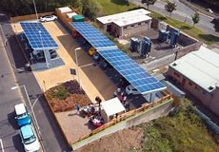
5.9.1 Car parking is currently important to the overall functional sustainability of Totnes, despite the inherently less sustainable nature of travel by private car. The NP therefore supports the provision of car parking sufficient to support the overall functional sustainability of the town.

5.9.2 The use of existing and provision of new car parking should not only support the local economy and the needs of the local community, but also promote the use of more sustainable modes of transport in terms of its pricing, use and location.

5.9.3 Over the NP period, however, the use of electric and driverless vehicles may change the way we chose to travel and the need for parking in the town. The NP sets policies in place to support and enable such change.

5.9.4 New development should meet the need for parking it generates on site. However, the NP supports forms of development which will give rise to reduced need for parking, either through the form and use of the development itself or specific measures to restrict vehicle use and numbers.

5.9.5 Exceptionally it may be acceptable to provide necessary parking off site where this can be shown to provide greater overall functional sustainability for the town and the development in question, and the off-site provision can be guaranteed as permanently available to the development.

5.9.6 When new parking is provided preference will be given to parking for electric vehicles with charging points and car club/pool and autonomous vehicles.

POLICY E10: CAR PARKING

1. Existing public car parking should be used and managed to best support the overall functional sustainability of the town. Where new development has impacts on public car parking these should be neutral or positive in terms of the overall functional sustainability of the town.

2. Development that would involve the loss of public car parking will not be permitted unless that loss is made up for elsewhere which will be of equal benefit to the overall functional sustainability of the town or it can be demonstrated that the parking is no longer needed due to changes in vehicle use.

3. New development should meet its assessed needs for parking on site unless off site provision would be of greater overall benefit to the functional sustainability of the town and the development in question, and that off-site provision can be guaranteed as permanently available to the development.

4. Parking and charging facilities for electric vehicles, car club/pool vehicles and autonomous vehicles will be preferred to parking for normal private cars. Where new housing development can demonstrate a reduced need for parking due to the utilisation of car club/pool vehicles and autonomous vehicles this will be supported, provided that there are measures in place to support their use.

5. Provision for cycle and motorcycle storage, parking and EV charging should be provided wherever appropriate.

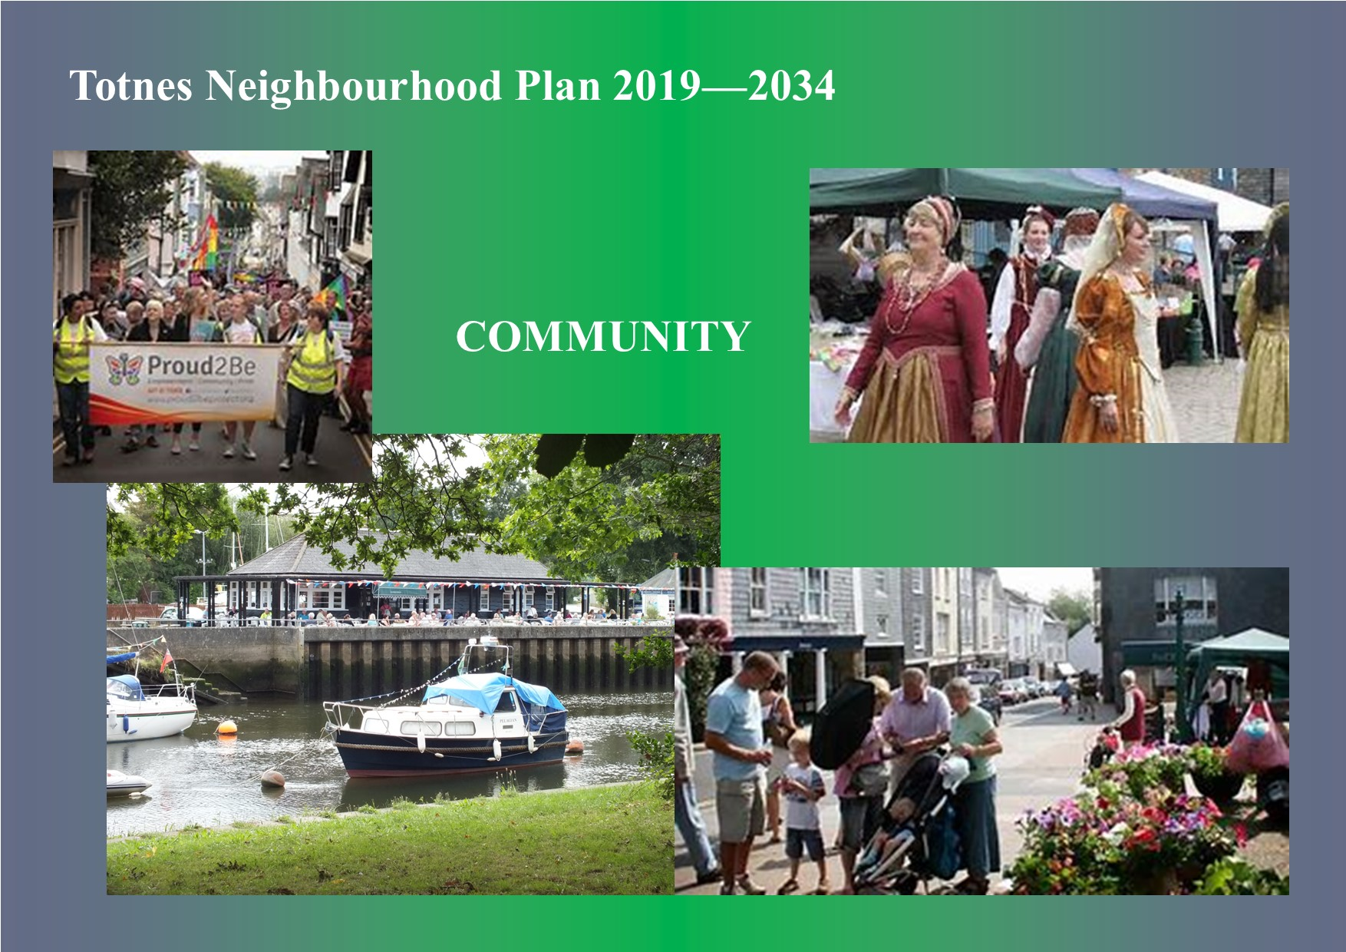 6. Community

6.1 The Public Realm

6.1.1 The quality of Totnes' historic environment deserves a similar quality of public realm to match. Enhancements include the creation of new spaces at Leechwell and Heath’s Gardens and improvements to the Rotherfold and Shady Garden, but much more needs to be done to reflect the quality of the town’s heritage. Within the historic core motor vehicles continue to have a dominating influence both in the narrow streets and in the car parks where there is limited landscaping. The wide range of street furniture and signs, coupled with poor maintenance, further detract from the town's appearance.

6.1.2 The opportunity exists to create a series of linked public spaces along the historic spine of the town running from the Town Bridge to Cistern Street including The Plains, the Mansion and Library, the Shady Garden, St Mary’s Churchyard, the Market Square including Butterwalk and the Rotherfold. Progress has already been made in enhancing some of these spaces through hard and soft landscaping, and the provision of bespoke street furniture to create spaces where people can meet, linger and perform, creating social and cultural activity and making a more attractive town centre.

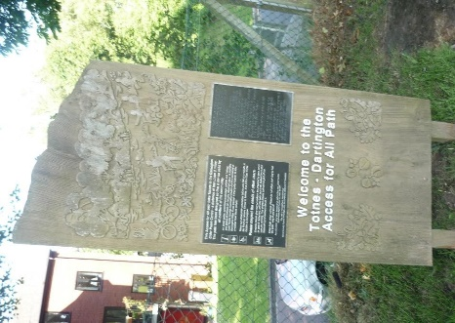
6.1.3 Beyond the Town’s core, the public realm includes major roads, such as the A385 corridor and the Western Bypass for through traffic, and access roads to residential and industrial areas. The major roads have been designed to meet the standards required by the highways authority resulting in places which prioritise car use over people. This is reflected in the use of signalised rather than pedestrian crossings along Station Road and Coronation Road which tend to be positioned to accommodate car users rather than walkers. While these roads act as barriers to movement between the parts of the town, they generally have good pavements although the quality of the pedestrian experience is reduced by exposure to traffic.

6.1.4 Within the residential and industrial areas of the town the quality of the public realm is significantly impacted by street layout, density of development and car parking, with many parts of the town dominated by the car. This need not be the case, and the new Baltic Wharf development demonstrates the sort of standard for public realm in new residential developments to which the town should aspire, requiring careful consideration of parking arrangements.

6.1.5 Public parks and gardens are an important element of the public realm and the NP protects and provides for the improvement of all of these. Outside spaces in residential areas also function as potential social spaces and should be attractive, safe and offer amenity green and play space. The concept of shared space to improve the pedestrian environment is also supported.

POLICY C1: THE PUBLIC REALM

1. New development should, wherever possible, make a positive contribution to the public realm, particularly within the historic core of the town, supporting Totnes’ reputation as a cultural and tourist destination.

2. Design and layout should create public spaces and streets and spaces which are:

a. in character with the town;

b. safe and well connected;

c. accessible and inclusive;

d. uncluttered and easy to maintain; and

e. incorporate suitable materials, landscaping, planting, street furniture and surfaces.

6.2 Open Spaces

6.2.1 Open spaces make important contributions to local character and environmental quality. In Totnes these include:

a. Formal and informal spaces for sport, recreation and play;
b. Amenity green spaces, spaces for nature conservation and green ways;
c. Growing spaces; and
d. Civic spaces (including town squares), cemeteries and graveyards.

6.2.2 The NP will maintain and enhance the provision, quality and diversity of public open spaces and recreational provision in and around the town.

Note: A full inventory of all current open spaces can be found in Appendix B and they are also shown on the Proposals Map and the map at Figure 2 (page 56).

POLICY C2: PUBLIC OPEN SPACES

1. The open spaces, amenity spaces, growing spaces and civic spaces shown on the Proposals Map are protected and should be retained in their current use and enhanced to raise their usefulness as such. Only development associated with and which will enhance the value of their current use will be permitted.

2. Any loss of open space should be replaced by alternative provision which is of equal or greater value to the community and local environment.

3. New developments should include open space at least in accordance with adopted standards and provide for its long-term management and maintenance.

4. Where the need for open space cannot be met on site a commensurate contribution towards provision of such open space elsewhere in the town should be made.

5. Open space provision should include:

a. formal and informal spaces for leisure, sport, recreation and play;

b. amenity green spaces, spaces for nature conservation and greenways; and

c. growing spaces.

6.3 Local Green Spaces

6.3.1 The medieval form of historic Totnes and its evolution to accommodate 21st century living, in particular the use of the car, have resulted in there being limited green space for residents, workers and visitors to the town centre. Leechwell, Heath and the Lamb Gardens, which have been established through community initiative, and Vire Island offer important green oases. Other important open spaces in the town include the Totnes Castle grounds, Borough Park, the ‘Chicken Run’ in Bridgetown, Follaton House grounds and arboretum, the allotments, various play area, and the wetlands adjacent to Brutus Bridge (see Appendix B and figure 2 below). The NP therefore designates them as areas of Local Green Space to protect them from inappropriate change.

POLICY C3: LOCAL GREEN SPACES

The following are designated as local green spaces:

1a-c. Totnes Cemetery, St Mary’s and St John’s Churchyards;

2a-d. Allotments at Kingsbridge Hill, Castle Meadow, Camomile Lawn, and Smithfields,

3. Borough Park;

4a-c. Leechwell, Heath and Lamb Gardens;

5a. Vire Island;

5b. The Chicken Run in Bridgetown;

5c. Follaton House Arboretum;

5d-e. Totnes Castle Grounds and meadow;

5f. Dedicated green spaces in new developments at Follaton Oak, Baltic Wharf and Camomile Lawn;

5g. Wetland adjacent to Brutus Bridge; and

6a-f. Play areas at Smithfields, Meadow Park, Westonfields Park, Higher Westonfields Loop, rear Follaton Community Hall and Collapark.

Figure 2 – C2 Public Open Spaces and C3 Totnes Local Green Spaces

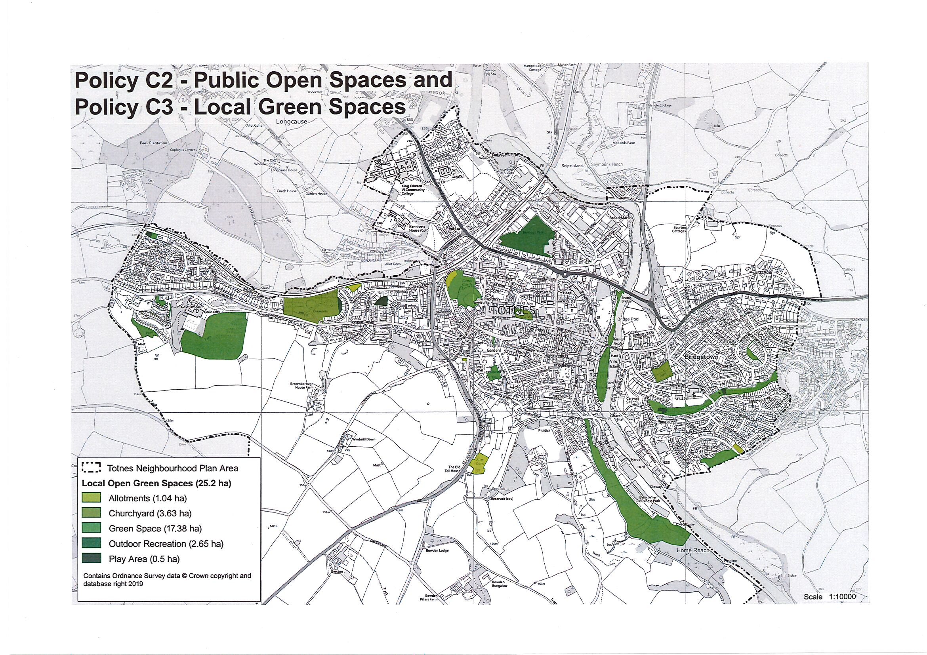

6.4 Housing

6.4.1 The JLP proposes a total of 528 new homes for Totnes over the plan period 2014-2034. Some of the sites allocated lie wholly or partly outside the administrative boundary of the town (and outside the area covered by this plan). The JLP aims to help meet local housing need through mixed use developments which protect the town's integrity, character and environment and provide appropriate infrastructure. It also includes a target that 30% on-site affordable housing will be sought for all schemes of 11 or more dwellings. The South Hams Strategic Housing Market Assessment 2017 determines an affordability test where the cost of the house can constitute up to 35% of gross income and still be affordable.

6.4.2 Much of the housing proposed in the JLP has already been built, is under construction or has planning consent. During the life of this NP other housing sites may come forward and the plan's policies aim to guide such developments and any changes to existing ones.

6.4.3 A central concern of this NP is meeting local housing need rather than satisfying demand for housing. This includes meeting known needs for housing in terms of size, tenure and affordability, and specifically increasing the number of smaller homes to meet the needs of local young and older people.

6.4.4 The South Hams Strategic Housing Market Assessment 2017 suggest that the mix of affordable dwelling sizes required is as follows:

1 Bed | 2 Bed | 3 Bed | 4+ Bed
38% | 30% | 20% | 12%
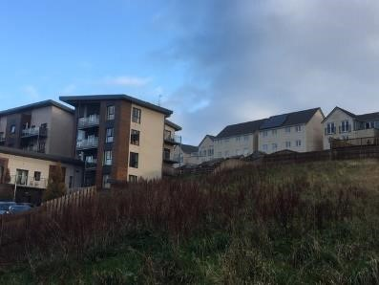
6.4.5 A target of 75% smaller homes is therefore included in the NP for sites of 11 dwellings or more. It is recognised, however, that in Totnes most unallocated development sites will be small. For development sites of fewer than 11 dwellings the NP seeks a target of at least 50%, which is considered to be reasonable. The target cannot, of course, apply to single dwelling developments.

6.4.6 The design of new homes should promote and enable sustainable lifestyles, incorporate the latest energy efficiency and carbon reduction measures, reduce waste, and be in keeping with and enhance their immediate surroundings.

6.4.7 The NP promotes community led and owned approaches to housing, which can bring strong advantages and innovative solutions:

- They can allow, over time, the returns from the housing development and provision of rented or shared ownership housing to be reinvested in the community.
- They do not require a profit element and therefore can provide greater benefits.
- As they are not registered providers of affordable housing, the affordable housing that they provide is not subject to the Right to Buy scheme and so can remain affordable in perpetuity.

6.4.8 As an exception to regular policies for housing provision, innovative, smaller and individual alternative housing may be considered for sites within the settlement boundary that would not otherwise be permitted. This might include container homes, Tiny Homes and houseboats.

POLICY C4: HOUSING

1. New housing development should address housing needs, particularly in terms of tenure and size, with priority given to meeting local housing needs.

2. Affordable homes should be included at least in line with adopted targets and arrangements should be made to ensure that they remain affordable in perpetuity.

3. Developments of 11 dwellings or more should include 75% one and two bedroom homes, for smaller developments (apart from single dwellings) the target is at least 50%.

4. New homes should be designed for sustainable living, incorporate carbon reduction and energy efficiency measures, minimise waste, complement their setting and enhance the locality. Incorporation of the latest energy efficiency measures and sustainable construction methods will be supported.

6.4.9 Totnes has achieved some successes in community led and owned projects, such as the Leechwell Gardens and the Lamb projects. These schemes bring greater benefits for the community as alternatives to developer led projects. The NP aims to build on and spread this success by giving specific support to community led and owned projects.

6.4.10 If proposals can be shown to be community led and that they will be community owned in perpetuity it is regarded by this NP as a strong material consideration in their favour, and such proposals may be supported in circumstances where proposals which were not community led and owned would not be, however there is still a requirement for such projects to accord with planning policies and the JLP.

6.5 Services and Facilities
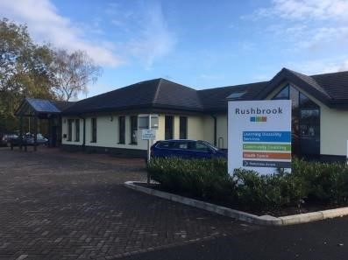
6.5.1 Totnes is generally well provided with services and facilities and this is a clear ingredient of its strong community. They are important for residents, businesses and visitors alike, and are key to the town's distinctive cultural and service roles. They combine with retail premises to create a place which is much more than just the sum of its physical attributes.

6.5.2 Educational facilities in Totnes are mixed in quality. The secondary education facilities, in particular, are currently in need of improvement having had little investment for over 50 years. Some buildings are in a critical state of repair. The NP supports the provision of high-quality education facilities fit for the purposes of 21st century learning and teaching.

6.5.3 Totnes has two general practices and a minor injuries unit and hospital which serves not just the town but the wider hinterland. The additional strain the new developments will place on the existing medical facilities need to be considered. The NP will ensure that new development does not diminish the services and facilities of the town and will encourage their enhancement and the provision of new services and facilities.

POLICY C5: SERVICES AND FACILITIES

New development is expected to maintain or enhance community services and facilities as a whole within the town. Proposals involving the loss of community services or facilities will not be permitted unless:

a. they are to be replaced with services or facilities of an equal or higher quality and value to the community on the same site, or another equally or better suited site within the town; or

b. the services or facilities can be demonstrated to be no longer needed or viable, and the proposed alternative use would provide equal or greater benefits to the local economy and community, including through contributions to development on other sites.

POLICY C6: NEW SERVICES AND FACILITIES

1. The provision of new services and facilities which will improve the breadth, depth and distinctiveness of the overall provision of services and facilities in the town will be welcomed.

2. Provision of new ‘everyday’ services and facilities in areas of the town where these are lacking will be particularly welcomed.

6.6 King Edward VI Community College

6.6.1 King Edward VI Community College (KEVICC) has a vital role to play not only as the prime source of secondary education for young people in the town and surrounding villages but also as a focus for community uses, particularly linked to sports, arts and cultural activities. The school occupies a range of facilities on a site bisected by the A385 with the two parts linked by a pedestrian overbridge. This creates operational challenges for the school which would undoubtedly benefit from significant investment in its physical estate. By comparison with many secondary schools in the South Hams, KEVICC has relatively dated and poorly configured buildings, although it occupies attractive grounds, which enables students to enjoy extensive open space.

6.6.2 At the school's request, KEVICC’s Lower Field was allocated as a site for residential development in the Totnes Site Allocations Development Plan Document in 2011. The site currently includes unoccupied school buildings, a new all-weather playing pitch and a large playing field. Lower Field is bordered on two sides by the residential areas of Swallowfields and Weirfields. Vehicle access is available from the A385 Ashburton Road which runs along the western boundary of this part of the school.
6.6.3 On the opposite side of Ashburton Road lies the main part of the school campus. This includes an extensive area of parking and a range of school buildings including reception, administrative offices, classrooms, School Hall and refectory. The Ariel Centre provides an arts and performance space for both school and community use. Somewhat removed from the main cluster of buildings and occupying the higher part of the site in a wooded setting, lies Kennicott House which is the Sixth Form centre. This historic property, to which additional structures have been added, has pedestrian access from Barracks Hill although the main entrance to the site is from the A385.

6.6.4 To the south of the main KEVICC site, but in the ownership of the school lies the Sheepfield which was allocated for housing in 2011. Adjoining this site (but separately owned) is the former Magistrates Court building which has recently been sold and planning consent has been granted for a small-scale residential development on the site of the former private nursery. The Police Hub and former police houses occupy the remainder of the land at the junction of the A385 and Western by-pass.

6.6.5 The Joint Local Plan (JLP policy TTV20) carries forward the allocation of parts of the KEVICC site, including the Sheepfield, for residential development with an indicative number of 130 homes. This includes a requirement for the provision of a replacement of the all-weather sports pitch, community facilities including public space alongside the River Dart with continuous river access, mitigation to deal with the potential for negative impact on greater horseshoe bats and their flyways, a high quality form of development which integrates with existing housing, safe and attractive pedestrian and cycle connections for residents to access local facilities and services and an appropriate strategy to mitigate for any impact on the A385 AQMA.

6.6.6 This NP affirms the JLP’s approach to the site, adding that a comprehensive master planning approach should be taken.

POLICY C7: EDUCATIONAL IMPROVEMENT AT KEVICC

Proposals for the rationalisation and upgrading of secondary educational facilities on land currently occupied by KEVICC will be supported providing they:

a. make appropriate provision to at least maintain and where possible or enhance community use of sports, leisure and arts/cultural facilities;

b. adopt appropriate measures to minimise the impact of traffic through provision for sustainable travel by staff, pupils and visitors; and

c. are part of a holistic approach to the whole site.

POLICY C8: DEVELOPMENT OF LAND AT KEVICC AS IDENTIFIED IN THE JLP

Residential development will be supported on land no longer required for educational or recreational purposes at KEVICC providing it:

a. is pursued through widespread inclusive community consultation which encompasses all of the KEVICC site and the Sheepfield;

b. is demonstrated how the proposals will facilitate the upgrading of the school facilities and can be integrated satisfactorily with the school; and

c. will contribute to the broader objectives of the NP, particularly for continuous riverside access and associated community facilities.

6.7 Steamer Quay
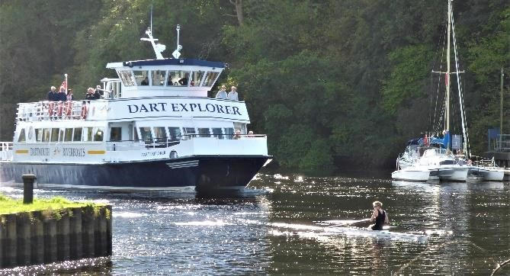
6.7.1 Steamer Quay lies on the east bank of the River Dart. It occupies a strategic riverside location, providing a gateway to the town for river boat users and is an important focus for water-based recreation and tourism, particularly given the access it provides to Longmarsh. This role could be enhanced through sensitive development directly related to the river and leisure uses. Public consultation has highlighted the importance of the Steamer Quay area to the community who place its recreation and leisure roles as being of importance.

6.7.2 The site is owned by South Hams District Council and is occupied by a variety of users including the seasonal caravan site, club facilities and storage associated with the Totnes Boating Association, the scout hut, the Rowing Club, a long stay car park, a coach park, a café, public toilets, a vet, the river boat business and a number of industrial units. A new riverside development of 60 flats for older people has been completed adjacent to the site and planning consent has been granted for a 68-bed care home on a neighbouring site.

6.7.3 A number of constraints need to be addressed to enable improvements to be carried out, including possible relocation of any existing users affected and protecting direct access to the river for those requiring it. The low-lying nature of the site means that it is at risk of flooding. The site lies outside the Totnes Conservation Area but within its visual sphere of influence. Any proposals should pay careful regard to that sensitive context and to views of the site from across the river. It will also be essential to maintain and wherever possible improve cycle and pedestrian routes alongside the river and connecting the residential areas of Bridgetown, the wider town and neighbouring parishes.

POLICY C9: STEAMER QUAY

At Steamer Quay only leisure or river related development will be supported, providing it has no adverse impact on the South Hams Special Area of Conservation’s population of greater horseshoe bats. Any such development must:

a. maintain or enhance leisure and river related facilities and activities on the site;

b. maintain or enhance existing services, uses, facilities, public areas and rights of way;

c. is pursued through widespread inclusive community consultation;

d. not harm the character, amenity, wellbeing, historic, environmental, nature conversation or archaeological values of the area and its surroundings;

e. respect the site's scenic quality and distinctive sense of place and the setting of the adjacent Conservation Area; and

f. adopt a high standard of design reflecting the prominence of the location and enhancing the riverside scene.

6.8 Market Square and Civic Hall
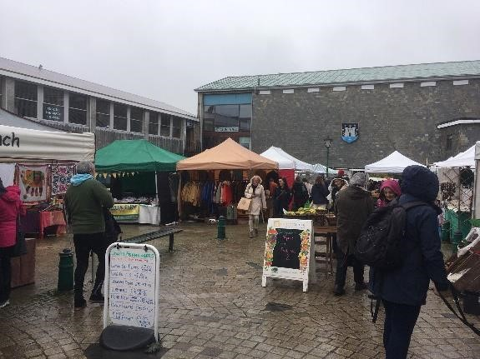
6.8.1 The Market Square including the Civic Hall and Civic Hall car park is a key element in the functioning of Totnes as a historic market town. The use of this area for regular markets and events contributes significantly to the vitality and viability of the town centre, drawing in residents and visitors alike. Evidence points to the market being a seedbed for the independent traders who give Totnes such a distinctive character. The Market Square and Civic Hall also fulfil an important social function as a meeting place, contributing significantly to the town’s strong sense of place and community.

6.8.2 The functioning of Totnes is also critically dependent upon the availability of adequate car parking. With some two thirds of Totnes’ catchment lying outside the town in surrounding villages and rural areas where public transport provision is limited, the car provides the principal means of accessing the shops and services offered. On market days, the monthly Good Food Market, other occasions such as the Christmas Markets and during the main holiday season, the demand for parking is high. There is also demand from employees and town centre residents. Protecting the supply of town centre parking is therefore an essential priority for Totnes.

6.8.3 Research shows that there is scope to improve the operation and appearance of the Market Square and Civic Hall, which has been the subject of investment by the Town Council in recent years. A recent public consultation has seen plans drawn up to redesign the Market Square which will include:

a. Improvements to the layout and circulation of the market
b. Repositioning planters and seating
c. Improvements to the hard surfaces to aid accessibility and
d. Upgrading street furniture (including the installation of a water fountain) and visual decluttering.

6.8.4 It is clear from consultation that the community recognises the vital role which the Market Square and associated town centre car parks play in the life of the town, acting as points of arrival and enabling Totnes to thrive and prosper. They are well established assets of genuine community value which need to be nurtured. Any change is likely to be difficult and complex to achieve given the wide range of stakeholders involved, the need to ensure continuity of operation and the likely costs involved. Improvements to the town’s car parks would be welcome in the form of roofs covered in photovoltaic panels with associated energy stores so that electric vehicles can recharge, or with grassed areas for amenity use and replanting at the edges of car parks and roofs. However, the NP aims to provide for positive change to occur and the policy approach being taken should be regularly reviewed (at least every 5 years) in light of changes in travel and transport.

POLICY C10: MARKET SQUARE AND CIVIC HALL

Proposals for positive change to the Market Square and Civic Hall will be supported providing they will:

a. be pursued through widespread inclusive community consultation;

b. support and complement the economic and social functioning of Totnes town centre;

c. ensure continuity of market operations;

d. at least maintain the number of trading pitches available;

e. at least maintain current levels of town centre parking; and

f. reflect the sensitive historic nature of the location.

POLICY C11: TOWN CENTRE CAR PARKS

Proposals for redevelopment of any land currently used for town centre car parking (Victoria Street, Heath’s Nursery, North Street, the Lamb, Heath Way and the Nursery) will only be supported providing it:

a. is pursued through widespread inclusive community consultation;

b. at least maintains the current levels of parking with sufficient resident and visitor car parking within easy walking distance of the town centre;

c. makes provision for the introduction of electric cars and car sharing technologies;

d. enhances the visual appearance of town centre parking through the introduction of hard and soft landscaping; such as permeable surfaces, tree planting and flower beds;

e. respects local amenity, especially for neighbours; and

f. contributes to the vitality, viability and functioning of the town centre.

6.9 Former Dairy Crest Site

6.9.1 The proposal for development of the former Dairy Crest site is included in the Joint Local Plan policy TTV22 site 5. The site is located on the northwest edge of Totnes adjacent to the river Dart, existing woodland, the Dart weir, the main railway station and existing housing, and at the head of the navigable part of the River. It is a historic feature of the town, with the Grade II listed Brunel Pumping Station building as part of the Brunel’s Atmospheric Railway. It provided substantial employment in the town for the 100 years until its closure in 2007.
6.9.2 The local community has long held aspirations to develop the site, recognising that there are opportunities to regenerate and develop the site, replacing the lost employment whilst enhancing the public access to the site and riverside and completing the flood prevention scheme for the whole town. The Neighbourhood Plan recognises that any developments at the site must balance activities that support the community and economically generating uses for it-development of the former Dairy Crest site should be subject to a comprehensive survey of the existing heritage assets and associated natural habitat assets and must avoid harm to these assets and protect and enhance the natural and built historic environment as set out in national and local policy.

Figure 3 – Former Dairy Crest Site

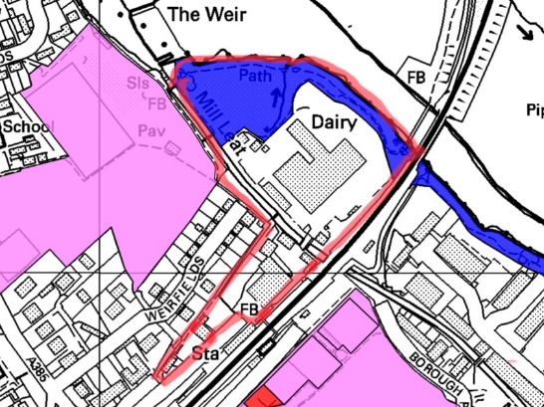

Policy area edged in red together with public space (blue) and sports grounds of Borough Park and KEVICC lower field (pink)

POLICY C12: FORMER DAIRY CREST SITE

The Plan supports improvements to the former Dairy Crest site which develop further the aims of JLP Spatial Policy SP6 and Policy TTV 22.

The improvements and qualities include:

restoration and reuse of the listed Brunel Building for community and public use;

mixed use development to meet local housing need, sustainable businesses and increase employment opportunities;

live/work and other employment units with a development threshold of no more than 6500m2;

a sustainable transport hub for non-fossil fuel modes of transport;

on site low carbon energy centre with the most appropriate technologies;

low cost, low energy hotel development with approximately 60 beds;

homes in the order of 60 plus units addressing local needs;

appropriate flood risk mitigation and management measures (including improvements to the leat to protect existing development downstream);

the wildlife corridor that follows the River Dart and associated natural habitat heritage assets are fully respected, protected and enhanced;

overall enhancement of the public realm while retaining the existing links.

A development brief expanding on the above qualities is included in Appendix E. All redevelopment of the former Dairy Crest site should respect this brief. The area covered by this policy is illustrated in Figure 3.

Re-development of the former Dairy Crest site should be subject to a comprehensive survey of the existing heritage assets and associated natural habitat assets and must avoid harm to these assets and protect and enhance the natural and built historic environment as set out in national and local policy. All proposals must also address the level 3 flood risks, the Sequential Test must first be successfully applied. The Exception Test may also need to be applied for certain components of the proposed redevelopment.

7. Delivery and Monitoring

7.1.1 Many of the NP's proposals will only happen with private sector investment, but this does not remove Devon County, South Hams District and Totnes Town Councils or other public bodies from their responsibilities for infrastructure and services. The NP’s policies aim to steer and shape development, but it is expected that developer contributions will be gathered through S106 agreements, Community Infrastructure Levy or similar in order to address any specific mitigation required and to offset the broader impacts of any new development.

7.1.2 The policies of the NP and the JLP will be complementary, together providing a firm platform for all parties to cooperate in promoting, enabling and delivering beneficial developments and improvements of all kinds. Conformity between plans will be key to unlocking funds to support the NP's delivery, and it is hoped that Devon County, South Hams District and Totnes Town and neighbouring parish councils will take a proactive role in this regard.

7.1.3 Once the NP is approved by referendum it will become part of the local development plan. This means that it will be a material consideration in the determination of planning applications. South Hams District Council will therefore be required to assess development proposals against the objectives of the NP alongside the JLP and any related implementation plan to ensure that the aspirations of the community are being met.

7.1.4 Monitoring may require the NP to be reviewed in due course to keep it up-to-date and relevant, particularly in relation to changing circumstances related to travel and climate change. A monitoring framework is suggested to help judge the effectiveness of the NP's policies. Any formal amendments to the NP will have to follow a similar process as was used to prepare the original NP. A monitoring framework has been prepared and is published alongside this NP.

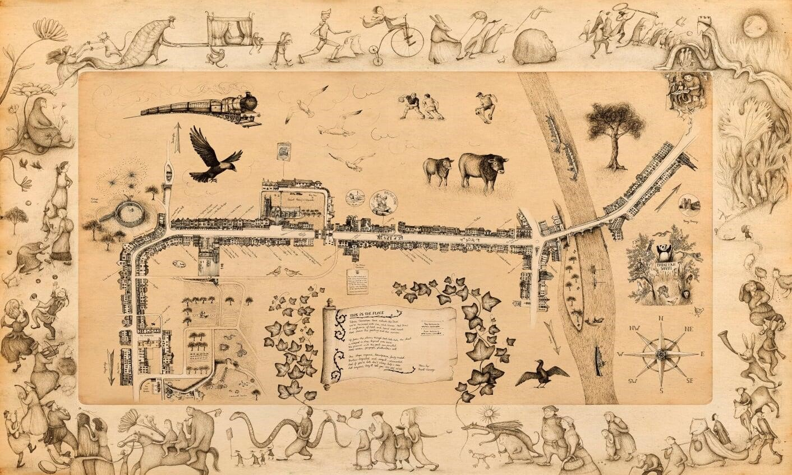

SEIREAP Ecological Footprint data.
Annual estimated passenger usage based on sales of tickets in stated financial year(s) which end or originate at Totnes from Office of Rail and Road statistics
The Tiny Home Movement is an architectural and social movement that advocates simple living in small homes, typically around 400sq feet.

