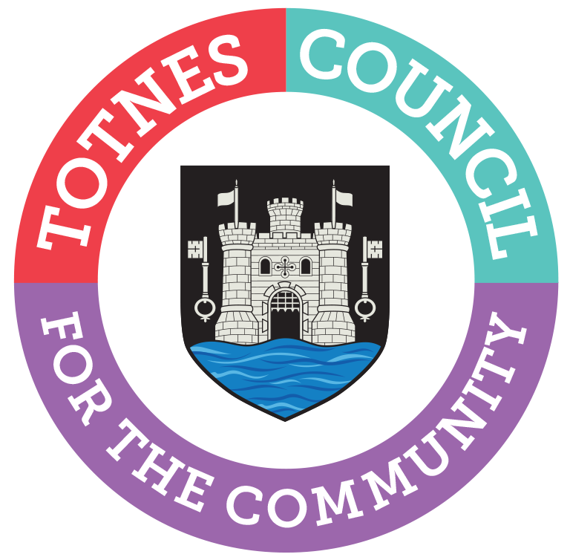

NOTICE OF VACANCIES IN OFFICE OF COUNCILLOR
PARISH OF TOTNES, TOTNES TOWN AND TOTNES BRIDGETOWN WARDS
Totnes Town Council is seeking up to two dedicated and motivated persons to fill upcoming vacancies as a Town Councillor.
The Council meet once a month at 6.30pm, in the Guildhall, with additional committee meetings held throughout the year.
This role is voluntary.
The role finishes in May 2023 with the elections being held on 4th May 2023.
Further details are available from the Town Clerk on 01803 862147.
Letters of application, outlining your experience, how you would help the local community and why you would like to be a town councillor, should be sent to: The Town Clerk, Totnes Town Council, The Guildhall Offices, 5 Ramparts Walk, Totnes, TQ9 5QH or emailed to clerk@totnestowncouncil.gov.uk.
Closing date for applications is midday on Wednesday 4th January 2023.
Your application will form part of the decision-making process for co-option at a Full Council meeting on 9th January 2023. Please be aware that your application will form part of the public agenda packs but with personal contact information redacted.

Eligibility Criteria
To qualify as a candidate a person must be 18 years of age and a Commonwealth citizen, citizen of the Republic of Ireland or a citizen of another Member State of the European Union and either:
(a) be registered as a local government elector within the electoral area; or
(b) have occupied as owner or tenant any land or other premises within the electoral area during the whole of the previous twelve months; or
(c) his/her principal or only place of work during the previous twelve months has been in the area of the electoral area; or
(d) You have lived in the parish/community area or within 4.8km (three miles) of it during the whole of the 12 months preceding appointment.
A person is disqualified for being elected as a local councillor or being a member of a local council if:
(a) You are employed by the parish/community council or hold a paid office under the parish/community council (including joint boards or committees).

(b) You are the subject of a bankruptcy restrictions order or interim order.

(c) You have been sentenced to a term of imprisonment of three months or more (including a suspended sentence), without the option of a fine, during the five years before polling day.

(d) You have been disqualified under the Representation of the People Act 1983 (which covers corrupt or illegal electoral practices and offences relating to donations). The disqualification for an illegal practice begins from the date the person has been reported guilty by an election court or convicted and lasts for three years. The disqualification for a corrupt practice begins from the date a person has been reported guilty by an election court or convicted and lasts for five years.

Catherine Marlton
Town Clerk
14th December 2022

