Green Travel Newsletter
January 2023
Hello everyone,
I hope you had a good Christmas and New Year.
We have a few interesting things to share with you this month. In this newsletter you’ll find updates on the following:
- Totnes & District Traffic and Transport Forum AGM, 25 January 2023
- Bike parking map - call for locations
- E-bikes are coming to Totnes
- Totnes Bike Hub update
- Funding opportunities

AGM: Totnes & District Traffic and Transport Forum, 25th January 2023
The next Traffic and Transport Forum meeting will also be the AGM in which we elect the new Steering Group for the Forum. Everyone welcome. We are looking for more people to join the Steering Group so do join us if you might be interested.
What is the Traffic and Transport Forum?
The TTF is an advisory group to Totnes Town Council (TTC), providing a space for discussion to identify and resolve traffic issues, and to develop new opportunities for sustainable transport and active travel. Forum meetings are open to everyone and are held quarterly, on the last Wednesday of the relevant month.
The Forum Steering Group is made up of representatives of different groups from Totnes and its surrounding districts. This includes businesses, active travel champions, residents, community groups and sustainability groups. Outside of Forum meetings, the Steering Group will meet as needed (also on the last Wednesday of the month).
If you would like to be a part of the Steering Group or get more information, please get in touch with me via greentravel@totnestowncouncil.gov.uk. You are also welcome to attend the meeting and make a decision then.
If you know of someone who you think might be interested, please do forward this information to them or ask them to get in touch.
When: 25 January 2023, 6.30 - 8pm
Where: Guildhall, Totnes
5 Ramparts Walk, behind St Mary’s Church. Entrance is through the old wooden door (with Guildhall sign) to the left of the red Totnes Town Council door entrance.

Bike parking map: Call for locations
Do you know of any bike parking that is not on the bike parking map (link below)? You can click on each bike icon to access further details and multiple images of each location.
If you do know of others, please get in touch - greentravel@totnestowncouncil.gov.uk .
If you can provide a precise location and even one or two images, that would be ideal, but a rough estimate is fine too. Unfortunately, I am unable to walk around all of town searching for bike parking so currently only Totnes town centre is covered.
If you have suggestions for new locations or types of infrastructure, please also get in touch as we’re trying to expand provision.
Map link: Click here or the image below
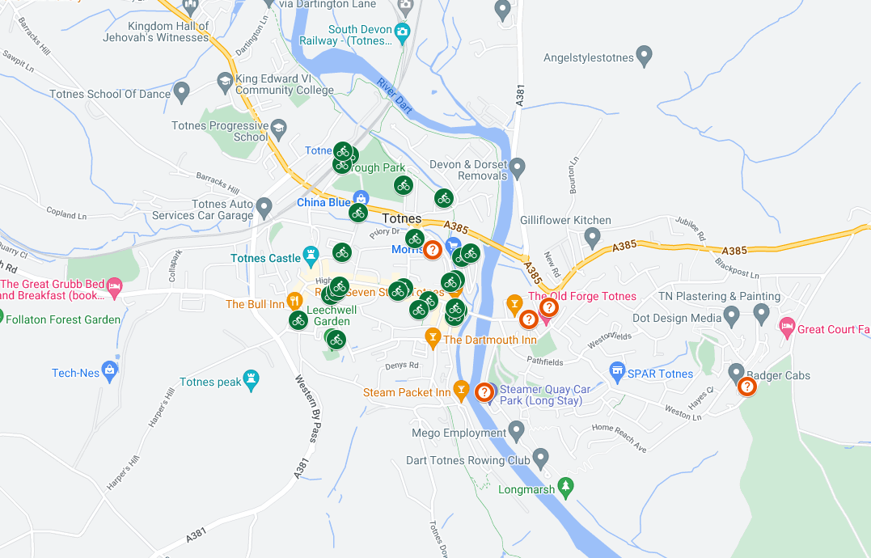

E-bikes are coming to Totnes!
Totnes Town Council have worked alongside Exeter-based social enterprise, Co Bikes, to successfully apply for £25,000 South Hams District Council funding to trial an e-bike scheme in the town.
The successful bid for funding through SHDC’s Climate Infrastructure Fund will contribute four stations and eight bikes to support an already growing network which will total seven e-bike stations and 26 bikes across Totnes and Dartington. The trial will run for 12 months and will hopefully start in the spring of 2023 (TBC). It is hoped the trial will prove the scheme is viable and enable it to become a permanent service in town with a wider offering.
The bikes will be the same type as those already found in Exeter and will be available to hire on-demand through the Co Bikes app. Because they are electric, the e-bikes can easily tackle hills and shorten journey times whilst helping people avoid getting tired or sweaty, giving them the confidence to make journeys by bike they may not have previously considered. E-bikes also reduce car journeys - in a recent Co Bikes survey, 54% of respondents said they used the bikes to make trips that would have otherwise been done by car.
The final details of the scheme are still being worked out and more information will follow soon.
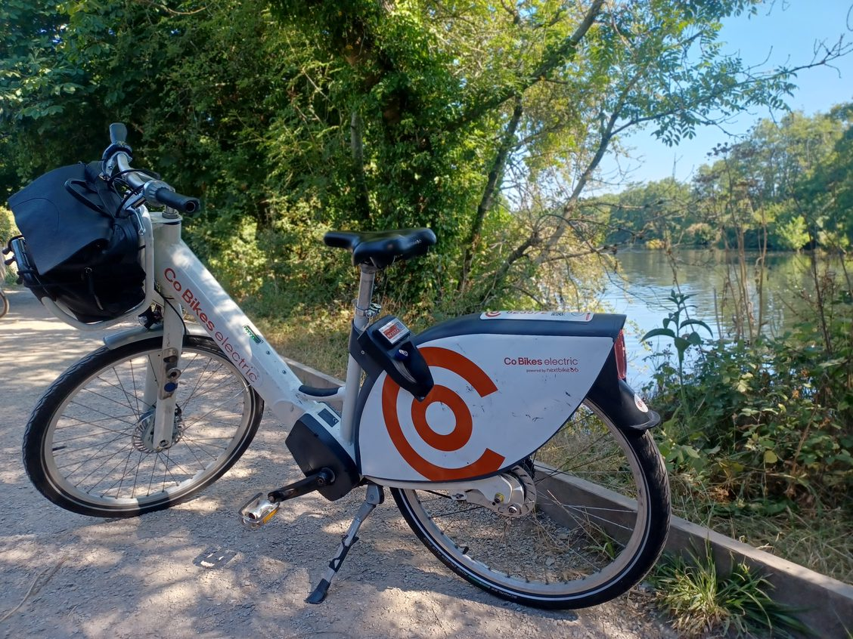

Totnes Bike Hub - upcoming events
The Bike Hub’s weekly Wednesday night social rides are on again. Meeting at the Bike Hub at 7pm every Wednesday evening, the rides are led by an experienced ride leader and always involve a pub stop. Riders need to have a bike in good working order, bring a pair of good lights and a bike lock. High viz clothing is advised as the lanes can be dark! The rides are around 2/3 hours.
Their volunteer days are on Mondays from 9-5. Come along and learn how to get their donated bikes back on the road! Their experienced mechanic will show you how to strip the bikes back and get them in good working order. It's a great way to learn a new skill, meet others and support your local community bike shop.
Refreshments are provided.
For more information, contact the Bike Hub (totnesbikehub@gmail.com)

Funding opportunities
Devon on Earth
Grants of between £2,000 and £5,000 are available to community organisations and groups for projects and initiatives which bring people together to reduce environmental damage and improve local areas in Devon, Torbay and Plymouth.
Deadline: 31 January 2023
Click here for more information.

Connecting You
Devon County Council is encouraging more organisations to apply to its Connecting You fund which was set up to trial innovative transport solutions to tackle loneliness.
All projects must take place within Devon and be for the benefit of Devon residents who are within our defined beneficiary groups:
- Older People aged 55+
- Young People aged 16-24
Grants of between £1,000 up to £10,000 will be considered. Grants are for revenue expenditure only.
Deadline: 31 January 2023
Click here for more information.
That’s it for now - thanks for reading.
To reiterate, the next Forum meeting and AGM will held on Wednesday 25th January 2023, 6:30 - 8pm at the Guildhall. If you have any agenda items you would like discussed, get in touch. And let me know if there is anything you would like to have included in a future newsletter.
Many thanks,
Maiken
Sustainability Officer
Totnes Town Council
greentravel@totnestowncouncil.gov.uk
If you have any thoughts or suggestions for projects that you think TTC should be working on, please don’t hesitate to get in touch: greentravel@totnestowncouncil.gov.uk

