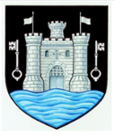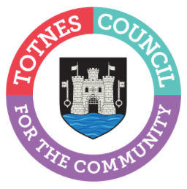

6 February 2023
NOMINATIONS FOR TOTNES TOWN COUNCIL’S 2023 COMMUNITY AWARDS NOW OPEN
Who in the community has made a difference to you this past year? Building on the success of last year’s Community Award, Totnes Town Council is asking you for your nominations for an individual and/or community group that you feel should be recognised for their good works in Totnes. These could be people or groups who give their time in many different ways – including, caring and supporting those in need, working with young people or the elderly, or helping people’s health and feeling of togetherness through exercise and sport.
After considering the idea for some time, in March 2022 Totnes Town Council launched its Community Award scheme to recognise the efforts of individuals who volunteer their time to help or enrich the lives of the community. The 2022 Community Award was presented to Graham Walker for his charity fundraising efforts in the town. In September 2022, the Council agreed that in 2023 the community would be asked for their nominations. Councillors will then consider these before making the final decision on the individual and community group/organisation award.
Please email (administrator@totnestowncouncil.gov.uk), phone 01803 862147 or call into the Council Offices with your nominations by Friday 10th March 2023 including a short explanation of why you’ve suggested them. Councillors will consider all the nominations and the awards will be presented at the Annual Town Meeting in May, which is open to all to attend.

Photo caption: (L-r) Cllr Emily Price, Mayor of Totnes, Graham Walker, 2022 Community Award winner, and Cllr Georgina Allen, Deputy Mayor of Totnes

-Ends
For more information, please contact Lucy Ferrier info@visittotnes.co.uk or call 01803 862147

