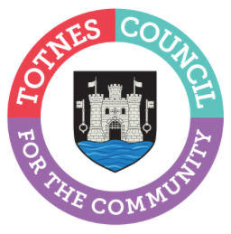

9 March 2023

TOWN DECORATED FOR A JOYOUS SPRING AND SUMMER SEASON

Totnes Town Council is creating a celebratory atmosphere and warm welcome by decorating the town with brightly coloured bunting for spring and summer 2023. On 19 March, the bunting will be festooned across the street from the Eastgate to The Rotherfold by local contractors AJ Paine and Son. The work has been scheduled to take advantage of the current road closure to ensure there is as little disruption to local people and businesses as possible. Totnes Town Council's Town Maintenance Officer will then oversee putting up additional bunting between the junction by The King William IV and the Eastgate as soon as possible depending on access (this is currently restricted due to the Wales and West works).

Cllr Emily Price, Mayor of Totnes, said: "We've invested in 1km of colourful bunting as part of our commitment to support our local economy and community. We hope it will help brighten up Totnes throughout 2023 and bring a little extra joy to local people and visitors alike as they walk through the town. Unfortunately, we won't be festooning bunting in Lower Fore Street. We have taken this decision due to the additional cost to close the road which would be required to enable us to decorate this area too (it costs approximately £1,000 to close the road).

“However, we understand that The Mansion will be decorating their frontage at some point in the summer, so this part of the town will still enjoy the jubilant ambience we're looking to create throughout the season. We also hope our other brilliant town centre businesses will get in on the party atmosphere and decorate their own buildings or windows.”

-Ends
For more information, please contact Lucy Ferrier info@visittotnes.co.uk or call 01803 862147

