AGENDA FOR THE FULL COUNCIL MEETING OF TOTNES TOWN COUNCIL

MONDAY 6TH MARCH 2023 IN THE GUILDHALL

Please note that public question time will be held prior to Full Council from 6.30pm.
There are stairs to the Council Chamber but if any member of the public has mobility issues the Council can relocate
to the lower Guildhall.

You are hereby SUMMONED to attend a meeting of the Council, on Monday 6th March 2023 at 7.00pm for a maximum of 120 minutes the purpose of transacting the following business:

WELCOME TO ALL ATTENDING AND OBSERVING
The Chair will read out the following statement:

Welcome to everyone attending and observing the meeting.

A reminder that open proceedings of this meeting will be video recorded. If members of the public make presentations, they will be deemed to have consented to being recorded. By entering the Council Chamber attendees are also consenting to being recorded.

This meeting is limited to 120 minutes and therefore members are asked to raise their points succinctly and not repeat the same view expressed by colleagues if it does not add to the debate.

APOLOGIES FOR ABSENCE AND DECLARATION OF INTERESTS
To receive apologies and to confirm that any absence has the approval of the Council. The Mayor will request confirmation that all Members have completed or made any necessary amendments to their Declaration of Interests.

The Committee will adjourn for the following items:

Reports from County and District Councillors.
- County Cllr Hodgson – no document.
- District Cllr Birch – no document.
- District Cllr Rose – no document.
- District Cllr Sweett – no document.

The Council will convene to consider the following items:

CONFIRMATION OF MINUTES
To approve and sign the minutes of the following Meetings:
(Please note confidential minutes can be agreed but any discussion must be held in Part 2)
- Full Council 6th February 2023 – document attached.

To note the following minutes:
b. Council Matters Committee 13th February 2023 – document attached.
c. Planning Committee 20th February 2023 – document attached.

CONSIDERATION OF ANY MATTERS ARISING REQUIRING A DECISION
To consider any matters arising from the Minutes and to approve any recommendations from Committees (document to follow):
(Please note confidential minutes can be agreed but any discussion must be held in Part 2)
- Full Council 6th February 2023.
b. Council Matters Committee 13th February 2023 – document attached.
c. Planning Committee 20th February 2023 – document attached.

CIVIC PROTOCOL AND PROCEDURE
To review the Civic Protocol and Procedure. Document attached.

CLIMATE CHANGE BUDGET
To consider a reallocation of the climate change budget. Document attached.

EVENT EXPENDITURE
To consider event expenditure given the response from the Elizabethan Society. Document attached.

LICENSING APPLICATION
To consider an application for a new premises licence from The Angel Totnes Ltd for The Angel, South Street, Totnes, TQ9 5DZ. Document attached.

LIST OF MEETING DATES
To note a list of upcoming meeting dates. Document attached.

NEXT MEETING
To note the next meeting date of Monday 3rd April 2023, 6.30pm public session, 7.00pm formal meeting in the Guildhall.

The Council will be asked to RESOLVE to exclude the press and public “by reason of the confidential nature of the business” to be discussed and in accordance with the Public Bodies (Admission to Meetings) Act 1960.

CONFIDENTIAL ITEMS FROM COMMITTEE (Standing Item)
To consider any recommendations or matters arising that are considered confidential in nature.

NEIGHBOURHOOD PLAN
To consider the draft response to a fact check on the Neighbourhood Plan examiner’s report (legally sensitive). Document attached.

CCTV QUOTES
To reconsider quotes for extending the Close Circuit television coverage outside the Guildhall and Guildhall garage area (commercially sensitive). Documents attached.

EASTGATE LEASE

To consider the lease on Eastgate (commercially sensitive). Verbal update.

ELMHIRST PROJECT (Standing Item)
To consider any update on the Elmhirst Site project (commercially sensitive). Verbal update.

CHRISTMAS LIGHTING
To consider Christmas lighting costs and how to proceed (commercially sensitive). Document to follow.

Agenda produced by:
Catherine Marlton
Town Clerk
1st March 2023

USE OF SOUND RECORDINGS AT COUNCIL & COMMITTEE MEETINGS
The open proceedings of this Meeting will be audio and video recorded. If members of the public make a representation, they will be deemed to have consented to being recorded. By entering the Council Chamber or Zoom meeting, attendees are also consenting to being recorded.

Televised, vision and sound recordings or live broadcastings by members of the press or public at Council or Committee debates are permitted and anyone wishing to do so is asked to inform the Chairman of the respective Committee of their intention to record proceedings.

ITEMS 3a & 4a - FULL COUNCIL MINUTES

DRAFT MINUTES FOR THE MEETING OF TOTNES TOWN COUNCIL
MONDAY 6TH FEBRUARY 2023 IN THE GUILDHALL

Present: Councillors E Price (Chair), T Bennett, S Collinson, J Cummings, J Hannam, R Hendriksen, J Hodgson, P Paine, B Piper, L Smallridge and L Webberley.

Apologies: Cllrs Adams, Allen and Peters, and District Cllrs Birch, Rose and Sweett.

Not Present: Cllr Skinner.

In Attendance: District Cllr Birch and Rose, members of the press and public, C Marlton (Town Clerk), P Bethel (Town Sergeant).

WELCOME TO ALL ATTENDING AND OBSERVING

APOLOGIES FOR ABSENCE AND DECLARATION OF INTERESTS
To receive apologies and to confirm that any absence has the approval of the Council. The Mayor will request confirmation that all Members have completed or made any necessary amendments to their Declaration of Interests.
The apologies were received and agreed unanimously.

The Committee will adjourn for the following items:

Reports from County and District Councillors.
- County Cllr Hodgson
- District Cllr Birch
- District Cllr Rose
- District Cllr Sweett

It was RESOLVED to suspend standing orders.

a. County Cllr (C Cllr) Hodgson gave a verbal update on her report: HATOC meeting and agreement to the pedestrian crossing near The Lamb (with community consultation and funding by the Town Council); Devon County Council (DCC) setting a budget to safeguard social care and services for children, and halving of the County Councillor locality budget; waste management; potholes; bus users forum.

b. District Cllr (D Cllr) Birch had sent his apologies and had circulated a report in advance.

c. District Cllr Rose had sent his apologies and had not circulated a report.

d. District Cllr Sweett had sent her apologies and had not circulated a report.

The Council reconvened.

3. CONFIRMATION OF MINUTES
To approve and sign the minutes of the following Meeting:
(Please note confidential minutes can be agreed but any discussion must be held in Part 2)
a. Full Council 9th January 2023.
It was RESOLVED to approve and sign the minutes.

To note the following minutes:
b. Council Matters Committee 16th January 2023.
Noted.

c. Planning Committee 23rd January 2023.
Noted.

d. Town Matters Committee 30th January 2023.
Noted.

4. CONSIDERATION OF ANY MATTERS ARISING
To consider any matters arising from the Minutes and to approve any recommendations from Committees:
(Please note confidential minutes can be agreed but any discussion must be held in Part 2)

a. Full Council 9th January 2023.
No matters arising.

b. Council Matters Committee 16th January 2023.
The recommendation in item 3b will be considered as separate Full Council item 5.

c. Planning Committee 23rd January 2023.
Item 5 - Scaffolding on Bogan House. It was RESOLVED unanimously that the Council emails Devon Highways to say that it will support the erection of scaffolding on Bogan House and for it to remain in place over the summer months to enable essential works to be completed. The Council would request that all necessary safety measures are taken given this busy location in the town, including covering/wrapping the scaffold if appropriate.

d. Town Matters Committee 30th January 2023.
Item 4 - Arrangements for the Christmas Lights Switch On 2023. It was RESOLVED unanimously that the community Christmas Lights Switch On takes place on Tuesday 28th November from 3-6pm, and that officers make the necessary arrangements to secure entertainment, refreshments and crafting activities (as set out in the note) within the budget set for financial year 2023/24.

5. BUDGET SAVINGS FOR 2023/24
To consider budget saving of £90K for financial year 2023/34.

It was RESOLVED unanimously that the following savings (totalling £90,000) are taken in the 2023/24 budget:

RECOMMENDED CUTS | SAVING 2023/24
Remove Arts and Events Grant Pot | £5,000
Reduce S137/Community Grants | £25,000
Remove CCTV and Traffic Calming | £50,000
Reduce Public Seating and Benches | £5,000
Reduce New planting and new planters and trees | £5,000
TOTAL SAVING | £90,000

6. TRANSPORT SCHEMES
To consider an update of the transport schemes in the Traffic & Transport Policy and Strategy.
It was RESOLVED unanimously to support the recommendations made in the report. A vote of thanks was extended to the Sustainability Officer for this work.

7. COMMITTEE MEMBERSHIP
To consider the following:
a. Cllr Allen and Cllr Peters’ appointment to the Council Matters Committee.
It was RESOLVED unanimously to accept Cllrs Allen and Peters’ appointment to the Council Matters Committee
b. Cllr Smallridge’s appointment to the Planning and Town Matters Committees.
It was RESOLVED unanimously to accept Cllr Smallridge’s appointment to the Planning and Town Matters Committees.

8. LIST OF MEETING DATES
To note a list of upcoming meeting dates.
Noted.

9. NEXT MEETING
To note the next meeting date of Monday 6th March 2023, 6.30pm public session, 7.00pm formal meeting in the Guildhall.
Noted.

The Council will be asked to RESOLVE to exclude the press and public “by reason of the confidential nature of the business” to be discussed and in accordance with the Public Bodies (Admission to Meetings) Act 1960.

10. CONFIDENTIAL ITEMS FROM COMMITTEE (Standing Item)
To consider any recommendations or matters arising that are considered confidential in nature.
No recommendations.

11. GROUNDS MAINTENANCE TENDER
To consider grounds maintenance tenders received for Totnes cemetery and Castle Meadow (commercially sensitive).
It was RESOLVED unanimously that the maintenance contract is awarded to Glendale on the condition that other options are explored over the next few months with the new Council. Councillors were particularly keen to consider employing someone to undertake the work or consider increasing hours for existing staff to cover the cemetery maintenance, but a report will be needed listing costs in terms of management time, employment costs, equipment purchasing and maintenance, insurances, cover arrangements for absence. This contract must be reviewed before the end of the 12-month anniversary of start.

12. TRESOC ENERGY CLUB PROPOSAL

To reconsider the Totnes Renewable Energy Society’s (TRESOC) energy club proposal for use of the solar panels on the Civic Hall (commercially sensitive).

It was RESOLVED to join the Totnes Energy Club for a 12 month period subject to the loss underwriting by TRESOC being confirmed in writing.

13. ELMHIRST PROJECT (Standing Item)
To consider any update on the Elmhirst Site project (commercial).
There was no new information to update Council with.

Cllr Emily Price
Mayor

ITEMS 3b & 4b - COUNCIL MATTERS MINUTES

DRAFT MINUTES FOR THE MEETING OF COUNCIL MATTERS

MONDAY 13TH FEBRUARY 2023 AT 6.30PM IN THE GUILDHALL

Present: Councillors B Piper (Chair), M Adams, J Hannam (joined at 18.35), J Hodgson (joined at 18.40), D Peters and E Price.

Apologies: Cllr Allen.

In Attendance: C Marlton (Town Clerk) and C Bewley (Finance, HR and Lettings Manager).

1. APOLOGIES FOR ABSENCE
The Chair read a statement about how the meeting would be conducted and recorded. The apologies were accepted.

The Committee will adjourn for the following items:

PUBLIC QUESTION TIME
There were no members of the public present.

The Committee will reconvene to consider the following items:

2. CONFIRMATION OF MINUTES
To approve the minutes of 16th January 2023 and update on any matters arising.
The minutes were AGREED as an accurate record of the proceedings.

3. BUDGET MONITOR

To consider the Budget Monitor including:

a. A breakdown of proposed spend on phase 2 of the Wayfinding project.
The Clerk explained that the actual installation costs for phase 1 was higher than quoted due to complexities, and therefore the costs budgeted for phase 2 have increased accordingly. It was AGREED unanimously that a maximum of £27K is allocated for phase 2 of the project (originally budgeted £32K).
b. Provisional allocation of the FY 2023/24 budget on events in the town.
The event funding provisional allocation was AGREED unanimously. It was suggested that Jamming Station is invited to provide music for the Spring community event.
c. The reserve projection.
Noted.
d. An increase on the ‘Welcome to Totnes’ signs and giving delegated authority to the Clerk for the design of both given the timescales involved.
It was AGREED unanimously: to replace the ‘Welcome to Totnes’ sign on the Newton Abbot road; and to give the Clerk delegated authority for the design of the signs and spend for the replacement.

4. PAYMENTS TO COUNCILLORS POLICY
To review the Payments to Councillors Policy.
This was reviewed and unanimously AGREED.

5. RESERVES POLICY
To review the Reserves Policy.
This was reviewed and unanimously AGREED.

6. COMMUNITY GRANT FOR THE LAMB GARDEN
To consider an extension to the delivery date and change of use for the community grant awarded for the Lamb Garden project.
The Clerk explained that the original grant was for a notice board to be placed in The Lamb (as well as garden trail leaflets). It was AGREED unanimously that an extension of six months be given for the funds to be spent on additional leaflets.

7. CHRISTMAS MARKETS
To consider a report for the 2022 events and arrangements for 2023.
The Clerk updated that: the budget in the report needs review as some costs came from the Arts and Events budget; and that South Hams District Council has agreed to hiring the space for the next two years. It was suggested that the Arts and Events Working Group looks at the entertainment provided at the event to try and reduce costs. It was agreed unanimously to RECOMMEND to Full Council to begin the tender process for a two-year contract for the organisation and management of the Christmas Markets event.

8. TOWN DECORATION

To consider revised costings and alternative solutions to the town decorations for summer 2023.
The Clerk updated that the costs for erection and road closure of bunting is higher than anticipated. It was AGREED to:
- Purchase and erect material bunting on upper Fore Street, High Street, the Market Square and the Rotherfold while the existing road closure is in force;
- Give the Clerk delegated authority to exceed the £3K budget allocation if required to purchase material bunting; and
- Make a suggestion to the community that they may wish to make bunting to decorate some areas of the town.

9. CHRISTMAS LIGHTS
To note a breakdown of the ARG on Christmas lights in 2021 and 2022, and the amount of money being transferred from the Chamber of Commerce to the Council.
Noted.

10. DATE OF NEXT MEETING
To note the date of the next meeting of the Council Matters Committee – Monday 13th March 2023 at 6.30pm in the Guildhall.
Noted.

The Committee will be asked to RESOLVE to exclude the press and public “by reason of the confidential nature of the business” to be discussed and in accordance with the Public Bodies (Admission to Meetings) Act 1960. (CONFIDENTIAL by virtue of relating to legal and/or commercial matters, staffing and/or the financial or business affairs of a person or persons other than the Council)

The Committee voted unanimously to permit one non-Committee Councillor to attend on the basis he has requested to join the Committee.

11. BANK STATEMENTS AND RECONCILIATIONS (Standing Item)

To consider the bank statements and reconciliations for November and December.
These were reviewed and unanimously AGREED.

12. HEARING LOOP REPAIR
To consider a quote for the repair of hearing loop in the Guildhall.
As an exception to financial regulations/best practice of multiple quotes, given the specialist nature of the repair the quote was unanimously AGREED. The Clerk was asked to check if the new system could be used to record audio.

13. CHAMBER OF COMMERCE
To consider a draft letter to the Totnes Chamber of Commerce.
It was AGREED that members of the Committee would redraft the letter by email before sending to the Town Clerk by 27th February 2023 for submission to Full Council.

14. WAYFINDING INSTALLATION COSTS

To note the increase in wayfinding installation costs.

Noted, with no concerns raised.

15. STAFFING UPDATE
For any general or urgent updates that required confidential sharing with Councillors
The verbal update was noted.

Catherine Marlton
Town Clerk
February 2023

ITEMS 3c & 4c - PLANNING COMMITTEE

DRAFT MINUTES FOR THE PLANNING COMMITTEE

MONDAY 20TH FEBRUARY 2023 IN THE GUILDHALL

Present: Councillors P Paine (Deputy Chair), T Bennett, J Cummings, R Hendriksen, J Hodgson (from 18.40) and L Smallridge.
Apologies: Cllrs Allen and Collinson.
In Attendance: S Halliday (Governance and Projects Manager).

1. WELCOME AND APOLOGIES FOR ABSENCE
To receive apologies and to confirm that any absence has the approval of the Council.
Cllr Paine read out a statement about how the meeting would be conducted and recorded.

The apologies were received and accepted.

The Committee will adjourn Standing Orders for the following items:

PUBLIC QUESTION TIME
There were no members of the public present.

The Committee reconvened Standing Orders.

2. CONFIRMATION OF MINUTES
To approve the minutes of 23rd January 2023 and update on any matters arising.
The minutes were approved as an accurate record of proceedings. Matters arising:

Item 5 – Scaffolding on Bogan House. It was RESOLVED that the Council emails Devon Highways to say that it will support the erection of scaffolding on Bogan House and for it to remain in place over the summer months to enable essential works to be completed. The Council would request that all necessary safety measures are taken given this busy location in the town, including covering/wrapping the scaffold if appropriate.

3. TREE WORKS APPLICATIONS
To make recommendations on the following tree works applications:
3a. 0163/23/TPO – H1: Hedge (a variety of species) - Lateral reduction on Southern side to maintain a 3m gap between the hedge and buildings and crown raise on southern side & western side by 2.4m above the footpath & 4m above parking area due to hedge encroaching on the neighbouring land. Follaton Rise, Totnes, TQ9 5DQ.
Support.

4. PLANNING APPLICATIONS
To make recommendations on the following planning applications:

4a. 4342/22/FUL & 4374/22/LBC - Refurbishment of existing annexe, reinstatement of side passage, upgrading lower rear lower roof & addition of solar panels and Listed Building Consent for refurbishment of existing annexe (ancillary to the main dwelling). Reinstatement of side passage to rear courtyard/annexe and separating dwelling from shop. Upgrading rear lower roof to the existing first floor bathroom and addition of solar panels on roof of main building. 90 High Street, Totnes, TQ9 5SN.
Support.

4b. 4504/22/FUL - Application for renovation of the ground floor/hall at the rear. Flat 41 Fore Street, Totnes, TQ9 5HN.
Support. The Committee would wish to see details of the arrangements for the storage of refuse and recycling bins included as part of this application.

4c. 0184/23/FUL – Conversion of basement to additional living accommodation and Provision of garden store and amenity area. Lower Ridgeside, Jubilee Road, Totnes, TQ9 5BW.
Support, but with a condition that this space is ancillary to the main dwelling.

4d. 0102/23/LBC - Listed Building consent for demolition of internal stud wall forming kitchen separation from hallway, remodelling of two first floor bathrooms. 6 Cistern Street, Totnes, TQ9 5SP.
Support.

4e. 0164/23/LBC – Listed Building Consent for replacement of four first floor windows. 1a Moat Cottage, Moorashes, Totnes, TQ9 5TN.
Support.

5. PUBLIC RIGHTS OF WAY

To note a report conducted by Totnes Ramblers on the condition of public rights of way in Totnes.
Noted. Cllr Hodgson, in her capacity as County Councillor, will raise the issue of the condition of Footpath 3 with the Devon County Council Footpaths Officer.

6. TRAFFIC AND TRANSPORT FORUM

To consider any recommendations from the Traffic and Transport Forum Annual General Meeting and meeting held on 25th January 2023.
Noted – there were no recommendations to consider. Cllr Bennett updated that this had been a busy meeting, which was well attended and positive. A new Chair and Steering Group have been appointed and building on wider discussions at the facilitation event last year around traffic calming measures work is ongoing to draw up a map of traffic concerns in and around the town.

7. EVENTS ON SOUTH HAMS DISTRICT COUNCIL LAND
To note the following events taking place on South Hams District Council land (no document):
a. Teignbridge Trotters Totnes 10K Event, Sunday 6th August 0700-1500hrs, Borough Park.
Noted.

b. Eat: Totnes Food Festival, Sunday 10th September 0700-1900hrs, Longmarsh.

Noted.

7. DATE OF NEXT MEETING
To note the date of the next meeting of the Planning Committee – Monday 20th March 2023 at 6.30pm in the Guildhall.
Noted.

Sara Halliday
Governance and Projects Manager
February 2023

ITEM 4 – CONSIDERATION OF RECOMMENDATIONS

4a. Full Council, 6th February 2023

No recommendations.

4b. Council Matters Committee, 13th February 2023

Item 7. Christmas Markets.

To RECOMMEND to Full Council to begin the tender process for a two-year contract for the organisation and management of the Christmas Markets event.

4c. Planning Committee, 20th February 2023

No recommendations.

ITEM 5 – CIVIC PROTOCOL AND PROCEDURE

Proposed new text is underlined

Civic Procedure and Protocol
TOTNES TOWN COUNCIL
AGREED XXX
NEXT REVIEW MARCH 2023
This document sets out the procedures and protocols to be followed in relation to the Council’s civic business.
- Mayoral Chains

1.1 When in attendance, it is the duty of the Town Sergeant to protect the chain/s and, after an event, to either return the chain/s to the Guildhall or, if this is not practical, to take them home. Chain/s must be kept in a safe place.

1.2 The Town Clerk is responsible for ensuring that the insurance is adequate to cover the chains at all times.

1.3 When the full chain/s is being worn the Mayor must be accompanied by the Town Sergeant or an escort of their choosing. If unaccompanied, only the medallion may be worn.

1.4 The full chain/s cannot be worn if an event takes place on the water. Neither can the chain/s be taken out of the country without the Council’s permission.

1.5 The Mayor may have to attend more than one event in a day, in which case they may take the chain/s home providing it/they are not left unattended.

- Civic Functions

  - On such occasions the Mayor wears the ceremonial robes and, if appropriate, the Town Sergeant and Mace Bearers wear full Civic dress. The Civic Events (and dates where known for 2023/24) are:

- Mayor Choosing Making – Thursday 25th May 2023
- Civic Service (February 2024 – TBC)
- Remembrance Sunday – Sunday 12th November 2023
- Civic Funerals
- Civic Dinner (October – TBC)

2.2 Other events include:

- The annual Orange Races (TBC)
- The opening of the Elizabethan Season – Tuesday 2nd May 2023

2.3 If the Mayor is requested to wear the robes on any other occasion, and chooses to do so, they will decide the dress code for the Town Sergeant and the Mace Bearers if they accompany them.

3. Civic Functions – Dress Code

  - The Mayor and Deputy Mayor will wear the full ceremonial robes.

3.2 The Town Clerk, Town Sergeant and Mace Bearers will wear full ceremonial dress.

3.3 Councillors will wear smart, suitable clothing (hats are optional).

3.4 Past Mayors’ medals and decorations may be worn.

- Order of Procession

4.1 This is the responsibility of the Town Sergeant and is as follows:

- Town Band (if present)
- Military
- Fire Brigade
- Mace Bearer – Town Sergeant – Mace Bearer
- Mayor and Deputy Mayor
- Town Clerk and Mayor’s Chaplain (if one is appointed)
- Mayor’s consort and Deputy Mayor’s consort
- Member of Parliament
- Guest of Honour/SHDC Chairman
- Honoured Citizens and Freemen of the Town
- Town Councillors
- Former Mayors and Magistrates
- Devon County Councillors
- District Councillors
- Chief Officials
- Other representatives
- Families, Guests, etc

4.2 If the Lord Lieutenant is present they will walk at the END of the procession to enter any building and HEAD the procession when the event is over.

- Mayor Making Ceremony

5.1 The Mayor Making Ceremony is not a public meeting, attendance is by invitation only and includes: sitting Councillors and partners/guest, former Mayors, honoured citizens and freemen, 2 x guests representing the outgoing Mayor’s charities, up to 10 x guests of the incoming Mayor, Mayor’s chaplain (if appropriate), mayors from neighbouring towns, the Chair of South Hams District Council, Schools (1 x teacher and 2 x pupils from KEVICC, The Grove, St Johns and TOPS).

5.2 Agenda for Mayor Choosing Making – see Appendix A.

5.3 At the discretion of the Mayor, flowers will be presented to the outgoing and incoming Mayor and Deputy Mayor at the appropriate time in the ceremony (see Appendix A) the Mayoral Choosing lunch. These are funded from the Mayoral budget.

5.4 The ceremony will start at 11.30am and the bells of St Mary’s church will be rung from 12.30pm.

5.5 The Mayor Making ceremony will be followed by either a small reception in the Guildhall or a lunch, depending on what the Mayor’s preference is. All those invited to the ceremony will be invited to the lunch for which there will be an individual charge as well as funding from the Mayoral budget.

5.6 Any blessing in St Mary’s Church following the ceremony is at the discretion of the Mayor.

5.7 Staffing requirements at the event: Town Clerk, Town Sergeant and 2 x Mace Bearers, Administrator Mayor’s PA, and Council Officers as required.

6. The Civic Service

6.1 This is held at the discretion of the Mayor, and it is suggested it is held in February is usually held in June. It is suggested that holding the service on a Sunday could help boost attendee numbers.

6.2 It is held in the Parish Church or in a church/location chosen by the Mayor.

6.3 The Order and content of the service are agreed by the Mayor and their Chaplain.

6.4 The Civic Party leave the Guildhall and process to the North Door of St Mary’s Church or, if the service is being held elsewhere, to that location. The order of procession is at paragraph 4 above.

6.5 On arrival at the Church, the Mayor, Deputy, Town Sergeant and Mace Bearers stand on either side of the Church Door until the rest of the congregation are in their seats. They are then escorted into the Church.

6.6 At the end of the Service the Standard Bearers will leave the Church followed by the Civic Party who will parade to the agreed location where the Mayor is to take the salute.

6.7 The Mayor, Deputy and Chairman of the District Council stand at the front and their escorts and the remaining Councillors stand behind them.

6.8 At the end of the March Past, the Mayor will wait and thank the participants. Everyone else should disperse.

6.9 Staffing requirements at the event: Town Clerk, Town Sergeant and 2 x Mace Bearers.

7. Civic Funerals

7.1 These can be held in the Guildhall at the request of the family, in respect of serving Mayors, past Mayors, serving Councillors, Honoured Citizens and Freemen of the town. However, all arrangements and costs (including Guildhall hire) must be made by the family/next of kin.

7.2 The Mayor and Deputy will wear black gloves, and black ribbons will be attached to the robes and to the Maces.

7.3 If the deceased was an Honoured Citizen or Freeman of the town the Council will offer to host organise, and pay for, the reception/wake after the funeral service up to £1000. However, all arrangements must be made by the family/next of kin.

7.4 The Civic Party parade to the front of the Church. The Mayor, Deputy, and Town Sergeant stand on either side of the door whilst the remainder of the procession take their seats inside. The Mayor and Deputy then take their seats and await the arrival of the coffin and chief mourners.

7.5 At the end of the service the Civic Party will leave the Church first and form a Guard of Honour on either side of the door.

7.6 Staffing requirements at the event: Town Clerk, Town Sergeant and 2 x Mace Bearers.

8. Civic Dinner

8.1 This is held at a venue and time of year of the Mayor’s choosing, but October is suggested. This is the Mayor’s event and the majority of the planning should be conducted by the Mayor, not the Council Officers.

8.2 It is normally a formal evening but a Mayor is free to make alternative arrangements.

8.3 The following dignitaries are invited:

- Lord Mayors of Exeter and Plymouth and Escorts
- Mayors and Escorts of Dartmouth, Salcombe, Ivybridge, Kingsbridge and Torbay.
- Chairman of the District Council and Escort (Chair is Council funded)
- Honoured Citizens and Freemen of the town (Council funded)
- The Police Inspector (Council funded)
- The Mayor’s Chaplain (Council funded)

8.4 In addition to those above, the Council pays for:

- The Town Clerk
- The Town Sergeant
- The Guest Speaker
- The Master of Ceremonies (if there is one)

8.5 The Mayor, Deputy (in full robes) and their escorts greet the guests as they arrive. Once the guests have arrived the Mayor and Deputy leave and disrobe.

8.6 If the Mayor wishes to have a formal evening, on their return from disrobing the Master of Ceremonies announces the Civic Guests and their escorts who process to their seats in the following order:

- Mayors of Ivybridge, Kingsbridge, Salcombe, Dartmouth and Torbay
- Chairman of the District Council
- Lord Mayors of Plymouth and Exeter
- Deputy Mayor and Mayor

8.7 After the meal the Deputy Mayor proposes the Loyal Toast and the Loving Cup ceremony takes place.

8.8 Staffing requirements at the event: Town Clerk and Town Sergeant.

9. Remembrance Sunday

9.1 This is organised in conjunction with the Royal British Legion and the Mayor’s Chaplain.

9.2 The Mayor, Deputy, their consorts, Councillors and invited guests meet in the Guildhall prior to the Parade.

9.3 The order of procession is as paragraph 4 above.

9.4 The parade proceeds along Church Walk to the assembly point where it joins the Town Band (if attending) and other organisations before proceeding to the front of the Church.

9.5 The Mayor stands to the left of the main door and the Deputy to the right. The remainder of the Civic Party line up alongside the Mayor.

9.6 The Mayor lays the first wreath.

9.7 After the outdoor Service of Remembrance the Mayor and Deputy remain outside until escorted to their seats by the Town Sergeant and Mace Bearers.

9.8 At the end of the Service the Standards are carried out of the Church, followed by the Civic Party who proceed to the area where the salute will be taken. The salute is taken by the Mayor, Deputy, and Chairman of the District Council, the remainder of the party stand behind.

9.9 After the salute has been taken the Mayor dismisses the parade.

9.10 Staffing requirements: Town Clerk, Town Sergeant and 2 x Mace Bearers.

10. TOWN SERGEANT

10.1 The Town Sergeant attends Full Council and the civic events as detailed above. Any use of the Town Sergeant to accompany the Mayor to events in the town or to drive them to other events locally is at the discretion of the Mayor, as all costs (time and transport) will be paid from the Mayoral budget.

Appendix A: Order of Business – Mayor Making Ceremony

The Town Mayor will preside.

1. The Town Mayor will welcome those present.

2. Prayers conducted by the Mayor’s Chaplain (if requested).

3. The Mayor calls upon Councillor X to propose the election of the Mayor for the coming year.

4. The motion is put.

- The Mayor calls upon Councillor Y to second the proposal.

6. The motion is put.

7. The formal motion is then put to the Councillors by the Mayor and a vote is taken.

8. The Mayor announces their appointment of the Deputy Mayor for the coming year.

9. The retiring Mayor and Deputy, Town Clerk and Town Sergeant proceed to the Mayor’s Parlour together with the newly elected Mayor and Deputy. Those retiring return to their seats. The new Mayoral Party return to the Lower Chamber. Music is played during this interlude.

10. The Town Mayor takes the Oath and presides for the remainder of the meeting.

11. The Town Mayor nominates their Chaplain for the coming year.

12. The Town Mayor thanks the Council for their election and talks about their year ahead including the nomination of their charity/charities.

13. Councillor X proposes a vote of thanks to the retiring Mayor and presents them with a Past Mayors medallion and flowers.

14. The retiring Mayor replies and presents flowers to their outgoing Deputy.

15. The Mayor asks Councillors to note those Councillors elected to serve as Lead Councillors, Committees, Outside Bodies/Organisations Working Groups and Advisory Groups as per the given list .

16. The Mayor asks a student from King Edward VI Community College to request the Mayor’s Holiday.

17. The Mayor will grant the request.

18. The Mayor asks a student from St John’s CofE Primary School to respond and present flowers to the new Mayor*.

19. The Mayor asks a student from The Grove Primary School to respond and present flowers to the new Mayor*.

20. IF ATTENDING the Mayor asks a student from TOPS to respond.

21. The Mayor will instigate “Three Cheers for His Majesty the King”.

22. IF APPROPRIATE, The Mayor will invite those present to accompany them to St Mary’s Church/alternative venue for a short service.

23. The Civic Party and guests then process to the lunch venue/return to the Guildhall for refreshments.

* The order in which St Johns and The Grove respond and who they present the flowers should alternate each year.

ITEM 6 – CLIMATE CHANGE BUDGET

Due to changes in priorities and on receipt of a £1500 grant from County Councillor Hodgson a new budget for the 2022/23 (current financial year) budget is proposed by officers.

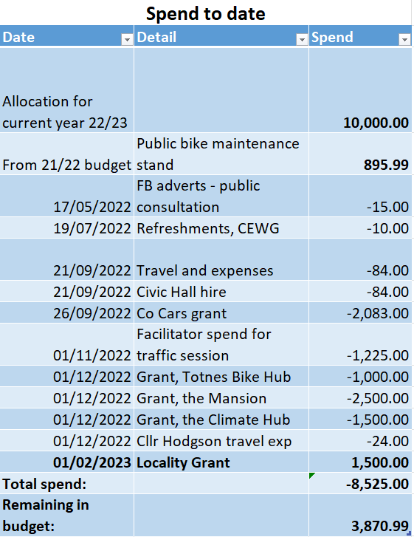

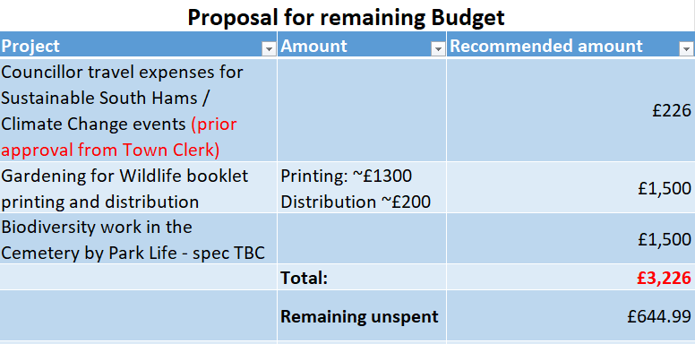
ITEM 7 – EVENT EXPENDITURE

Following the agreement of the budget allocation below the Town Clerk approached the Elizabethan Society to offer to partner with them on the Orange Races in August to expand the offer and cover the cost of the road closure. The Elizabethan Society have now declined this offer so we are asking Council to consider a reallocation of expenditure to another event in August.
Proposed:
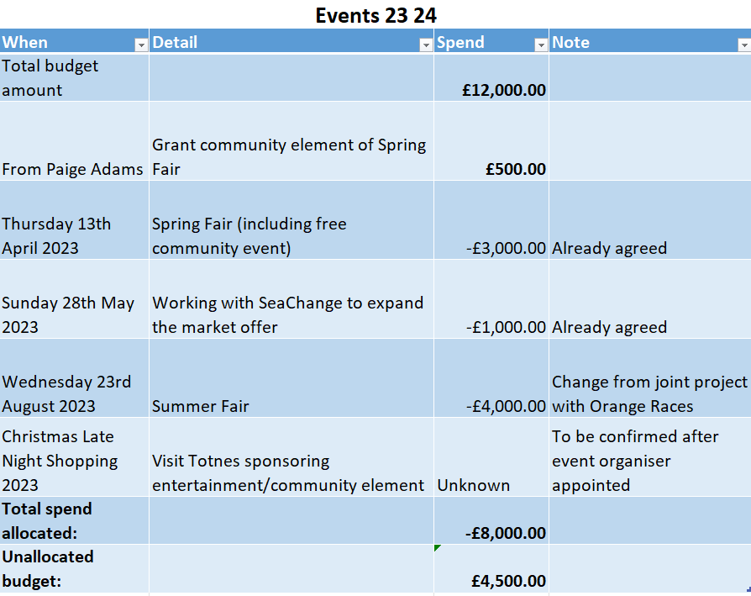

Details and updates on the format of these events will be tabled for the Arts and Event Working Group meeting on 15th March 2023 at midday.

ITEM 8 – LICENSING APPLICATION

South Hams District Council has received an application for a new premises licence from The Angel Totnes Ltd for The Angel, South Street, Totnes, TQ9 5DZ.

The application is for:
• Films: Sun-Wed 09:00 – 21:00; Thurs-Sat 09:00 – 22:00.
• Live and recorded music: Fri & Sat 09:00 – 00:00.
• Late night refreshment: Fri & Sat 23:00 – 00:00.
• Sale of alcohol for consumption on and off the premises: Sun-Wed 10:00 – 21:00; Thurs 10:00 – 23:00; Fri & Sat 10:00 – 23:30.
• All the above activities until 00:00 on Bank Holidays and selected local celebration days; until 01:00 during SeaChange Festival; until 02:00 New Year’s Eve.

ITEM 9 – LIST OF MEETING DATES

March
Full Council – 6th March at 6.30pm
Council Matters Committee – 13th March at 6.30pm
Arts and Events Working Group – 15th March at 12.00pm
Planning Committee – 20th March at 6.30pm
Climate Emergency Working Group – 21st March at 6.30pm
Traffic and Transport Steering Group – 22nd March at 6.30pm
Town Matters Committee – 27th March at 6.30pm

April
Full Council – 3rd April at 6.30pm
Council Matters Committee – 17th April at 6.30pm
Planning Committee – 24th April at 6.30pm
Traffic and Transport Forum – 26th April at 6.30pm

May
Annual Meeting of the Council – 15th May at 6.30pm
Annual Town Meeting – 17th May at 6.30pm in the Civic Hall
Mayor Making – 25th May at 11.15am in the Guildhall (this is not a public meeting – it is for all Councillors and invite only)

