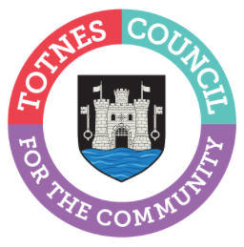

20 March 2023

TOTNES’ HISTORIC GUILDHALL REOPENS FOR THE SUMMER SEASON
Totnes Town Council will be reopening The Guildhall to the public on Tuesday 4 April 2023 after the winter break. This town centre gem, located just off the High Street behind St Mary’s Church, dates back over 1,000 years and offers a fascinating insight into the history of the town. Inside you’ll see the old town gaol and magistrate’s court as well as the Council Chamber where Oliver Cromwell is said to have sat to plan the closing stage of the Civil War in 1646. Admission is free, but donations to help with the upkeep of the building are welcome.

The Guildhall will be open Monday-Friday 11am-3pm (except bank holidays) until October thanks to a dedicated group of volunteers who are on hand to answer visitor questions. The building may occasionally need to be closed for Council events and weddings so please check first to avoid disappointment.

-Ends
For more information, please contact Lucy Ferrier info@visittotnes.co.uk or call 01803 862147

