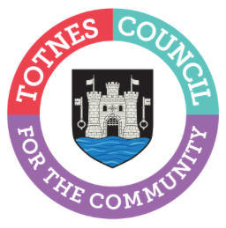

2 March 2023

COULD YOU VOLUNTEER AT TOTNES’ HISTORIC GUILDHALL?
In April, Totnes Town Council will once again open up Totnes’ historic Guildhall to visitors, and they’re looking for volunteers to help. Anyone thinking about getting involved can come along to the Guildhall for a coffee and chat at 12noon on Friday 24th March. During this time, you can take a look around and find out more about what volunteering at the Guildhall involves.
The Guildhall dates back to the 16th Century. Visitors can see the original prison cells and the table where Oliver Cromwell is believed to have sat when planning the closing stages of the Civil War as well as a choice of interesting artefacts relating to the town’s history.
Catherine Marlton, Totnes Town Council Clerk, said: “Our volunteers do a wonderful job enabling us to open this special building to the public and share the town’s history with visitors and locals alike. We’re very lucky to have the support of a number of residents who so kindly give up their time to help but we’re always looking for more people to help out too. Volunteers work in two shifts a day 11am-1pm and 1pm-3pm and play a really important role welcoming visitors and overseeing our collection. We often have two volunteers helping out so it can be a lovely social thing to do as well as a chance to find out more about local history or share your knowledge with others. We’d love to hear from you if you have a couple of hours spare a week and you’d like to get involved. Please come along for a coffee and chat or get in touch.”
The Guildhall is open to the public Monday-Friday, 11am-3pm from April to October and entry is free (donations welcome). In 2022, over 4,000 people from all over the world, including Australia, Germany, Denmark, Spain, France and the United States visited. The Grade 1 listed building is maintained and managed by the Town Council and donations from visitors help to support the upkeep of this important town landmark.
If you’re interested in joining the Guildhall volunteer team, or have any questions, come along to the Guildhall (on Rampart’s Walk, behind St Mary’s Church) for a chat at 12noon on Friday 24th March. Alternatively, call 01803 862147 or email civichall@totnestowncouncil.gov.uk

-Ends
For more information, please contact Lucy Ferrier info@visittotnes.co.uk or call 01803 862147

