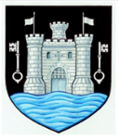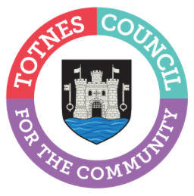

17 May 2023

TOTNES TOWN COUNCIL CONFIRMS 2023 MAYOR, DEPUTY MAYOR, AND TOWN COUNCILLORS
At the Full Council meeting on 15 May 2023, Cllr Emily Price was elected as Mayor of Totnes with Cllr Sarah Collinson elected as Deputy Mayor. Following the uncontested May 2023 Town Council elections, three seats (two for Bridgetown Ward and one for Town Ward) remained empty. Residents were invited to put themselves forward to fill these seats and at the Full Council meeting, Town Councillors co-opted Chris Beavis, Jeff Chinnock, and Nick Roberts to these positions resulting in all seats now being filled.
2023 Totnes Town Council Councillors
- Cllr Georgina Allen
- Cllr Luisa Auletta
- Cllr Chris Beavis
- Cllr Tim Bennett
- Cllr Jeff Chinnock
- Cllr Sarah Collinson (Deputy Mayor)
- Cllr Tom Cooper
- Cllr John Cummings
- Cllr Jill Hannam
- Cllr Jacqi Hodgson
- Cllr Darren Peters
- Cllr Ben Piper
- Cllr Anna Presswell
- Cllr Emily Price (Mayor)
- Cllr Nick Roberts
- Cllr Lisa Smallridge

Cllr Emily Price commented: “I’d like to welcome our new councillors and thank those who are continuing to serve the town. I’d also like to send my heartfelt thanks to those who have now stepped down from the Town Council – your knowledge, experience and dedicated hard work to support Totnes will be sorely missed. I’m pleased to continue to serve as Mayor of Totnes for another year and hope that together we will all be able to make a positive difference for everyone who lives and works here.”

On Thursday 25 May 2023, the traditional, formal Mayor Making Ceremony will take place at The Guildhall. More details on councillors, and the groups and committees they are standing on, can be found here: www.totnestowncouncil.gov.uk/your-council/your-councillors/

-Ends
For more information, please contact Lucy Ferrier info@visittotnes.co.uk or call 01803 862147

