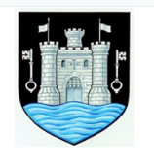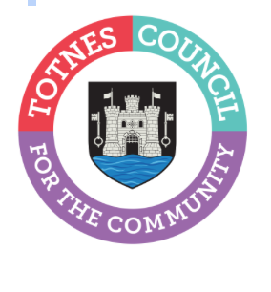
5 May 2023
TOTNES TOWN COUNCIL ANNUAL TOWN MEETING
Totnes Town Council will be holding its Annual Town Meeting on Wednesday 17 May at 6.30pm in the Civic Hall. The meeting gives members of the public a chance to ask questions and discuss topics they feel are important for the town as well as find out more about the current work of the Town Council. At this year’s meeting, the mayor will also announce the winners of the 2023 Totnes Town Council Community Award.

Catherine Marlton, Totnes Town Council Clerk, said: “We look forward to seeing as many people as possible at this meeting. It’s your chance to find out more about some of the things we do, including the grants we award to local community groups, our green travel initiatives, the work of our Town Maintenance Officer, plans for the Christmas lights in the town this year, the community events and markets we organise and our tourism strategy. If you do have any questions you’d like to ask, please contact us by 12 May to give us chance to prepare a response. Submit your questions by e-mail to reception@totnestowncouncil.gov.uk or call 01803 862147.
“Anyone who is not able to make it in person to the meeting can find out more about the work of the Town Council by looking at our website www.totnestowncouncil.gov.uk”

- Ends
Note to Editors
For more information, please contact Lucy Ferrier, Marketing & Communications Manager at info@visittotnes.co.uk

