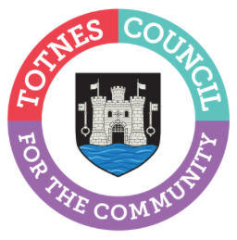
5 May 2023

BOOK YOUR SPACE NOW FOR TOTNES CHRISTMAS MARKETS 2023
Local makers and producers are being asked to sign up now if they would like to have a stall at one or all of the three 2023 Totnes Christmas Markets and Late Night Shopping events. Run by Miss Ivy Events on behalf of Totnes Town Council, the evenings are a town-wide celebration of festive family-friendly fun with live music and entertainment, street food and craft stalls. The events take place on the first three Tuesdays of December from 3pm-9pm on 5, 12 and 19 December 2023.

Stalls can be booked now at https://missivyevents.co.uk/book-a-stall/ with priority given for traders located within 3-miles of Totnes who apply before 6 June 2023. After this date, booking will be open to anyone from wider-Devon or its borders, although priority by distance from Totnes will still be given alongside the need to ensure the markets offer a good range of high-quality items. Stalls cost from just £30 per night and there’s a choice of indoor and outdoor pitches. Due to the popularity of the markets, it’s advisable to book a space as soon as possible and before the deadline of 15 August 2023. All booking applications will be reviewed after that date and applicants informed in September.

Catherine Marlton, Totnes Town Council Clerk, said: “We’re so excited to be planning for Christmas 2023. We’ve listened to the feedback from last Christmas and will be making 2023 even better with more of everything, including street food and music. We organise these events to help the community get together to meet friends, chat to stallholders and to really get into the Christmas spirit. The markets are also an important boost for our local businesses, including established local shops and market traders as well as smaller new start-ups from the local area. By bringing new people into the town for these special events, we help our businesses to reach new customers and make it easier for people to shop small and local.”

Miss Ivy Events, who ran the successful Christmas evenings in 2022, has once again been chosen to co-ordinate the events following Town Council’s invitation for applications for this role earlier this year.

- Ends
Note to Editors
For more information, please contact Lucy Ferrier, Marketing & Communications Manager at info@visittotnes.co.uk

