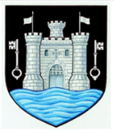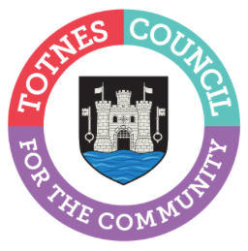

18 May 2023

TOTNES TOWN COUNCIL ANNOUNCES COMMUNITY AWARD WINNERS
Congratulations to Pat Shepherd and Food in Community, Totnes Town Council's 2023 Community Award winners.
In February 2023, Totnes Town Council invited members of the public to nominate an individual or community group that they felt should be recognised for their good works in Totnes. The responses received included people and groups who give their time in many different ways. These included: caring and supporting those in need, working with young people or the elderly, or helping people’s health and feeling of togetherness through art, exercise and sport. The nominations were reviewed by councillors in March and the winners were presented with a pewter medal featuring the town crest at last night’s Annual Town Meeting in the Civic Hall.
Cllr Emily Price, Mayor of Totnes said: “I’d like to say a huge thank you to these deserving winners of our Community Awards 2023. Their tireless work and dedication has made a positive difference to many people in Totnes and I’m proud we are able to recognise their achievements through this award. I’d also like to thank our brilliant runners up – it was a very tough job to choose just one winner in each category.”
The 2023 Totnes Community Award (Individual) nominees were:
- Katherine Alexander for “her exceptional work in developing the pub into a hub at the heart of the creative community in Totnes.”
- Claire Allford who “has, for many years, given time and energy to a variety of committees, initiatives, and events to improve the town.”
- Malcolm Curley “creator of animal sculptures for the now famous Bridgetown Safari.”
- Steve Dyer for “many years keeping the streets of Totnes clean.”
- Maggie Hawkyard who “has volunteered as a coach at Dart Amateur Rowing Club for many years and has worked tirelessly to fundraise for new premises and equipment.”
- Pat Shepherd for “her work to bring the Mansion back to life, setting it in the heart of the community and giving it a vibrant future.”
- Lisa Smallridge for “heading the save the field campaign to make sure that future generations of the community have a safe green space.”

The 2023 Totnes Community Award (Group) nominees were:
- Food in Community for “their tireless work and commitment to making sure those struggling in the town are fed.”
- South Hams Citizens Advice for “providing support and free advice to 1000s of individuals in South Hams and Totnes over many years.”
- St John’s Community Café Volunteers for “creating a wonderful, supportive, friendly environment and a safe space for so many people.”
- Totnes Tennis Club for working “worked so hard to make out tennis club a great place to play tennis for the members but more so for the community.”

- Ends

Note to Editors
For more information, please contact Lucy Ferrier, Marketing & Communications Manager at info@visittotnes.co.uk

