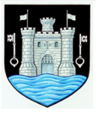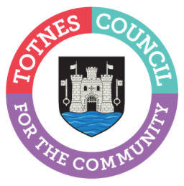
5 May 2023
TOTNES TOWN COUNCIL INVITES COMMUNITY GROUPS TO APPLY FOR A GRANT
Totnes Town Council is inviting local community groups to apply for a grant to support projects that make positive changes in the town. Over £25,000 is available. Grant applications open on the council’s website at www.totnestowncouncil.gov.uk/your-community/community-grants/ on 5 May 2023. Community organisations have until 5pm on 4 June 2023 to submit their application.
Totnes Town Council’s Clerk, Catherine Marlton, said: “The Town Council provide grants to local groups to help support their vital work in the community. As we navigate the cost-of-living crisis, the work our community groups carry out is proving to be a real lifeline for so many of us here in Totnes. I’m proud that we can help support this vital work to continue and expand by offering these grants.”
To apply for a grant, community organisations need to complete the simple form on the council’s website, which asks for details on how the funds will be spent. Projects that help deal with the current cost of living crisis or building resilience in the community will be viewed favourably. The grants are funded by a portion of the Council Tax that is collected from Totnes residents. Councillors will allocate the available funding at the Full Council meeting on Monday 3 July 2023 and successful applicants will be informed after this date.
Last year, Totnes Town Council allocated grants worth £49,000 to a diverse range of community groups including Totnes Caring, South Hams Citizens Advice, Totnes Bike Hub, St John’s Church, Inclusive Totnes and Bridgetown Alive!
If you’d like to find out more, please email: community@totnestowncouncil.gov.uk To apply for a grant, go to www.totnestowncouncil.gov.uk/your-community/community-grants/

- Ends
Note to Editors
For more information, please contact Lucy Ferrier, Marketing & Communications Manager at info@visittotnes.co.uk

