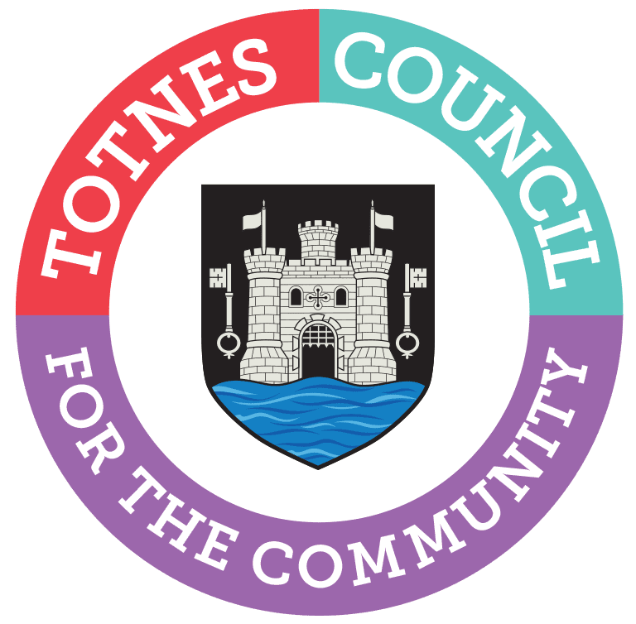

Climate & Ecological Emergency Forum
  - Date: 18th July 2023, 6.30-8.00pm
  - Venue: Guildhall, Totnes & via Zoom. The hybrid meeting will be held at the Guildhall in Totnes, behind St Mary’s Church, entrance through the old wooden Guildhall door (from 6.25pm).
  - ﻿Zoom Link: https://us06web.zoom.us/j/81907263154
  - Meeting ID: 819 0726 3154
Everyone welcome.

Agenda
  - 1. Welcome & who is here (6.30)
2. Notes and actions from previous meeting (6.35)
You can download the draft notes here: https://drive.google.com/file/...
3. Draft Terms of Reference (6.55)
4. Friends of the River Dart motion discussion (7.10)
View more information about FoRD here: https://drive.google.com/file/...
5. Transition Town Totnes - Energy Wise grant discussion (7.20)
6. South Hams emissions data presentation (7.30)
View the data here: https://docs.google.com/spread...
7. AOB (7.50)
  - Date of next meeting: 19th September 2023, 6.30-8pm

