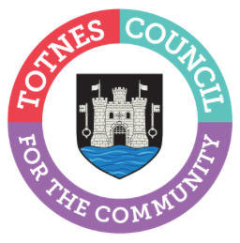

26 July 2023
Join the Community Conversation in the Market Square on Fridays in August

Totnes Town Council is currently inviting residents and business owners to have their say on priorities for the town through its ‘Community Conversation’ survey. Town Councillors will be in the Market Square on Fridays 4, 11, 18 and 25 August between 10am-2pm to answer your questions and to help anyone who needs assistance completing it.

The results of the survey will help identify the priorities for the town ahead of writing the Town Council’s Strategic Plan for 2024-30 and setting the budget for the next year. The survey can also be completed online at www.totnestowncouncil.gov.uk/community-conversation/ Paper copies of the Community Conversation survey will be delivered to all households in the town in August via Royal Mail. Additional paper copies can be picked up at Totnes Town Council's offices at 5 Ramparts Walk (behind St Mary's Church).

Cllr Emily Price, Mayor of Totnes said: "Your views really are important and will help shape what we do as a Town Council over the coming years. If you think supporting our local community groups is important, let us know. If you want to see more support for sports or the arts, let us know. Tell us what is important to you as a resident or business in Totnes. We've put into place lots of ways to complete the survey so everyone can have a chance to have their voice heard. It's quick and simple to go online and fill in the survey. You can complete a paper survey and return it to our Town Council office or come and have a chat with me or one of our other councillors in the Market Square on Fridays throughout August."

Residents have until 5pm on Wednesday 6 September 2023 to have their say. For more information, please go to www.totnestowncouncil.gov.uk/community-conversation/ email reception@totnestowncouncil.gov.uk or call 01803 862147 Mon-Fri 10am-4pm.

-Ends
For more information, please contact Lucy Ferrier info@visittotnes.co.uk or call 01803 862147

