Appendix A – An Overview of Totnes and Its Four Neighbourhoods

Introduction

- The location and physical form of Totnes has been and continues to be significantly influenced by its geography. The town developed at the lowest crossing point of the River Dart, benefitting from access to the sea and a strong defensive position. Topography helped to shape the form of the walled medieval and Elizabethan town, characterised by burgage plots which ran perpendicular to High Street and later Fore Street, producing the distinctive grain of the town centre and the east west pattern of growth eastwards across the river into historic Bridgetown and westwards along Plymouth Road.
- The arrival of the railway in the mid-19th century provided a stimulus for growth after two centuries of relative stagnation. The land between the railway and the historic town became increasingly developed but the railway line established a new barrier to movement on the north edge of the town. This remains today, funnelling east-west through traffic across the railway bridge on A385/ Station Road.
- The increasing mobility associated with the growth of motor transport in the 20th Century is reflected in the expansion of the town, primarily to the east (Bridgetown) and west (Plymouth Road and Follaton). This has also been reflected in the physical constraints to development, in particular low-lying land subject to flooding and steep hillsides surrounding the town. The approach of the landed estates surrounding the town (Dartington Hall, The Duke of Somerset and Sharpham) has also been a factor in where growth has taken place.
- Historically movement to the south of Totnes passed through the town centre via High Street and Kingsbridge Hill. Following on from initial work as part of WW2 troop and tank movements, the Western By-Pass was built in the late 1950’s and in the 1980's Brutus Bridge was constructed upstream from the older bridge. These provide an alternative route around the town, although severing some parts of the settlement from the historic core.
- These natural and man-made barriers have contributed to the creation of four distinctive neighbourhoods within the town. These are shown in Figure 1 and are recognised by local people as key elements in the make-up of present-day Totnes. They include: the Town Core; Plymouth Road and Follaton, being that part of the town which lies beyond the Western By Pass; the Northern Quarter, lying along Ashburton Rd and to the north of Station Road and Brutus Bridge; and Bridgetown on the eastern side of the River Dart.
- Each of these makes a distinctive contribution to the character of the town and reflects the varied qualities of place encountered. They provide a useful basis for identifying key strengths and weaknesses in the way the town works and managing change through the Neighbourhood Plan.

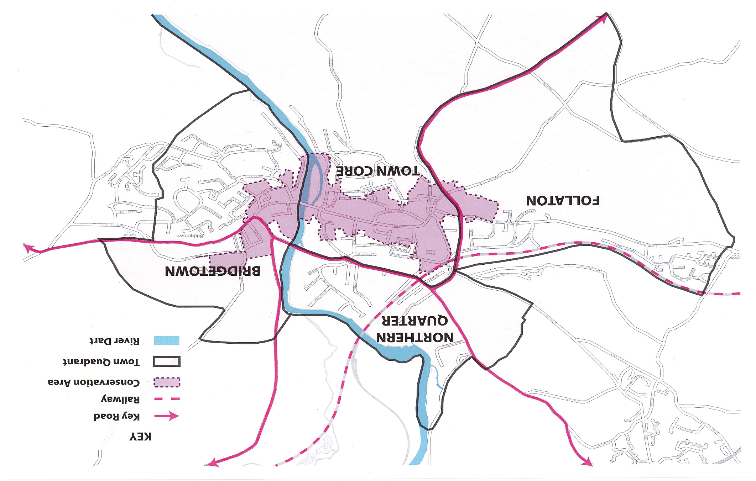
Figure 1 Map showing the four neighbourhoods of Totnes

Town Core

- The area bounded by A385 to the north, the Western By-Pass, the River Dart to the east and the parish boundary to the south can be considered as the Town Core. This includes the bulk of Totnes Conservation Area, although this extends eastwards across the town bridge into Bridgetown and for a short way along Plymouth Road to the west. The majority of the town’s retail and service companies are located in this area, which includes the High Street/Fore Street, the Narrows, the Plains and Morrison’s supermarket. It also includes the town’s main public spaces including the Market Square, The Rotherfold, St Mary's Churchyard, the Shady Garden and Library Square.
- Not surprisingly the Town Core is the main destination for shopping, trips to the community hospital, library or museum, or simply to meet people for a meal or a drink and take in the ambience of the historic town. The market town function is supported by the presence of both short term (Civic Hall, Victoria Street, Heath’s Nursery) and longer term (North Street, the Lamb, Heath Way and the Nursery) car parks and some limited on-street short term and disabled car parking. Parking is also available at Station Road and Morrisons. Both facilities are well integrated with the traditional high street.
- The demand for parking spaces is particularly high on market days (Friday and Saturday), for the monthly Good Food market, and on other occasions such as the Christmas Markets and during holiday periods. High Street, Fore Street and the Narrows are the main focus of pedestrian movement enjoying good permeability via the streets, lanes and back alleys which run perpendicular to the main spine. The steepness of the street and narrowness of the pavement gives rise to potential pedestrian/vehicle conflict in the Town Core, which also has limited disabled access in places. There has been a long running debate about the best way of managing the need for access for servicing shops and accommodating ‘pop and shop’ use of Town Core’s shops whilst offering an attractive and safe environment for pedestrians.
- There is growing consensus that the use of shared space would benefit the Town Core. It could focus initially on key public spaces such as the Market Square and St Mary’s Church, combined with periodic closures for events, as the best way of achieving the necessary behaviour change by drivers who use the High Street as a ‘rat run’ at peak hours, whilst improving the quality of the public realm to match the historic fabric of the town. The Totnes Town Council Transport Policy and Strategy sets out ideas for improvements.
- The Town Core is home to a growing residential community occupying a range of accommodation including historic properties, ‘living above the shop’ and converted riverside warehouse apartments, as well as more traditional terraced and semi-detached property. The redevelopment of Baltic Wharf is adding substantially to the stock of homes in close proximity to the facilities and services found in and around the Town Core. This adds activity and vibrancy to both the daytime and evening economy but can give rise to potential conflicts between uses, e.g. in relation to resident parking and disturbance from events and activities, which need careful management, and increased traffic congestion.
- The dense nature of the medieval core results in limited open space to serve Town Core residents and visitors. Vire Island is currently one of the few locations where access to the riverside can be enjoyed by members of the public on the Town Core side. Elsewhere Leechwell Gardens, Heath’s Garden and Castle Meadow provide attractive green oases in a sea of car parking. Community led schemes for environmental enhancement at the Shady Garden and the Rotherfold demonstrate the potential for achieving a much more attractive public realm. Proposals are being developed to make more of St Mary’s Churchyard and environs and a number of projects to improve and enhance the Market Square have been agreed in recognition of its importance as a key space in the town. This provides an opportunity to create a progression of “town squares” along the historic spine of Totnes.
- To the north and west, the Western Bypass and Coronation Road act as barriers to movement with key crossing points limited to Plymouth Road, Lower Collapark, Malt Mill, Castle Street and Station Road. There are also limited crossing points over the Dart, at Brutus Bridge which is heavily traffic dominated and the old Bridge. In contrast there are a number of footpaths and cycle routes and low-key routes (Fishchowter’s Lane, the permissive Sharpham drive and public footpath adjacent to the river) into the South Hams AONB countryside to the south of the Town Core.

Bridgetown

- Bridgetown covers that part of Totnes which lies on the eastern bank of the River Dart. From its historic core, which is designated as part of the Totnes Conservation Area and includes a range of fine buildings and terraces, Bridgetown spread up the hillside during the 20th and 21st century and has spilled over into the neighbouring parish of Berry Pomeroy. The recent development of the riverside sites known as Quayside and Camomile Lawn has resulted in building up to the parish boundary to the south and breaching skyline views from the town. To the north development has been prevented from going into the Bourton Valley which is the only area of open landscape which remains within this part of Totnes.
- To the north of the Old Town Bridge Bridgetown’s riverside comprises low lying meadows which are heavily exposed to traffic using the A385 Brutus Bridge crossing and the A381 Newton Abbot Road. To the south residential apartments front the river as far as the Caravan Park, public car park and facilities associated with the Dart pleasure boat terminus. This is a focus of significant visitor and recreational activity which extends along the river past employment units and the boat club to Longmarsh car park and recreational area, some of which lies beyond the town boundaries. This area represents the most accessible part of the town’s waterfront affording fine views across the river and down the upper reaches of the estuary.
- The A385 Bridgetown Hill forms part of the heavily trafficked and air polluted through route between Torbay and Plymouth. Congestion at peak hours results in traffic using the Old Bridge, despite traffic calming, in an attempt to avoid queues at the main junctions. The volume of traffic gives rise to elevated levels of air pollution impacting on residential properties which is reflected in the designation of this area as an Air Quality Management Area (AQMA).
- Flanking the A385 Bridgetown Hill are a number of substantial residential properties which provide a grand entrance to the town from the east. On the north side of the road lie Bourton and Jubilee Roads which include a number of large late 19th/early 20th century homes some of which have been redeveloped or subdivided, and where casual parking has become a particular concern to local residents in recent times.
- The majority of homes in Bridgetown however were developed in the post WW2 period in a number of phases. This includes former council housing and a number of areas of private development which are of piecemeal layout and design. For example, there are a large number of cul de sacs resulting in poor circulation and legibility and in places extensive on street parking impedes movement.
- This incremental approach to development, which has continued at Camomile Lawn, has resulted in Bridgetown having local facilities largely concentrated in the older part of the neighbourhood where a church, primary school, pub, convenience store with Post Office, butchers, hairdresser, dental surgery, South Hams Children’s centre and Chinese takeaway can be found. However, many people depend on travelling across the River Dart for the majority of their needs and whilst the area is served by the community bus (Bob the Bus), particularly important for elderly residents, and some local bus services, the majority of residents choose to use the car, adding to the congestion and environmental problems which beset the area.
- The ‘Chicken Run’ offers a potential green spine running through the area, although access to it is restricted. It is the subject of continued investment in children’s space to make it a more sustainable route for movement (walking and cycling) and designation as an area of Local Green Space.
- Access to the open countryside is limited by the absence of public footpaths onto and across the surrounding land forming part of the Duke of Somerset’s Estate. The exceptions to this are Longmarsh (which sits in the Berry Pomeroy parish), which is an extensively used recreational area, and Bourton Lane which provides a quiet route into the Bourton Valley.

Plymouth Road / Follaton

- This area stretches out along Plymouth Road west of the Western Bypass. A small part of the Totnes Conservation Area falls within it, incorporating a number of predominantly 19th century listed buildings. Other historic buildings include the former workhouse, now converted into residential accommodation, a medieval farmstead and most prominently Grade II* listed Follaton House, now the headquarters of South Hams District Council and other organisations. However, the Plymouth Road/Follaton neighbourhood is primarily comprised of a mix of private and social housing which was predominantly constructed in the inter-war and post war period.
- The form of development represents a long ribbon following and taking primary access from Plymouth Road and occupying the flatter land. As elsewhere in the residential areas of Totnes, development took place on a piecemeal basis with the majority of residential roads being cul de sacs. However, both Collapark and Follaton form distinct, identifiable neighbourhoods.
- Follaton benefits from access to a local shop and community hall but generally residents are dependent on facilities and services elsewhere in the town. However, the Western Bypass acts as a barrier to movement with only two pedestrian crossing points (at Plymouth Road junction and Lower Collapark). Indeed, footpath provision along Plymouth Road is not continuous and uninviting due to traffic and parked cars, and the narrowness of the pavement near the town is a problem for access e.g. parents with children and the disabled. As a result, movement is heavily car dependent, particularly from Follaton, despite the community bus services.
- The northern edge of the area is clearly defined by the main railway line and Malt Mill Lake, the brook which marks the boundary with Dartington parish. This provides a potentially valuable wildlife corridor and possible green travel route, particularly if it could incorporate the valley floor.
- To the south of Plymouth Road and Follaton lie the steep slopes occupied by Broomborough Farm. These form an important backdrop to the town in its landscape setting and have been consistently considered inappropriate for development. The recent development at Follaton Oak demonstrates the challenges of building on such slopes in terms of the extensive site works and slope stabilisation required.
- The Arboretum at Follaton House and the historic route up Harpers Hill, which provides a play area and community orchard, provide important opportunities for informal recreational activity and access to the countryside which need to be protected. Clusters of informal accommodation found in this area must not form the basis for inappropriate development in the countryside. Elsewhere public green space provision is limited to a Woodland Trust area at Harpers Hill, informal gardens at Broomborough, local play areas, a small cluster of allotments and the town cemetery.
- Follaton House represents an important but diminishing source of employment in Totnes and is the administrative centre for the South Hams. With a trend towards shared services and joint authorities there must be some uncertainty over its future. This could impact on the use and function of the buildings and surrounding land, much of which is occupied for parking for staff and visitors.

Northern Quarter

- The Northern Quarter is occupied by a range of uses which have an important role to play in the success of Totnes as a market town. These include King Edward VI Community College (KEVICC) which occupies land on either side of Ashburton Road; the Police Hub close to Redworth junction; the mainline railway station which handles around 700,000 passengers a year and is the key rail gateway to the South Hams; the Industrial Estate which accommodates a range of employers and services including Leatside surgery and the civic amenities site; Borough Park sports pitches and associated leisure facilities; several car parks; and access to the Dart Valley Steam Railway and Rare Breeds Farm tourist amenities.
- In addition to these facilities the Northern Quarter contains pockets of housing, most notably at Babbage Road/Borough Park Road/Coronation Road, Weirfields/Redworth Terrace and Swallowfields. Recent development has taken place beyond the parish boundary at Puddavine with additional proposals planned at Dartington Lane and on the Transition Homes site. However, there is a shared objective to maintain a green buffer between Totnes and Dartington.
- The Northern Quarter faces the prospect of significant change through development during the period of the Neighbourhood Plan reflecting the presence of sites with planning consent or allocated for development as set out in the JLP. These include:
    - Development on the former Dairy Crest site, with a proposed mixed-use regeneration scheme to deliver the restoration and reuse of Brunel’s listed atmospheric railway building as well as affordable and older persons housing, a hotel, and employment spaces.
    - Land owned by KEVICC for residential-led development for 130 new homes, now subject to review by the School which is exploring plans to upgrade its facilities for the future.
    - Changes in occupation and use on the Industrial Estate which continues to adapt to the evolving needs of businesses and service providers.
    - Potential improvements to the swimming pool and leisure facilities at Borough Park.
    - Potential for the rationalisation of emergency service facilities serving the town (Police, Fire and Ambulance Services).
- Development in this part of Totnes faces a number of challenges, most notably connected with the traffic congestion and resulting poor environmental conditions associated with through traffic. This is most acute at the Coronation Road Roundabout and Redworth Junction. However, the Northern Quarter benefits from good access to public transport services (rail and bus) and is relatively close to the facilities and services which the town has to offer, being served by footpaths and cycleways. However, despite the presence of signalled pedestrian crossings road traffic acts as a barrier to sustainable movement.
- The low-lying nature of much of the area also creates a risk of flooding. Work has been completed by the Environment Agency to strengthen flood protection along the River Dart. This creates the opportunity to enhance the quality and accessibility of the riverside walk and cycleway, and maintenance of the access for all path specifically designed to accommodate the disabled and visually impaired, as well as cycles and pedestrians.
- Environmentally the Northern Quarter fails to provide an attractive sense of arrival to the town despite fine views of the historic town centre (Totnes Castle and St Mary’s). Ashburton Road lacks a clear character and is heavily impacted visually by the KEVICC overbridge and lines of queuing traffic. The railway station is also dominated by the presence of cars and buses and, with the exception of the historic signal box and canopies, indifferent buildings and a plethora of signs. Little advantage is taken of the presence of the nearby Borough Park and links to the town centre are difficult to navigate.

The River Dart

- Totnes is a riverside town. The River Dart continues to play an important role in the life of Totnes which is where rainfall draining from the high ground of Dartmoor meets the tidal waters of the Dart Estuary. The ebb and flow of the tide which reaches the town weir creates an ever-changing scene and emphasises Totnes’ links to the sea which were the source of much of its prosperity. Signs of these links still exist today in the clustering of converted historic warehouses, the presence of boatbuilding and the regular pleasure boat trips and sailors to and from Dartmouth.
- Over the centuries man has sought to derive benefit from the resources the river bestows. This has included draining marshy land for development, engineering structures (bridges, weirs, quay walls, and slipways), creating water abstraction and discharge points and constructing buildings to take advantage of access to the water and views. This exposes parts of the town to the risk of both fluvial (river) and tidal flooding, which is increasing as a result of climate change and sea level rise. The Environment Agency has completed works to provide enhanced flood protection along the banks of the Dart but flood risk is an ongoing consideration for planning in Totnes.
- The primary use of the river in Totnes is recreational. The town weir is the focus for informal swimming from what is effectively the town beach. In addition, the weir is the site of an Archimedes Screw installation which provides a source of renewable energy. The river also accommodates moorings and is used for rowing and canoeing above and below the weir for which access points, parking and boat storage are important. Events such as the Longmarsh Canoe Festival, the Head of the Dart, Totnes Regatta, Duck Race and Dart 10k swim attract many visitors to Totnes. The management of water use below the town weir is the responsibility of the Dart Harbour Authority. Any works or structures below the mean high-water level for spring tides requires licensing by the Marine Management Organisation.
- The river divides Bridgetown from the rest of the town but can be crossed by the Old Bridge and Brutus Bridge. Brutus Bridge is dominated by through traffic and is an unattractive route for pedestrians. The Old Bridge offers a better alternative, but the pavements are narrow resulting in potential conflict with vehicle movement. A footbridge upstream from the railway bridge gives access to the Steam Railway and Rare Breeds farm.
- Movement along the river is facilitated by mixed sections of footpath and cycleway. To the north of the Old Bridge this runs on the west side of the Dart, while to the south public access is mainly limited to Vire Island and Steamer Quay on the east side of the river. Riverside routes are of variable quality both in terms of access for people with disabilities and the quality of the adjacent environment. There are significant opportunities for improvement.
- Significantly the River Dart provides an opportunity for better integrating three of the town quarters (the Town Core, Bridgetown and the Northern Quarter) and helping to shape the character and quality of potential sites and key parts of the town, including: Dartington Lane/Plantation (part of which falls within the town); the industrial estate; and Steamer Quay.

