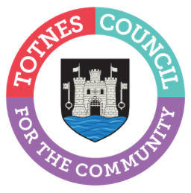
24th October 2023
Funding for community events in Totnes

Totnes Town Council is immensely proud to have been able to find funds and provide support for community events in Totnes in the last couple of years, including the Summer Fair this year and Totnes Festival last year. The Totnes Festival brought theatre into the community through lockdown in a way that was almost unique across the country at the time, but which was so essential during and after such a difficult period.

We are now seeing a very welcome and much needed revival of ideas locally, including a planned repeat and development of Totnes Festival in 2024, Bridgetown Alive planning a summer festival next year, and a resurrection of lantern processions being facilitated by tireless community volunteers.
The Town Council has been asked for up-front funding for some events next year. As the Council is currently in the midst of agreeing our strategic priorities for the next three years, and because budgets are allocated so far in advance, we are simply unable to award anything until the 2024/25 budgets are finalised. With that said there are many members who have supported the development of community arts in town who will be advocating for this to continue, assuming that finances allow.

Cllr Piper, Chair of the Arts Working Group, added: “It is so heartening to hear that the Totnes Festival (with NDP Circus) and Bridgetown Alive are gearing up for 2024 events. Whilst I know the current challenges around funding will leave some disappointed, it is important that we balance all the needs of the local community through the setting of our strategic priorities. I for one am very hopeful that the value added by community events will be clear to see when we do set the budget going forward. We really want to thank all the local volunteers and groups who have worked so hard on developing these ideas. I can think of nothing better than Totnes having a full and wide-ranging series of events. It is long overdue for visual and performing arts featured more prominently in Totnes.

“In the meantime, the staff team will continue to provide support and marketing for anyone wishing to join in our cycle of seasonal events. If you would also like to be considered for funding in future years, please do contact them via: reception@totnestowncouncil.gov.uk to ensure that your ideas and requests can be heard and carefully considered. If we have your contact information we can forward external funding opportunities as we receive them. We also have a page on our website highlighting grant opportunities: www.totnestowncouncil.gov.uk/your-community/funding-opportunities/”

-Ends
For more information, please contact Lucy Ferrier info@visittotnes.co.uk or call 01803 862147

