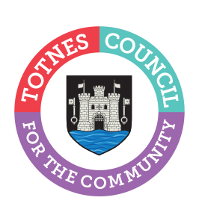

Community Awards Policy
TOTNES TOWN COUNCIL
AGREED 2ND OCTOBER 2023
NEXT REVIEW OCTOBER 2025

In March 2022 Totnes Town Council launched its Community Award scheme to recognise the efforts of individuals who volunteer their time to help or enrich the lives of others in the community.

This policy sets out: the categories of award; eligibility; nomination process; Council consideration of nominations; format and presentation of awards.

Categories of Award

There are two categories of Community Award:
- Individual award; and
- Community group award.

Eligibility

Nominations should be for individuals or community groups that are carrying out their work within the Totnes parish boundary.

Individual Town Councillors and council officers are not eligible to receive an award under this scheme and any nominations for them (regardless of whether they are acting outside of their council role) will be discounted.

Nomination Process

Nominations are invited from members of the public and Councillors to propose one name per category for those who they consider deserve recognition for the time they give to the community. This could be through a number of different ways, for example: caring and supporting those in need; working with young people, the elderly or vulnerable; helping people’s health and feeling of togetherness through exercise and sport.

Nominations can be made by email, in writing, by telephone or in person.

The timeline each year for the nomination process is as follows:

- February - nominations will be invited from the public through the Totnes Directory, Town Council Website and Social Media with a closing date of mid-March.

Council consideration of nominations

The timeline for Council consideration of the awards each year is as follows:

• End March - Town Matters Committee will consider the nominations received in Part 2 of the meeting, and make a shortlist of recommendations to Full Council.
• April - Full Council considers Town Matters Committee recommendation.

Format and presentation of awards

Depending on the number of nominations received, the top three nominees in each category (as determined by Full Council) will be invited to attend the Annual Town Meeting in May where the awards will be presented.

Council officers will write to all nominees informing them that they have been nominated and depending on numbers inviting them to attend the Annual Town Meeting.

Certificates will be produced and presented to all nominees, the runner up and winner in each category.

The winners of each award will be presented with a medal based on the town council logo, engraved on the back with the year, name of the winner and the category of award. The individual medal will be presented on a ribbon and the group medal in a presentation box.

All medals and associated costs will come from the Civic Events budget.

