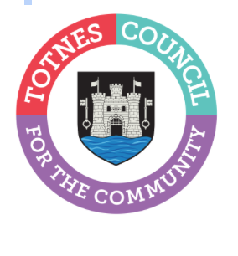

16 November 2023
Free Family Fun at the Totnes Christmas Lights Switch On Event

This year’s Totnes Christmas Lights Switch On takes place on Tuesday 28th November between 3pm-6pm in the Market Square and Civic Hall. This free, family-friendly, community event is organised by Totnes Town Council. There will be entertainment and children’s crafts to enjoy before the Christmas Tree lights in the Market Square are officially switched on by the Mayor of Totnes – Councillor Emily Price - at 5:30pm.

Cllr Emily Price, Mayor of Totnes, said: “This is such a special event to get the community together at the start of the festive season. I love to see so many of the town’s kids and their families at the Civic Hall, making Christmas crafts and getting excited about the coming celebrations. The moment when the lights on the tree are switched on really does herald the start of Christmas for me!”
Free activities include making crowns and having bouncy festive fun in the inflatable snow globe. There will also be a chance to make your own jam-jar lantern to take home, which you could then also use if you want to take part in the Totnes Carnival Lantern Procession on 19 December. Please BRING YOUR OWN JAM JAR and we’ll provide the rest of the materials to create a colourful lantern, including a battery-operated tea-light to make it glow. Children can bring along a letter for Santa to post in the box in the Civic Hall and you never know, Father Christmas might even make a special appearance! There will also be singing from the Year 6 classes at Totnes St John’s and The Grove Primary schools. Finally, stilt walkers, Totnes Brass Band, and two performances from Elfic the Jester will all ensure the festive fun is flowing throughout the afternoon.

Refreshments will be available courtesy of Pizza Pirates at a subsidised cost. Pizza will be sold at £1 per slice (numbers limited, first come, first served). For anyone who needs transport to and from the event, Bob the Bus will be running a free service between Bridgetown Spar, the Market Square, and Follaton Stores. Please see timings below.

Bridgetown Spar: 4:00pm, 5:00pm, 6:00pm and 7:00pm
Market Square: 4:15pm, 4:45pm, 5:15pm, 5:45pm, 6:15pm and 6:45pm
Follaton Stores: 4:30pm, 5:30pm, 6:30pm

To find out more about the event email reception@totnestowncouncil.gov.uk or look on our website: www.totnestowncouncil.gov.uk/

-Ends
For more information, please contact Lucy Ferrier info@visittotnes.co.uk or call 01803 862147

