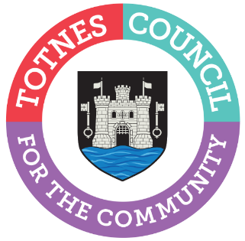
Totnes Town Council

Traffic, Transport and Pedestrian Policy 2023
Unformatted version

Summary

- Totnes is situated at the junction of roads linking Torbay, Plymouth, Exeter, Newton Abbot, and Kingsbridge/Dartmouth. The town is a significant pinch-point as the Brutus Bridge is the only substantial river road crossing for traffic travelling between Plymouth, the southern South Hams and Torbay. Developments within and around Totnes, especially Torbay, have an impact on town traffic.
- This document is intended to outline Totnes Town Council’s (TTC) position relating to traffic, transport and pedestrians in the town and neighbouring parishes. It outlines our vision, three key aims, three core objectives, and fifteen key actions.
  - Our vision is to ensure: sustainable and accessible travel for all; safe and healthy streets; and a pleasant, prosperous and vibrant town.
  - Our three key aims are: access for all; sustainability; and community engagement.
  - We have outlined three core objectives with 15 linked actions to achieve these. The three core objectives are:
    - Increase, and improve access to, active travel
    - Reduce the volume of through-traffic in the town centre
    - Enable traffic to move through town along the A385 and A381 as efficiently as possible
- The Traffic & Transport Forum have created a ‘hotspot map’ that helps to identify problematic areas in town. It seeks to highlight issues rather than suggest solutions. It has helped to inform this Policy.

- Appendix B contains an overview of current and potential projects that will help us achieve our aims and objectives, and which are supported by TTC Councillors. This will be updated regularly so the public can follow developments and as new projects are identified.

Contents
1. Introduction 4
2. Relevant Transport Plans 5
3. Glossary 7
4. Current situation & key issues 8
5. Public Sector Equality Duty 9
6. Vision 10
7. Aims 11
8. Objectives & key actions 13
9. Implementation, Monitoring and Evaluation 15
Appendix A: Maps of geographical boundaries and road networks 16
Appendix B: Current and potential schemes, projects and issues 19

List of figures
Figure 1: Transport hierarchy 11
Figure 2: Map illustrating boundary of 'Town Centre'. 16
Figure 3: Map illustrating boundary of area and key villages 17
Figure 4: Strategic road network around Totnes 18
Figure 5: Strategic road network in the South West 18

Introduction
5

This document is intended to outline Totnes Town Council’s (TTC) position relating to traffic, transport and pedestrians in the town and neighbouring parishes (see Appendix A for a map of geographic boundaries). The Traffic, Transport and Pedestrian Policy will be referred to in this document as ‘the Policy’.

The Policy explains TTC’s vision, aims, core objectives and key actions. It also contains a list of current and potential projects aimed at delivering these.
All action must align with efforts to mitigate and adapt to climate change and the ecological crisis, as explained in the Devon Carbon Plan.

Reference should be made to this Policy alongside other planning guidance when considering all future plans and developments in the town. Decisions made should be in keeping with these principles. This information will help inform Devon County Council (DCC) and South Hams District Council (SHDC) in the context of considering travel schemes submitted for s106 grant funding which would benefit the Totnes area.

This Policy has been drafted within the context of several transport plans as listed in section 2. It will be reviewed every three years. Information on the associated schemes listed in the Appendix and other relevant transport plans will be updated every six months.

Relevant Transport Plans

Devon Carbon Plan, 2022
https://devonclimateemergency.org.uk/view-devon-carbon-plan/

Devon County Council Electric Vehicle Charging Strategy
Draft, consultation document
https://devoncc.sharepoint.com/sites/PublicDocs/Corporate/HaveYourSay/Forms/AllItems.aspx?id=%2Fsites%2FPublicDocs%2FCorporate%2FHaveYourSay%2FTransport%2FEV%20charging%20strategy%2FDevon%20EV%20Strategy%20consultation%20draft%2Epdf&parent=%2Fsites%2FPublicDocs%2FCorporate%2FHaveYourSay%2FTransport%2FEV%20charging%20strategy&p=true&ga=1

Devon County Council Transport Infrastructure Plan: Delivering Growth in a low carbon environment
March 2020, prepared by DCC
https://democracy.devon.gov.uk/documents/s30349/Transport%20Capital%20Programme%20Reportv%20-%20Appendix%20II.pdf

Clean Air Strategy 2018
Prepared by South Hams District Council
https://www.southhams.gov.uk/media/3014/2018-Clean-Air-Strategy/pdf/Clean_Air_Strategy_2018.pdf?m=637922753090270000

Plymouth and South West Devon Joint Local Plan, 2014-2034
https://www.plymouth.gov.uk/adopted-plymouth-and-south-west-devon-joint-local-plan

Devon and Torbay Local Transport Plan 3 (LTP 3), 2011-2026
Devon County Council
https://www.devon.gov.uk/roadsandtransport/traffic-information/transport-planning/devon-and-torbay-local-transport-plan-3-2011-2026/

Totnes: Movement, safety and pedestrian comfort in the town centre
July 2012, prepared by Hamilton-Baillie Associates Ltd for the Totnes on the Move Community Board, in association with Jacobs UK Ltd on behalf of Devon County Council.
Note: This report focuses on Shared Space which the government placed a moratorium on in 2018.
Document not available online but can be requested from TTC Sustainability Officer: greentravel@totnestowncouncil.gov.uk

Totnes Transport Strategy
December 2012, prepared by Jacobs for Devon County Council
https://www.plymouth.gov.uk/sites/default/files/A385TotnesCorridorStrategyReport.pdf

Glossary
2

Active Travel Making journeys in physically active ways, such as walking, wheeling and cycling.
DCC Devon County Council
HATOC Highways and Traffic Orders Committee (Devon County Council)
SHDC South Hams District Council
The High St Refers to Fore St, High St & the Narrows
The Policy Traffic, Transport and Pedestrian Policy
Through-traffic Refers to traffic that is purely passing through town
Cut-through traffic Traffic that passes through smaller residential streets that has neither an origination nor destination point in that neighbourhood
Town Centre See map in Appendix A
TTC Totnes Town Council

Final version to link words in body with glossary.

Current situation & key issues
- Totnes is situated at the junction of roads linking Torbay and Plymouth (A385), Exeter (A384), Newton Abbot (A381) and Kingsbridge/Dartmouth (A381). The Brutus Bridge is the only substantial river road crossing for traffic travelling between Plymouth, the southern South Hams and Torbay. It is therefore a significant pinch-point.

When the Brutus Bridge was built in 1982 it was met with objection: it was felt it should have been constructed further upstream, in line with the Kingsbridge Hill Western By-pass, in order to take through-traffic away from the town centre. Its present location has failed to achieve this, and traffic congestion in the town continues to be an increasing problem and a source of considerable frustration.
- The 2012 Totnes Transport Strategy states that approximately 70% of traffic on the A385 is through-traffic. More up-to-date data is needed, both of traffic volumes/speeds and pollution – these must monitor side routes as well as the A385 due to the impacts of satnavs.
- It is anticipated that there will be an increase in the number of private cars due to developments in Torbay, Teignbridge, and the South Hams. An increase in delivery vehicles is also expected. In addition, tourism leads to considerable surges in traffic numbers during the holiday seasons.
- Public consultations and workshops have shown that there is a desire amongst the community for a reduction in cut-through traffic in town and that this must be considered holistically. Cut-through traffic impacts not only the High St but also other roads. Any action taken must consider the interplay between these.
- The A385 through Dartington and Totnes has been a designated Air Quality Management Area (AQMA) since 2008 due to high levels of nitrogen dioxide. More information about AQMAs can be found here: southhams.gov.uk/article/3902/Air-Quality
- There are significant constraints on the uptake of cycling locally due to high volumes of traffic on narrow roads and a lack of safe cycling infrastructure. The Devon and Torbay Local Transport Plan 3 acknowledges the need to create a fully linked up local cycle path network. This needs to extend to outlying villages, particularly since the surge in e-bike popularity has made commuting by bike more viable over longer distances and hilly terrain.
- There has been a long-standing controversy about the presence of cars on the High Street. This is in part due to the narrowness and absence of pavements in certain sections which makes access for shoppers and other pedestrians difficult and unsafe, especially for those with additional needs. This has been exacerbated by continuing increases in cut-through traffic. On the other hand, there are valid questions around maintaining accessibility to shops, particularly for those with mobility issues and for deliveries.
- This Policy acknowledges the need for: continued access for residents to their residences; continued access for emergency and delivery vehicles and community transport; the need for easy access for pedestrians, particularly disabled access; the need for adequate vehicle access and parking overall in the town to support trade; and a desire to improve the pedestrian experience in the town centre and other streets in the locality.
- Most homes in the centre of Town do not have their own off-street parking and must therefore park in car parks or on-road.
- The last 20 years have seen significant changes in driver behaviour. The introduction of satnavs has had a particular impact, increasing traffic along smaller and residential roads. Excessive traffic along residential routes impacts on day-to-day wellbeing and the desire for peaceable living for residents: noise and air pollution; risk of harm from aggressive/speeding drivers and behaviours if challenged; fearful experiences of crossing key walking/wheeling routes. A map has been created to identify key traffic/safety hotspots across town (rb.gy/c6w7l).

Public Sector Equality Duty
The Town, District and County Councils are bound by the Public Sector Equality Duty which requires due regard to be given to: the need to advance equality of opportunity between people who share a protected characteristic and those who do not, removing or minimising disadvantages suffered by people due to their protected characteristics, taking steps to meet the needs of people from protected groups where these are different from the needs of other people, and encouraging people from protected groups to participate in public life or in other activities where their participation is disproportionately low. Protected characteristics include age, disability and maternity and pregnancy.
Totnes Town Council will always strive to eliminate discrimination, advance equality of opportunity, advance good relations between those sharing protected characteristics and those who do not. Decisions relating to this Policy will be informed by transparent and appropriately rigorous equality impact assessments and the Council will always investigate how negative impacts may be mitigated (Equality Act 2010).

Vision

Sustainable and accessible travel for all | Safe and healthy streets | A pleasant, prosperous, and vibrant town.

Aims

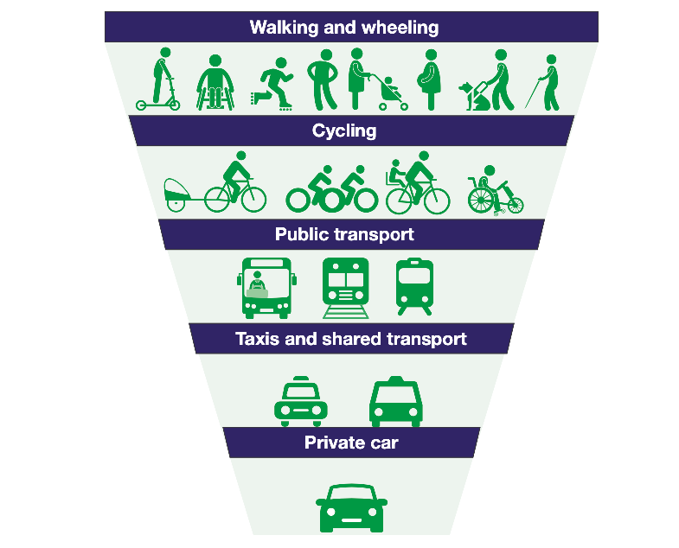
- Access for all
Figure 1: Transport hierarchy (Source: Transport Scotland)

Our primary aim is to address the travel needs of:

- Residents in Totnes and its 15-parish hinterland who depend on the town for provisions, services, and employment.
- Those with additional travel needs or who experience greater barriers in safely accessing and using pedestrian infrastructure. This could be for reasons of age, disability, or other protected characteristic; income; or who through choice do not have access to private transport.
- Businesses and their customers who need access to premises, including organisations and companies providing services and deliveries to the town.
- People who come from a wider area and who contribute to the local economy.

- Sustainability

We will:
- Promote the reduction of fossil fuels in meeting transport needs.
- Reduce the need to travel by motorised vehicle.
- Prioritise and promote transport based on the hierarchy illustrated in figure 1.

- Community Engagement

We will:
- Consult and engage widely with residents on transport proposals that will affect travel, parking, and traffic in and around Totnes.
- Give due regard to the Public Sector Equality Duty by designing consultation and engagement activities to be accessible to all, based on universal design and reasonable adjustment principles.
- Work in partnership with community groups that have a transport remit, statutory authorities, and other relevant authorities.
- Link with Neighbourhood Plans to create and propose implementation of strategic sustainable transport measures.

Objectives & key actions
4

Our core objectives are to improve health, wellbeing and air quality by:
- increasing, and improving access to, active travel
- reducing the volume of cut-through traffic in the town centre
- enabling traffic to move through town along the A385 and A381 as efficiently as possible
Below are 15 key actions that will underpin these objectives. These are of equal importance as no one on its own can achieve the desired outcomes.

Key actions
  - Require comprehensive transport assessments and mitigating green travel plans/measures for all planning developments that are likely to generate significant amounts of travel, or where there may be local traffic problems associated with a planning application. In addition, monitor these plans and hold developers to account for their implementation.
  - Engage and collaborate closely with SHDC, DCC and other councils/stakeholders to ensure they fully understand the issues and contexts of Totnes, and how measures/developments elsewhere directly and indirectly impact the town. Seek to hold others to account for policies or decisions that can be expected to impact negatively on traffic volumes and congestion in the town.
  - Advocate for effective action to improve the air quality in Totnes and surrounding area and to address unlawful levels of air pollution in the Totnes Air Quality Management Area by the relevant duty-bearers.

  - Encourage more walking and cycling in the town and surrounding parishes by promoting proposals that improve and extend the footpath and cycleway network, as well as any other relevant projects such as cycle infrastructure, quiet lanes, and so forth.
  - Support improvements to the safety, accessibility, and experience of pedestrians across town, with particular attention to roads and routes that are disproportionately affected by cut-through and through-traffic and particular attention to the access and safety of people with protected characteristics. For instance, through safety improvements to existing paths, opening cut-throughs, making space for separated cycle paths, connecting quiet roads to walking routes, leisure amenities, and the surrounding parishes.
  - Support the expansion of car clubs, and car and bike sharing.
  - Support and expand local community transport to provide sustainable travel within town as well as to and from communities surrounding Totnes.
  - Support proposals that improve accessible and reliable public transport. Seek to protect and improve local and national rail and bus routes through lobbying DCC, government, rail and bus companies, and the Local Enterprise Partnership.
  - Promote transport exchange hubs which support public transport and other sustainable modes. This requires a strategic integrated initiative in association with neighbouring areas and private transport providers.
  - Support and propose schemes to reduce and limit the negative impacts of through-traffic in town, taking a holistic approach that considers not only the A385 and High St but the town as a whole.
  - Support suitable traffic reduction and speed restriction measures in and around the town, ensuring the town is properly consulted. Proposals need to ensure lengthy traffic jams at key spots are avoided so that Totnes doesn’t become a 'no go' zone for visitors and shoppers.
  - Support our traders, residents, and visitors with measures to ensure adequate parking and easy access to the town centre.
  - Support SHDC and DCC in the suitable expansion of electric vehicle chargepoints.
  - Support schools and other organisations to develop green travel plans if they do not already have them, and work with them to implement these.
  - Consult with residents through the TTC community engagement policy and debate at the Traffic and Transport Forum.

Implementation, Monitoring and Evaluation
4

  - Statutory authority
While TTC can seek and promote traffic projects and schemes, all projects relating to roads must be approved by DCC as the local Highways Authority. DCC have a statutory duty to produce a Local Transport Plan (LTP). The current LTP 3 2011-2026 can be found via the link in section 2.

TTC must therefore liaise closely with DCC to progress projects that require DCC support. This is primarily done through the DCC Highways and Traffic Orders Committee (HATOC) for the area: the South Hams HATOC. These meetings take place approximately three times a year.

  - Progressing action
TTC primarily develops and progresses actions relating to the schemes outlined in Appendix B through the Traffic & Transport Forum and Steering Group, as well as through projects led by the Sustainability Officer. The Forum is an advisory group to TTC and TTC Councillors ultimately decide whether to support the recommendations they make.

The Hotspot Map is a live document used to identify priorities and how they change over time. This can be found here: rb.gy/c6w7l

  - Reviews and updates
This Policy will be reviewed and evaluated every three years. Information on the associated schemes listed in Appendix B and other relevant transport plans will be updated every six months.

  - Infrastructure Levy
The Levelling-up and Regeneration Bill was introduced to Parliament on 11 May 2022. In this Bill the government intends to replace section 106 agreements and the existing Community Infrastructure Levy (CIL) with a new Infrastructure Levy which is aimed to help councils to bring forward more affordable housing. The thresholds and rates of the new Infrastructure Levy would be set in charging schedules set and raised by local planning authorities (rather than nationally), meaning that rates would be tailored to local circumstances. It is noted that some aspects of this Policy may need updating to reflect this new situation if the Bill becomes legislation.

Appendix A: Maps of geographical boundaries and road networks
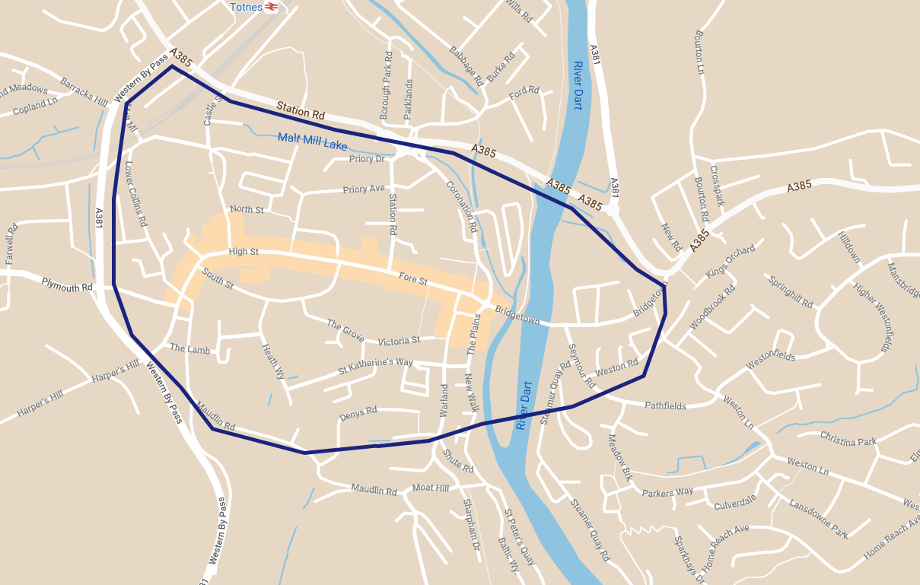
Figure 2: Map illustrating boundary of 'Town Centre'.
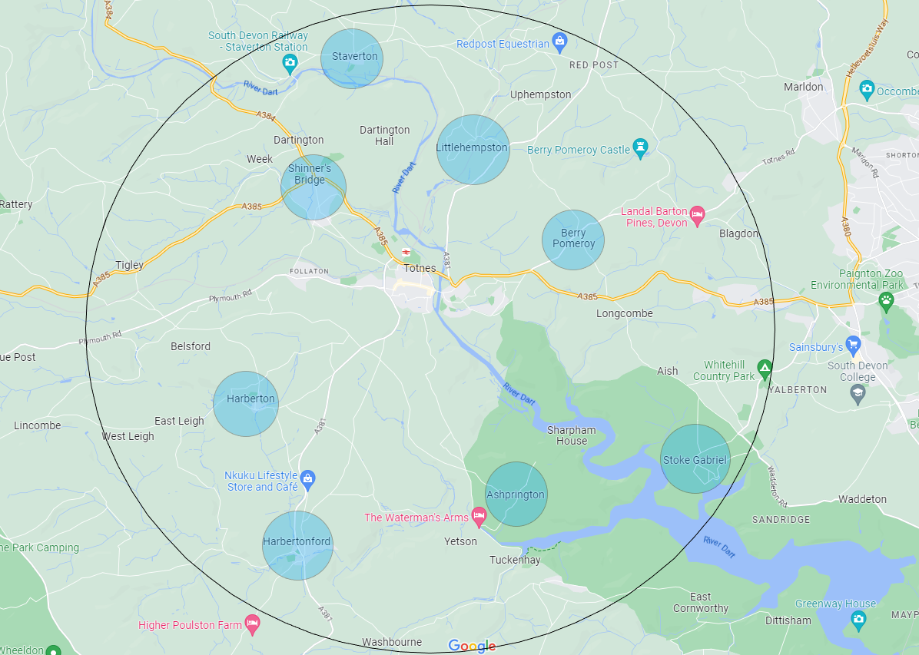
Figure 3: Map illustrating boundary of area and key villages
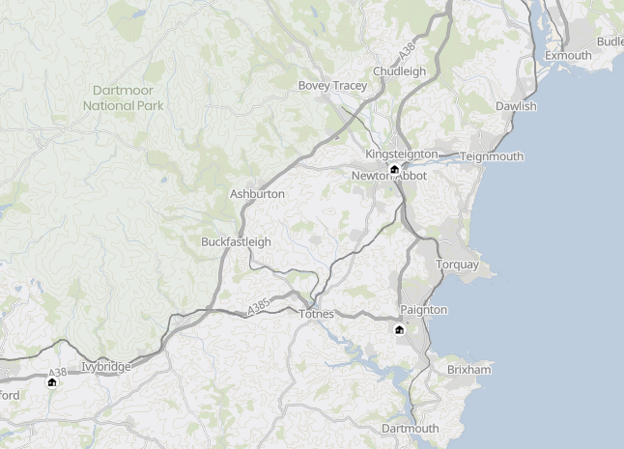
Figure 4: Strategic road network around Totnes (Source: National Highways)

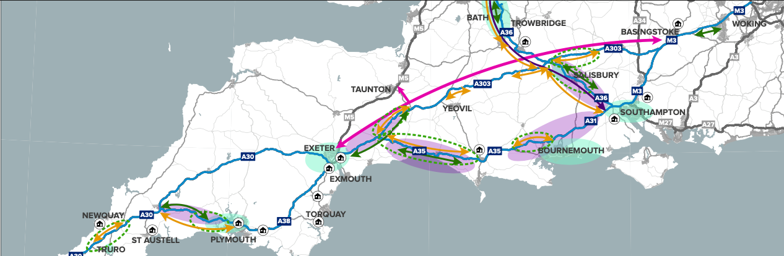
Figure 5: Strategic road network in the South West (Source: National Highways)

Appendix B: Current and potential schemes, projects and issues
Our core objectives are to:
- Increase active travel
- Reduce the volume of through-traffic in the town centre
- Enable traffic to move through town along the A385 and A381 as efficiently as possible

Some of the schemes that might achieve these ambitions may not yet be known – new projects will be added as they emerge. The hotspot map will be used to reconfirm priorities as time goes on and contexts change.

Projects not listed in any particular order. Projects will be prioritised at a later stage with DCC guidance.

Projects & schemes
Number | Scheme | Feb 2023 update comments / notes | Linked key action | Status | Priority level (TBD)
1 | Engagement with DCC and other councils/stakeholders  Collaborate closely with DCC and other councils/stakeholders to ensure understanding of issues in Totnes and ensure a holistic approach. | N/A | 8.2 | Ongoing
2 | E-bikes  Needs to be a commercial venture. | Year-long e-bike trial to commence in 2023 in collaboration with Exeter-based social enterprise, Co Bikes. Funding awarded (to Co Bikes) by SHDC Climate Infrastructure Fund, GWR and TTC. Start date TBC. Challenges in finding a suitable location for a charged docking station.  UPDATE: Co Bikes have ceased operating as of July 2023. E-bike trial still desirable but unlikely to go ahead as grant money likely lost and no other viable contenders to take it on. | 8.3, 8.4 | To start in 2023
3 | Community Transport: Bob the Bus:  Promotion and publicity to encourage more passengers, to widen the demographic appeal and further extension of the service. | TTC in regular dialogue with Bob the Bus to support both financially and with officer time. | 8.7 | Ongoing
4 | Explore possibility of produce a ‘Walking and Wheeling Safety Audit’ of Totnes as a whole. To help inform future improvements, such as adding more zebra crossings. | Expanded from walking safety audit to incorporate accessibility and cycling. Needs to link closely with A10.  Important to liaise with DCC prior to any work.  To include potential for additional pedestrian crossings, such as on Bridgetown Hill (which is particularly pertinent with recent bus route changes.) | 8.4, 8.5 | TBC / 2023
5 | Support and collaborate with Totnes Bike Hub | TTC have supported TBH via grants and through officer time. | 8.4 | Ongoing
6 | 20mph speed limit zones in all town and village centres (including arterial routes that traverse these centres) where this measure has been sought by the local Parish Councils &/or Neighbourhood Plan Groups. (and A385) | DCC in charge as Highways Authority.  In March 2022 TTC applied to DCC to be a part of new pilot schemes – submitted expression of interest for gaps in 20mph zones to be plugged. Unsuccessful but DCC will be adding more schemes in 23/24.  Hopefully DCC will learn from Cornwall Council’s pilot schemes that are proving very popular.  Sustainability Officer actively pursuing this through supporting a Devon wide campaign. | 8.4, 8.5 | Ongoing
7 | Monitor and publicise air quality data.  Both along AQMA and elsewhere in town.  Work with residents/traders/schools to install air quality monitors widely across town. | Air quality monitor (IQAir AirVisual Pro) being installed by Town Maintenance Officer on High St in February 2023.  Three mobile monitors available to borrow from TTC. | 8.3 | TMO to install 15 March 2023  Data will be available to view online when fully installed
8 | Cycling infrastructure improvements  Bike parking | Bike parking map created and continuously added to.  New bike racks.  Covered bike parking.  Potential for storage lockers. | 8.3, 8.4, 8.5, 8.6 | Ongoing
9 | Support local schools and organisations to develop Green Travel Plans | Sustainability Officer and TTC Councillor collaborating to engage with schools. | 8.14 | Ongoing
10 | Hotspot map  Expand and share more widely the hotspot map, which identifies problematic areas in town. Be mindful of ensuring a wide range of views are considered so that problematic areas aren’t ignored. |  | 8.2, 8.15 | Ongoing
11 | Consultant assessment  Explore possibility of TTC commissioning an expert consultant’s assessment of traffic issues and options for the town. This would incorporate the hotspot map as part of the brief and be linked to the overarching ambitions. |  | 8.3, 8.4, 8.5, 8.10, 8.11 | Yet to be explored
12 | Pedestrian crossing at the Lamb | HATOC currently investigating how TTC could go about funding it separately from DCC. See HATOC minutes from 4.11.2022. | 8.4, 8.5 | Ongoing
13 | Explore possibility of pedestrian crossing at top of Bridgetown Hill  This is mentioned in the SHDC Clean Air Strategy 2018 (pp. 7 & 38).  With the changes to the GOLD bus route (route no longer through Bridgetown) this is needed more than ever to ensure safe crossing for those using bus stop on hill. |  | 8.4, 8.5 | Start date TBD
14 | Kingsbridge Hill proposal  Ending through-traffic, via low-cost change of road layout.  Moving location of 40mph speed limit sign near top of hill below Windrush, to new position at T-junction with Western Bypass at top of hill. | Kingsbridge Hill Area Residents Association (KHARA) are pursuing the possibility of closing off the top of the hill to traffic from one direction, making the top one-way only. Supported by Traffic & Transport Forum in April 2022 meeting.  DCC Cllr Hodgson requested it be put on HATOC agenda July & November 2022 but denied by DCC.  Campaign is ongoing. | 8.4, 8.5 | Ongoing
15 | Explore options for Plymouth Road  Lack of safe routes into town for Follaton residents due to lack of pavements and crossings, particularly at each end of the road.  Drivers often go too fast, speed camera not in operation.  Potential for more pedestrian crossings. | No action since 2019/2020. Still a real issue, however, and recommend it is kept in. Lack of safe routes into town for Follaton residents, with many vehicles going very fast.  Widening the road at the cemetery would 1) cost a lot, 2) is unlikely to get Highways support and 3) only speed traffic up rather than slow it down. | 8.4, 8.5, 8.11 | Ongoing
16 | Explore options for St Katherine’s Way/Heath Way/the Lamb route  High volume of traffic, especially during rush hour. Some problematic areas for walkers/wheelers, especially by St Katherine’s Way/Heath Way corner, and outside Grove School.  Suspected air quality issues – data required.  Desire to encourage more active travel, especially schoolchildren. |  | 8.4, 8.5, 8.11
17 | Electric vehicle chargepoints Support DCC/SHDC with charging point rollout where possible, and direct residents to funding opportunities | EV chargers can be found at Morrisons, Victoria St car park, Pavilions Long Stay, and Cider Press car park in Dartington.  SHDC and DCC main drivers here – DELETTI project currently being implemented, new charge points being installed at the following locations:  - Heaths Nursery car park, Totnes  - Steamer Quay, Totnes  Should be completed early 2023.  China Blue will also be installing a chargepoint.  DCC has also created an EV charging point strategy. Limited ability for TTC to take action due to lack of land. Can support via directing residents/businesses to apply for funding. | 8.13 | Ongoing
18 | Painted cycle lanes  Coronation Road from the traffic lights by the Mill to the bus stops and outside the Seven Stars Hotel.  The cycle lanes are short and narrow and vital to cyclists transiting the town centre. Both lanes need to be wider and extended from the Plains through to the Morrisons petrol station. | The cycle lanes need resurfacing in bright tarmac. The faded road markings need replacing as they put cyclists at risk. | 8.4 | Start date TBD
19 | Redworth Junction  Explore options for improving Redworth Junction. It currently impedes traffic flows through town.  A roundabout has previously been suggested – further research required. |  | 8.10, 8.11
20 | Cycle Network improvements  Strategic routes:  Totnes – Riverford – Buckfastleigh  Totnes – Stoke Gabriel  Totnes – Littlehempston | Current projects include:  Totnes-Buckfastleigh  Feasibility study being created by Sustrans for cycle route between Dartington Hall and Buckfastleigh via Riverford (paid for by Riverford).  Expected completion date: April 2023  Totnes – Stoke Gabriel – Paignton  Feasibility study created, however landowner issues need resolving.  Totnes to Littlehempston  Setbacks in 2019 mean campaign has been relatively quiet recently. | 8.4 | Ongoing
21 | Totnes Rail Pedestrian and Cycle Path Underpass  Route from rail station under Station Road bridge to Castle Street and with an extension through to Lower Collins Road. Initial discussions with Network Rail have been positive but would need to await their programme of relocation of signal boxes (estimated 2021/2). Requires works to connect to both Castle Street and Collins Road. | Attempts made in early 2022 to contact Network Rail to discuss this further but with no success. | 8.4, 8.5 | Dormant
22 | Western Bypass at Cistern Street  Explore options to improve pedestrian safety when crossing road across to Harper’s Hill. | No action. Traffic island/refuge still needed | 8.5 | Dormant
23 | Seven Stars Roundabout and The Plains | Safety issues with the area. Natural crossing point is not where the dropped kerbs are and there have been several accidents (particularly with older people) falling into the road.  Also issues with fading road markings for cyclists heading onto Coronation Road.  Potential for some simple, low-cost options to mitigate issues. | 8.4, 8.5 | Start date TBD
24 | Transport hub – keep in mind when opportunities arise with new land/developments | Ongoing | 8.9 | Ongoing

