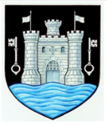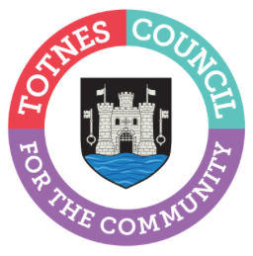

24 January 2024
NOMINATIONS FOR TOTNES TOWN COUNCIL’S 2024 COMMUNITY AWARDS ARE NOW OPEN
Who in the community has made a difference to you this past year? Totnes Town Council is now inviting your nominations for an individual and/or community group that you feel should be recognised for their good works in Totnes. These could be people or groups who give their time in many different ways – including, caring and supporting those in need, working with young people or the elderly, or helping people’s health and feeling of togetherness through exercise, sport or crafts.
Cllr Emily Price, Mayor of Totnes said: “The Totnes Community Awards are your way to publicly thank those unsung heroes in our town who make the lives of others happier, easier, or more fulfilled. Please do get in touch to nominate anyone or any group who you feel should be celebrated for the impact they have made on local people’s lives. You’ll need to tell us why you think they should be recognised with an award, so make sure you include a couple of lines to explain this. Once the nominations are in, Councillors will meet to consider each one. The awards will then be presented at the Annual Town Meeting on Wednesday 29th May 2024, which is open to all to attend.”
Please email (administrator@totnestowncouncil.gov.uk), phone 01803 862147 or call into the Council Offices at 5 Rampart’s Walk (behind St Mary’s Church) with your nominations by Sunday 17th March 2024. Alongside a short explanation of why you’ve suggested them, please also include a contact email or telephone number for the person or group you have nominated so we are able to get in touch with them. For more information on eligibility and the nomination process, please read the Community Award Policy at: www.totnestowncouncil.gov.uk/council-business/policies/

Photo caption 1): Cllr Emily Price, Mayor of Totnes with Food In Community, Totnes Community Award 2023 Group winners.
Photo caption 2) (L-r) Cllr Emily Price, Mayor of Totnes with 2023 Individual Totnes Community Award winner Pat Shepherd.

-Ends
For more information, please contact Lucy Ferrier info@visittotnes.co.uk or call 01803 862147

