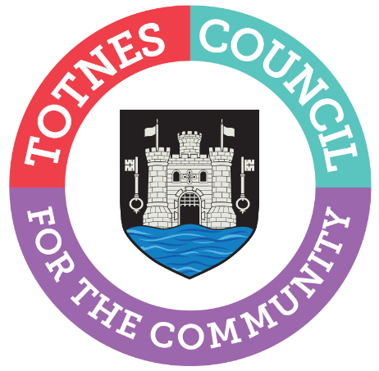

TOTNES TOWN COUNCIL COMMUNITY GRANTS
GRANT FUNDING APPLICATION FORM

How to use this form: this form can be printed and completed by hand,
or can be filled in electronically.

Name of organisation
Name and address of the person making
the application on behalf of the organisation
Position held in organisation
Telephone
Email
Do you have a Facebook/ Twitter account/ Website that you would like to be linked to through Totnes Town Council?
Bank details  If you are successful, our preferred payment method is via BACS. | Bank name:  Sort Code:  Account Number:
Have you received a grant from this Council in the last 3 years? If so, for how much and what was it for?

What are the aims of your organisation?
What is the name of the project/activity you are applying for?
When will the project be started/finished?

Financial information
What is the total cost for the project/activity?

Please complete the budget breakdown attached which will be used for monitoring purposes
What is the amount of grant requested from Totnes Town Council?
How much have you raised already?
Is the grant for match funding? (i.e. are funds from elsewhere dependent on our funding?)
Have you applied elsewhere for a grant, if so, which organisation(s),for how much,
and when will you know?

Criteria
Please read the Community Grants Policy for further information.
(500 words maximum)

Additionally we’d like to know about who you are working with and the long-term impact of your. Please answer the following questions.
1 a) How many people will this project benefit?

b) How many are involved in decision-making and ownership of this project?

c) Will your project encourage more Totnes residents to get involved?
If so, how?

2. Are you partnering with other Totnes groups and, if not, could you consider doing so?

3. We want to know how you will be sure your project is successful. What will you be measuring and how will you measure it?

4. Will your project continue after this grant is spent? If so, how will it be funded?

Budget (please complete the following budget for your project)

Title | Description | Total amount | Amount requested
Management costs
Training
Office costs (rent, telephone etc)
 | Sub Total
Salaries
Expenses (travel etc)
Venue hire
Materials
Publicity
Volunteer expenses
Other (please specify)
 | Sub total
 | TOTAL

Declaration
We confirm that all the information contained within this application is true and accurate to the
best of our knowledge and belief, and that we are authorised to submit this application on behalf of the group. We have read and agree to abide by the terms and conditions
(please click/tick box to agree)

We have provided copies of the following necessary documents (refer to Community Grants Policy) to support the application (please click/tick as appropriate):

Accounts Bank statement or paying-in slip Constitution
(to double check bank details)

NB. Scanned copies are acceptable if you end your application by email.
Applications will not be taken to committee without all these supporting documents
To support our application we have attached our organisation’s policies as outlined in the Community Grants Policy (please list below):

Signature 1 (person submitting form)

Signature 2 (Chair or senior representative of the organisation)

Typed entries acceptable for email applications
Date:

Please return your completed application form to: administrator@totnestowncouncil.gov.uk by the deadline advertised.

