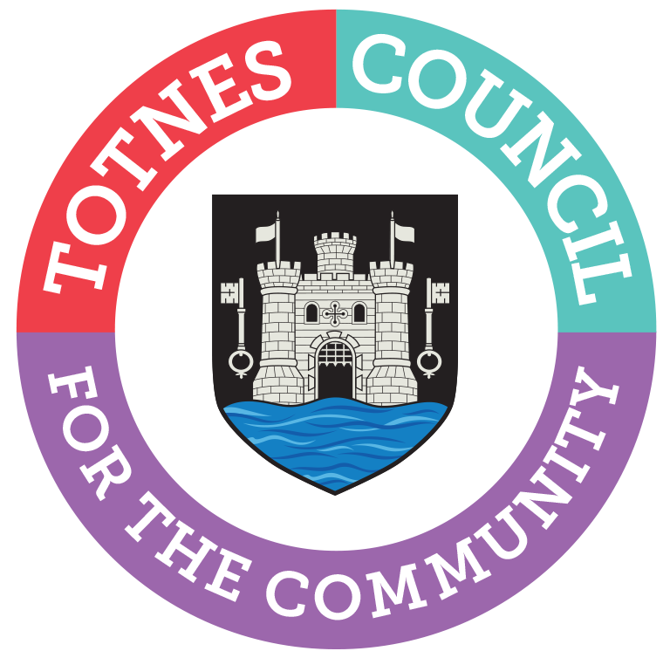

TOTNES TOWN COUNCIL
Local Government Act 1972 Section 87(2)
NOTICE OF VACANCY IN OFFICE OF COUNCILLOR
NOTICE IS HEREBY GIVEN that a vacancy exists in the office of Town Councillor for the Bridgetown Ward of Totnes Town Council.
Unless ten or more electors of the Totnes Bridgetown Ward, on or before Thursday 4th April 2024, submit a request in writing for an election to be held, the Town Council will take steps to fill the vacancy by co-option.
Requests must be sent to the Returning Officer, South Hams District Council, Follaton House, Plymouth Road, Totnes, TQ9 5NE.

Catherine Marlton
Town Clerk
13th March 2024

