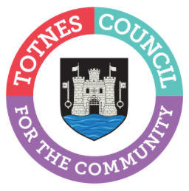

6 March 2024
TOURIST INFORMATION CENTRE WILL NOT REOPEN FOR SEASON
Totnes Town Councillors have made the difficult decision not to reopen the town’s in-person Tourist Information Centre (TIC). Visitor information will continue to be delivered online at www.visittotnes.co.uk, via the new signs and maps dotted throughout the town, and with a printed town map that will be available from a number of key locations in the town. Local printed information, for example bus timetables, will continue to be available from other locations in Totnes, including the Town Council office.
Cllr Emily Price, Mayor of Totnes, said: “With costs rising and our council’s determination to keep Council Tax increases as low as possible for our community, we’ve had to prioritise what we do. In our Community Conversation survey, which was held in summer 2023 to identify the priorities for residents and businesses, our tourist information centre scored low compared to things like supporting community groups and maintaining the town. We’ve also looked at the number of people who use the in-person service, which has dropped significantly since the Covid pandemic. As a result, we’ve opted not to recruit a new Seasonal Tourist Information Assistant this year and we won’t be opening the in-person Tourist Information Centre. I would like to reassure our businesses that we remain committed to supporting them by actively promoting tourism and encouraging visitors to spend as long as possible in our town via our alternative Visit Totnes channels. And I’d like to reassure any local people who used the Tourist Information Centre to get a copy of a printed bus timetable that these will still be available online from Devon County Council and in print (while stocks last!) from other locations in the town including the Council Offices at Rampart’s Walk, which is open Monday-Friday 10am-4pm.”
The TIC, which was previously located in the Market Square, received 2,279 in-person enquiries in 2023. The number of pages viewed on www.visittotnes.co.uk in 2023 was over 330,000. Alongside other staffing reductions in non-statutory areas, it is estimated that the closure will help to save the Town Council around £95,000 a year.
-Ends
For more information, please contact Lucy Ferrier info@visittotnes.co.uk or call 01803 862147

