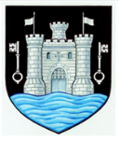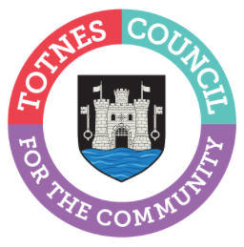
26 April 2024
TOTNES TOWN COUNCIL ANNUAL TOWN MEETING
Totnes Town Council will be holding its Annual Town Meeting on Wednesday 29 May 2024 at 5pm in the Civic Hall. The meeting gives members of the public a chance to ask questions and discuss topics they feel are important for the town as well as find out more about the current work of the Town Council. The mayor will also announce the recipients of the 2024 Totnes Town Council Community Awards during the meeting.

Cllr Emily Price, Mayor of Totnes, said: “Our town meeting is your chance to find out more about what the Town Council does for the community. Come along to meet the people who represent you and see our current and planned activities to help the town to thrive. This includes the grants we award to local community groups and the impact these have, the work of our Town Maintenance Officer keeping the town looking its best, the plans for Christmas lights and markets, our commitment to improving sustainability, and how we promote the town to visitors to support our local businesses.
“You’ll be able to find out more about our priorities as a council during the meeting but we also want to hear from you. If you have any questions you’d like to ask, please contact us by 21 May to give us chance to prepare a detailed response. Please submit your questions by e-mail to reception@totnestowncouncil.gov.uk or call 01803 862147.
“Anyone who is not able to make it in person to the meeting can find out more about the work of the Town Council by looking at our website www.totnestowncouncil.gov.uk We look forward to seeing as many people as possible on the 29 May.”

- Ends
Note to Editors
For more information, please contact Lucy Ferrier, Marketing & Communications Manager at info@visittotnes.co.uk

