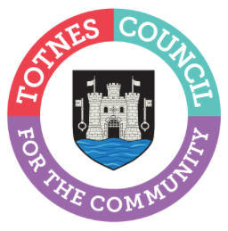
12 April 2024

BOOK YOUR SPACE NOW FOR TOTNES CHRISTMAS MARKETS 2024
Local makers and producers are being asked to sign up now if they would like to have a stall at the 2024 Totnes Christmas Markets and Late Night Shopping events. Run by Miss Ivy Events on behalf of Totnes Town Council, the evenings are a town-wide celebration of festive family-friendly fun with live music and entertainment, street food and craft stalls. The events take place on the first three Tuesdays of December from 3pm-9pm on 3, 10 and 17 December 2023.

Stalls can be booked now at www.missivyevents.co.uk/book-a-stall/ Stalls cost from just £35 per night and there’s a choice of indoor and outdoor pitches. To ensure the market supports the local community as much as possible, priority will be given to traders by distance from Totnes alongside the need to ensure the markets offer a good range of high-quality items. There are also a very limited number of stalls that will be offered at a reduced rate to younger people aged under 16 years old from Totnes who have items they have made that they would like to sell. Due to the popularity of the markets, it’s advisable to book a space as soon as possible and before the deadline of 15 August 2024. All booking applications will be reviewed after that date and applicants informed in September.

Cllr Emily Price, Mayor of Totnes, said: “It may seem early to be planning for Christmas 2024 but we’ve already been contacted by people wanting to have a stall – so if you’re interested, make sure you get your application in early! Last year, we pulled out all the stops and had some wonderful feedback from traders, residents and visitors. We’ll be building on this again this year with lots of music, food, and fun to deliver the unique Totnes festive experience – and we hope you’ll be part of that too. We organise the Christmas Markets and Late Night Shopping events to help the community get together to meet friends, chat to stallholders and to really get into the Christmas spirit.
“The markets are also an important boost for our local businesses, including established local shops and market traders as well as smaller new start-ups from the local area. By bringing new people into the town for these special events, we help our businesses to reach new customers and make it easier for people to shop small and local.”

Miss Ivy Events will be co-ordinating the events again this year following on from their successful bid last year to run the events in both 2023 and 2024.

- Ends
Note to Editors
For more information, please contact Lucy Ferrier, Marketing & Communications Manager at info@visittotnes.co.uk

