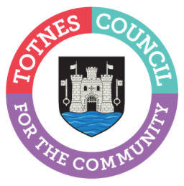
23rd April 2024
CALL OUT FOR LOCAL CREATIVES FOR THE TOTNES CHRISTMAS MARKETS
We are looking for local performers, creatives, and community groups to join in the festivities at the Totnes Christmas Markets and Late Night Shopping events on Tuesdays 3, 10 and 17 December 2024. From musicians and street entertainers to light show designers, we’re keen to hear from anyone who can add lots of fun and sparkle to these very special community evenings. Taking place outdoors from 3pm-9pm, we’re particularly interested in acts involving lights that will have an impact after dark. Let us know your ideas for how you can help us to make Christmas 2024 in Totnes the best ever!
Amongst other things, we’re looking for:
– walkabout theatre and performance
– musicians, including buskers
– creative installation pieces/lightshows/video wall etc
– community choirs and performers or individuals/groups who want to put out a hat to raise money for charity
If you’d like to apply please email jo@missivyevents.co.uk with ‘Totnes Performer Call Out’ in the subject line by 17 May 2024.
We’d love to hear about you and your act, including:
– production needs e.g. power, shelter
– fees (if applicable)
Ends
Note to Editors
For more information, please contact Lucy Ferrier, Marketing & Communications Manager at info@visittotnes.co.uk

