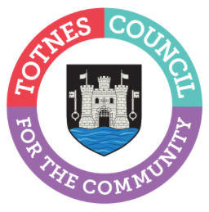
25 April 2024
PUT YOURSELF FORWARD TO BECOME A TOWN COUNCILLOR
Totnes Town Council is seeking up to two dedicated and motivated persons to become a Town Councillor. The vacancies have arisen due to two recent resignations, one for Totnes Town Ward and one for Bridgetown Ward. One vacancy will be filled by co-option and there will be a by-election to fill the other vacancy.
These vacancies were advertised earlier this year by the Town Council and South Hams District Council, inviting residents in each ward to make a request for an election. At least 10 residents are required to make a request in writing for an election to be held. South Hams District Council did not receive the required number of requests for the vacancy in Bridgetown Ward. As a result, this position can be filled by co-option. South Hams District Council did receive the required number of requests for an election for the vacancy in Totnes Town Ward. As a result, a by-election will take place on a date to be confirmed.
Residents and local business owners are now invited to put themselves forward for co-option as a councillor to the Bridgetown Ward position. Town Councillors will then review the applications and make an appointment. The deadline for anyone interested in being considered is midday on Thursday 23 May 2024, so that Full Council can review the applications at the meeting on 10 June 2024.
Residents and local business owners will also be able to nominate themselves as a candidate for the by-election in Totnes Town Ward. The deadline for nominations will be confirmed shortly.
Cllr Emily Price, Mayor of Totnes, explains how local people can make a difference as a town councillor: “As a local councillor you can become a voice for your community. An integral part of a councillor’s role is engaging with local people, groups, and businesses to determine their needs. You’ll help make decisions on the services and projects the council should take forward, and you’ll get involved to ensure the town council’s services truly meet the community’s needs.”
For more information on how to apply for the co-option position, the eligibility criteria, and the form that must be filled out, please see https://www.totnestowncouncil.gov.uk/your-council/what-we-do/make-a-change-become-a-councillor/ or contact the Town Clerk on 01803 862147.
The Council is made up of 16 Councillors – 10 representing Totnes Town and 6 representing Totnes Bridgetown. The Council meet once a month at 6.30pm, in the Guildhall, Totnes, with additional committee meetings held throughout the year. These roles are voluntary.

-Ends
For more information, please contact Lucy Ferrier info@visittotnes.co.uk or call 01803 862147

