**Full Council Monday 13th May 2024 - Clerks Report**

**General update**

A huge thank you to Sara for covering my absence this month at Full Council.

Civic Hall Access - There have been numerous exchanges and meetings about access to the Civic Hall. I believe the situation is now resolved, but not without some teething issues. The fish van has been relocated and the line painting to ensure access to the rear of the Civic Hall is imminent.

Work is ongoing to provide Councillors information to inform the proposed Strategy Delivery Group around ongoing, historic and proposed projects.

Market Square and hire of SHDC Spaces – I had a meeting with Cllr Birch on 9th May which I will update members about at the first Strategy Delivery Group meeting.

DCC engagement – I have yet to have a reply from DCC regarding the email reference Green Travel and traffic management from mid April.

Dairy crest/Atmos – the upholding of the planning appeal in relation to this site has been circulated to members.

Community Grant Applications - Deadline for applications was 9th May and Sara is collating the applications, We will be oversubscribed on available funds. I have had several enquiries about this and how much to ask for.

Community Economic Plan (CEP) – there have been ongoing conversations about the timeline and input for the CEP process. A further update will be circulated via committee.

Work is ongoing to prepare for the Annual Town Meeting and Mayor Making. The latter is no longer a public meeting and is by invitation only.

Elections/co-option – work is ongoing to promote the vacancies at time of writing there was not formal timeline for the election although we have a provisional booking for the 20th June in the Civic Hall.

Totnes Conservation Area Appraisal and Management Plan – Cllrs and representatives of TOTSOC and Totnes Museum had a meeting on 10th April with the SHDC officer who is leading on this review. The planned consultation is on hold pending further dialogue between SHDC, TTC and community groups.

Castle Street – I participated in a meeting in April regarding the Castle Street issue of access and damage caused by large vehicles. It was agreed on site by multiple parties to install an old ‘finger’ post to replace the current existing small bollard. This bollard has now been stripped by a local metal fabricator and is waiting for DCC to install. It is much larger and solid cast iron which will be a real physical deterrent.

Civic Funeral – we saw a sad but dignified goodbye to Jean Harrop in March. She requested a Civic Funeral and the family were so pleased with the Town Council representation.

Standing Orders – We have been doing some work on best practice and amendments to Standing Orders which is being progressed via committee.

Museum – In partnership with Trustees an Expression of Interest for significant funding for remedial work to the museum has been submitted to the Arts Council. Huge thanks to Cllr Auletta, Kate Wilson and Alan Chandler for doing all the work on this.

Devon and Torbay Devo Deal – We submitted our detailed objection. The subsequent consultation report has been sent to members, it appears that it is proceeding.

Totnes Conservation Area Action Management Plan (CAAMP) – Concerns have been raised and members updated.

Ongoing issues at Cistern Street – Members updated by email

Graffiti - the issues are ongoing and the team are consistently reporting it in multiple ways.

Community Safety Partnership (CSP) - I attended this meeting in April and have forwarded updates and note to all members.

Grants – please check and circulate all opportunities on our website. The list is being constantly updated and there are new opportunities coming online all the time.

Citizens Advice Bureau (CAB) – Really interesting stats circulated to all members:

*‘We continue to experience a high level of demand, especially for benefits applications, debt, help with energy bills and housing.*

*We now have outreaches in Dartmouth, Ivybridge, Kingsbridge and Totnes (Bridgetown) and our specialist energy team is working with partner organisations across the district to reach more people. In the next few months we'll be launching a volunteer recruitment drive so we can reach more people in the area and carrying out a research project into the needs of young people in the South Hams.’*

**Christmas Lights**

* The cross street ‘Welcome to Totnes’ Christmas lights (as well as the castle and Eastgate images) were collected on 18th April for refurbishment which will replace all rope lighting with low energy LED rope lights, as well as carrying out any frame repairs needed. The lights are due to be delivered back on 9th May. Cllrs have been emailed images of the works.
* Electrical points on The Plains. Liaison with building owners to get the permission required to site the electrical box on the Waterside House (which has been received) and keeping existing businesses aware of planned works. Date for the works yet to be received.

**Cemetery**

* 100 percent safety check carried out of all memorial stones in the week of 15th April. This happens every 3 years to check the safety of all stones and then remedial works are carried out as required and/or families contacted. The outcome is a small number of stones that can be recemented by the TMO but a memorial mason has been engaged to lay down one large stone on the kerb sets in the oldest part of the cemetery. Each year there is an annual check of stones considered to be high risk due to size and/or location, as well as checking any newly installed stones.
* Grounds maintenance in the cemetery – two cuts have been conducted in the cemetery in April as per the contract. However, there was a report of a damaged stone through grounds maintenance which the Council will make good.
* The Grounds Maintenance contractor plans to sow wildflower seed on the tops of raised kerb sets in the left hand section of the cemetery. The Council has found out that some strimming and non-glyphosate weed killing has taken place in preparation of these plots.
* Reports of dead trees behind 59 Smithfields which are being investigated.
* Local/regular funeral directors and memorial masons updated on the new cemetery fees as at April 2024.

**NALC/DALC/SLCC/RSN updates**  
  
**Model Financial Regulations**   
NALC’s Model Financial Regulations have had a significant review and re-write. The new document is now exclusively available to local (parish and town) councils in membership of NALC and their local county association. Regardless of the size of your council or its activities, it’s essential that the council takes due care with the precept it raises from local people. Local council financial control can be complicated to navigate and can cause frustration when it takes time away from the delivery of services and activities. Our recently revised model financial regulations consolidate all the essential procedures and financial regulations your council requires into one accessible document. This resource helps ensure effective and transparent financial management.

### ****NALC and SLCC meeting****

In their latest quarterly meeting, NALC and the Society of Local Council Clerks (SLCC) [**discussed the critical state of local government finance**](https://nalc.us12.list-manage.com/track/click?u=16886b5d6c31eade2f9a50027&id=6290f945e4&e=e45f5ee842).

**Larger Councils Committee**  
The Larger Councils Committee held its in person meeting for the year at NALC’s offices in London on 30 April. Here are a few highlights:

* The committee noted the update from Management Board on its work plan and asked for cyber security to be included in our work on artificial intelligence (AI). Additionally, they requested that resources from the Study Tour be shared more widely and the number of places increased in future years. They also suggested that consideration should be given to start times for the National Network: Super Councils, as part of an effort to get more councillors involved.
* A discussion took place on artificial intelligence and its application to larger councils, including what it means in local government terms, how it impacts the operations and service delivery of larger councils now and in the future.
* The committee were joined remotely by Jennifer Bevan, finance advisory network advisor at The Chartered Institute of Public Finance and Accountancy (CIPFA), who gave a presentation on financial resilience in local government, speaking about the pillars of resilience, risks and warning signs, best practice and the way forward.
* Updates were also provided on the work of the Martyn’s Law Steering Group and our national networks on coastal communities, climate emergency and super councils.

**Long-Term Plan for Towns webinar**  
I was pleased that NALC was asked by the chair of the government's new Towns Unit, Adam Hawksbee (who is also deputy director of the think tank Onward), to help organise a well-attended webinar on 24 April on the [**Long-Term Plan for Towns**](https://nalc.us12.list-manage.com/track/click?u=16886b5d6c31eade2f9a50027&id=38ce0d8f43&e=e45f5ee842)for our local councils in the 75 areas which will receive funding. In September 2023, the Prime Minister launched the Long-Term Plan for Towns as part of its levelling up programme, selecting 55 towns across Great Britain to receive funding. At the Spring Statement, the Chancellor confirmed additional funding worth £400 million to extend this programme to an additional 20 towns, bringing the total investment to £1.5 billion. Adam hosted the webinar, and in his introductory remarks, he thanked NALC for our support before going on to remark that he was unashamedly a champion for local councils, citing Onward’s [**Double Devo**](https://nalc.us12.list-manage.com/track/click?u=16886b5d6c31eade2f9a50027&id=083a4a0bfa&e=e45f5ee842) report, which makes the case for empowering our councils. He spoke in depth about the programme’s guidance, timescales, and support before taking questions from attendees (which included colleagues from SLCC), on issues ranging from monitoring and evaluation, involvement in Town Boards and sharing good practice.

**What's happening about the Combined County Authority?**

Devon County Council and Torbay Council are in the final stages of sealing a level 2 devolution deal. On 22 April, DCC considered the responses to the public consultation, voting in favour of continuing with the deal. Read the cabinet minutes. Torbay is due to vote on 30 April.

The next stage will be a submission to the Secretary of State of the Department for Levelling Up, Housing and Communities. All going well, the constitution for the Combined County Authority, and the terms of reference for the Team Devon Joint Committee (which DALC will be a member of) will be finalised (expected approx. September 2024).

**Rural Coalition meets DEFRA minister**  
Cllr Keith Stevens, met with Department for Environment, Food and Rural Affairs (DEFRA) minister Robbie Moore MP at the [**Rural Coalition**](https://nalc.us12.list-manage.com/track/click?u=16886b5d6c31eade2f9a50027&id=72de17ea5a&e=e45f5ee842) meeting this week. With a background in farming and as a former councillor including on Alnwick Town Council, the minister was keen to stress his support for rural areas and raising their profile across government. He explained that his priorities were loss of facilities, transport and broadband. During the meeting Keith emphasised the important role local (parish and town) councils play, especially in supporting community hubs, which the minister acknowledged. We also took the opportunity to thank the minister for recognising the extension of the Community Ownership Fund to our councils in the Government’s recent [**rural proofing report**](https://nalc.us12.list-manage.com/track/click?u=16886b5d6c31eade2f9a50027&id=98409c822e&e=e45f5ee842) and urged him to support making other similar national funding streams available to the sector.

**Local government finance**  
Continuing the theme of last week’s bulletin, the Guardian and Observer published a piece on 30/3/24 entitled [**“England’s parishes and towns raise council tax surcharge to fund scrapped local services,”**](https://nalc.us12.list-manage.com/track/click?u=16886b5d6c31eade2f9a50027&id=5925a6ae57&e=e45f5ee842) informed by NALC’s briefing. The article highlighted the 8.5% increase in precepts taking overall spend to nearly £800m. Also, it noted that Mayors and Police and Crime Commissioners were increasing their charges by more than the average 5% increase in council tax by principal authorities. Our chair, Cllr Keith Stevens, is quoted extensively calling out our sector as “the unsung heroes of local government, stepping up to play a more active role in improving their communities, and increasingly taking on more responsibilities from financially challenged larger authorities.”  It is, of course, also worth pointing out that the average precept charged by a parish or charter trustee for 2024-25 will be £85.88, which is an increase of £6.74 or 8.5%.   
  
**Government report on devolution**  
The Department for Levelling Up, Housing and Communities (DLUHC) has just published its [**annual report on devolution (2022-23).**](https://nalc.us12.list-manage.com/track/click?u=16886b5d6c31eade2f9a50027&id=8445afd4be&e=e45f5ee842) This Annual Report brings together updated information about devolution agreements reached or implemented between government and areas between 1 April 2022 and 31 March 2023. Key highlights from the report are as below:

* Between 1 April 2022 and 31 March 2023, the government negotiated and announced six new mayoral devolution deals.
* Outside of the areas named in the Levelling Up White Paper, the government focus, from 1 April 2022 to 31 March 2023, has been on opportunities to pursue further mayoral devolution deals.
* Between that period, two statutory instruments (SIs) were made to implement the devolution deal between the government and the Tees Valley Combined Authority. These SIs were created on 30 January 2023, and they established two mayoral development corporations.
* An additional SI was made on 20 February 2023 to abolish the South Yorkshire Passenger Transport Executive and transfer its functions into the South Yorkshire Mayoral Combined Authority.

NALC will continue to engage with DLUHC and wider government to ensure that the local (parish and town) council tier is factored, where relevant, into future devolutionary discussions between central and local government.   
  
**Reconnecting communities through community transport event**  
NALC hosted an event on reconnecting communities through community transport on 27 March 2024. 90 participants attended the event. The event featured expert speakers Caroline Whitney, director for England at the Community Transport Association, and Will Austin, clerk at Bridport Town Council. They discussed the significance of community transport, strategies for establishing partnerships and accessing funding, and ways local councils can contribute to reconnecting communities through transportation. Caroline emphasised the inclusivity and social impact of community transport, highlighting the role of drivers in building relationships with passengers. Will shared insights from Bridport town council’s experience in implementing a community transport service, focusing on benefits for social inclusion and environmental sustainability. Despite challenges such as the COVID-19 pandemic, Will underscored the importance of resilience and expert advice for successful implementation.

**Correspondence log**

This will be circulated separately.

**Visit Totnes**

**Visit Totnes digital stats**

March has seen lots of activity on our social platforms, giving us a combined reach of 569,000 accounts. We had 26,000 views of our website.

Our highest performing social media post in March was our ‘reasons to visit’ post on both Instagram and Facebook which has so far achieved combined impressions totalling over 1million*

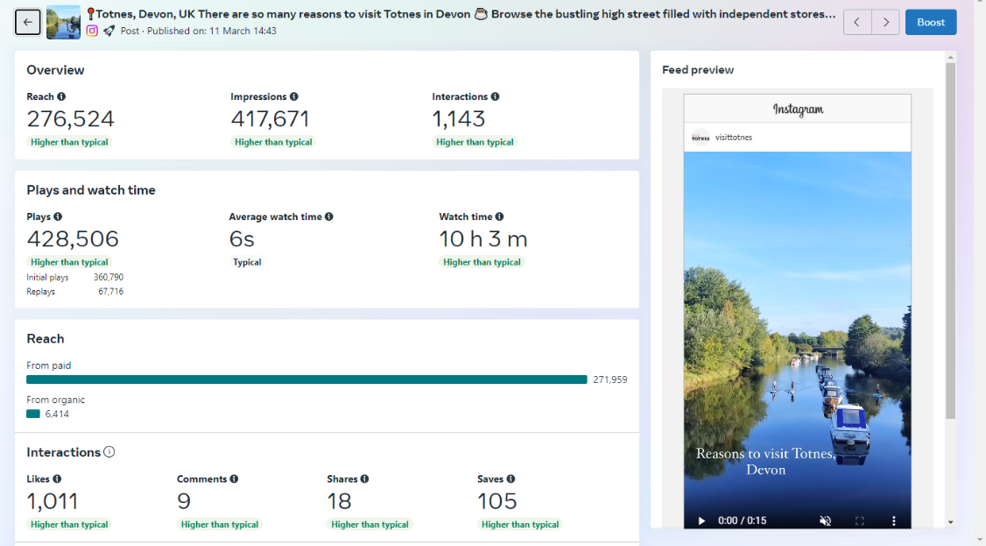

*(Reach is the total number of people who see our content. Impressions are the total number of times our content is displayed, no matter if it was clicked or not.)

**Annual and quarterly digital stats at a glance for Visit Totnes**

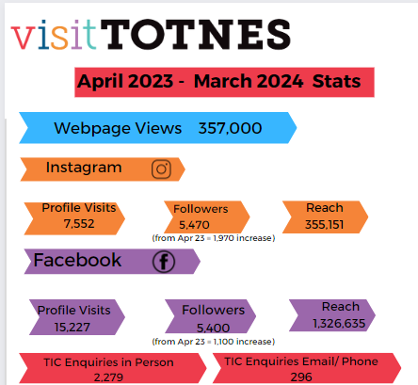

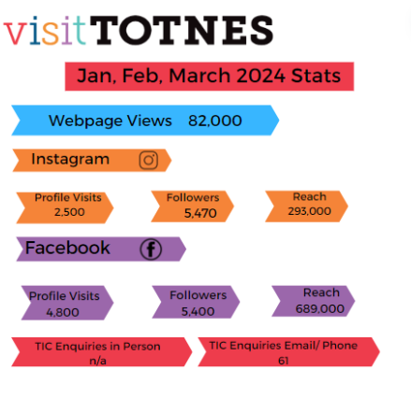

**Other**

Visit England has announced that Devon and Partners have achieved a new Local Visitor Economy Partnership (LVEP) accreditation for the county.  More info here: [ANNOUNCEMENT: Local Visitor Economy Partnership (LVEP) for Devon (mailchi.mp)](https://mailchi.mp/fd9d500cf661/announcement-local-visitor-economy-partnership-lvep-for-devon?e=d01c5f1039)

Visit Totnes is on page 42 of the new free Dartmoor National Park Enjoy Dartmoor magazine: <https://www.dartmoor.gov.uk/enjoy-dartmoor/planning-your-visit/enjoy-dartmoor-magazine>



Our Discover the Dart campaign, linking up with Discover Dartmouth, continues with a direct email campaign:



**Totnes Town Council digital stats:**

In March, the website had just under 3,000 views.

We reached 8,000 accounts on our two main social platforms

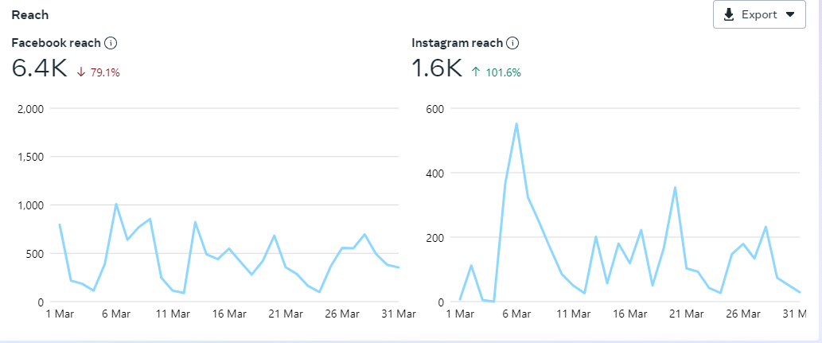

**Totnes Town Council Press Releases**

* Councillor Vacancy notice - <https://www.totnestowncouncil.gov.uk/councillor-vacancy-totnes-town-ward/>
* Parkrun – 1 year celebration (community grant): <https://www.totnestowncouncil.gov.uk/3-2-1-go-for-parkrun-in-totnes/>
* Christmas Markets – Stallholder applications open: <https://www.totnestowncouncil.gov.uk/book-your-space-now-for-totnes-christmas-markets-2024/>
* Christmas Markets – call out for local creatives: <https://www.totnestowncouncil.gov.uk/call-out-for-local-creatives-for-the-totnes-christmas-markets/>
* Put yourself forward to become a town councillor: <https://www.totnestowncouncil.gov.uk/put-yourself-forward-to-become-a-town-councillor/>
* Annual Town Meeting date: <https://www.totnestowncouncil.gov.uk/totnes-town-council-annual-town-meeting-2/>

**Council Assets**

**Guildhall:**

Visitor numbers have been really encouraging in April. We welcomed 1137 people from all corners of the globe through the doors which is an increase from 799 in 2023.  A huge thanks to the volunteers (and councillors who have stepped in ) for their continued support. We have a good working relationship this year with English in Totnes which means that all visits are booked in (as opposed to previous years when they would just show up en masse) and then I send a ‘bill’ at the end of each month for them to make a donation. Dick Evans has kindly agreed to be the ‘tour guide’ for when they’re booked in. The gratitude and positive response from the students (as well as the language schoolteachers) has been enormous. The new street signs have been very warmly received with lots of positive comments about how nice and ‘in keeping with the building they look. I’d like to think that the better street signage is one of the factors that has led to   the increase in visitor numbers.

**Civic Hall:**

Civic hall bookings are continuing to look good for the rest of the year. Regular hirers now occupy the hall every weekday evening (as well as all day on a Wednesday) and after a slow April, the weekends are filling up. A promoter from Bristol has now booked in 4 touring artists – the first one being Brian Bilston on May 11th. They will be staying locally so helping the local economy as well. New fire exit doors have been completed – now just waiting for the bike racks to be relocated and the hatching to be done to be fully operational. The door also came in very handy for a catering firm to unload straight from the market square without having the hassle of using the ramp. Lots of positive steps forward with the access to the ramp on market days. The fish van will have a new position along the railings with their queue going down into the market (as opposed to across the ramp entrance) so things should become slightly easier to manage when hirers want to unload for weekend events.

**Catherine Marlton**

**Town Clerk**

**10th May 2023**