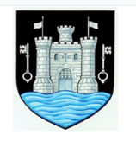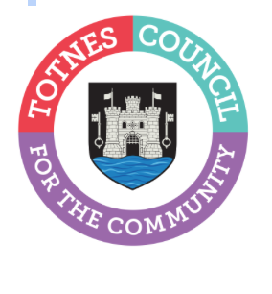
12 June 2024
TOBIAS ROBSHAW CO-OPTED TO ROLE OF TOWN COUNCILLOR
At the Full Council meeting on Monday 10 June 2024, Totnes Town Council councillors co-opted Tobias Robsham to fill the vacancy for Bridgetown Ward. A committee member of Inclusive Totnes, Tobias Robshaw explained their reason for becoming a town councillor is to “play a more supportive and active role within the community” and to “assist in increasing the town’s prosperity and improving the lives of people in Totnes.”
A by-election will take place on Thursday 20 July to fill the current vacancy for a town councillor to represent Totnes Town Ward. These two vacancies, which arose due to two resignations, were advertised earlier this year by the Town Council and South Hams District Council, inviting residents in each ward to make a request for an election. At least 10 residents are required to make a request in writing for an election to be held. South Hams District Council did not receive the required number of requests for the vacancy in Bridgetown Ward. As a result, this position could be filled by co-option. South Hams District Council did receive the required number of requests for an election for the vacancy in Totnes Town Ward. As a result, a by-election is taking place.
Last month, residents and business-owners were invited to put themselves forward to become a town councillor. The Council is made up of 16 Councillors – 10 representing Totnes Town and 6 representing Totnes Bridgetown. The Council meet once a month at 6.30pm, in the Guildhall, Totnes, with additional committee meetings held throughout the year. These roles are voluntary.

-Ends
For more information, please contact Lucy Ferrier info@visittotnes.co.uk or call 01803 862147

