## **ITEM 2c – DISTRICT COUNCILLOR BIRCH REPORT**

**John Birch**

**SHDC Member for Totnes**

**Report to the Totnes Town Council meeting to be held on**

**Monday 1 July 2024**

I report on the following.

**Livewest planning application for housing development at Parkers Way, Totnes**

The S106 agreement for the Livewest redevelopment at Parkers Way has finally been completed, and SHDC has issued the planning approval notice. The development provides for the demolition of the redundant flats and construction of 35 new social housing units.

There are some pre-commencement conditions to be discharged before works can commence, and planning officers will be working with Livewest on this in the coming months to enable works to commence.

**Community Action - Climate and Nature**

 Sustainable South Hams is proposing a project to support all parish, town and district councillors who wish to take more action for climate and nature.

Ruth Leonard-Williams, Project Manager at Sustainable South Hams in collaboration with Cllr John McKay, Lead Member for Climate Change and Biodiversity at South Hams District Council, and Adam Williams, Principal Climate Change Officer, request the following be reported in the hope it will be of interest to Totnes Town councillors.

 Following recent meetings and events with councillors in South Hams it has emerged that a significant number are keen to help enable more community action around climate and nature. Sustainable South Hams is planning to develop a support package for councillors to help with this but wishes to make sure that it meets councillors' needs and understand better what forms of support would be useful and the sort of content they would like it to contain.

On Friday 11th October at Follaton House SSH is coordinating a symposium for South Hams parish, town and district councillors. The event will showcase a whole range of practical projects to inspire, connect and support action on climate and nature. Please save the date and it is hoped you will be able to attend.

**SHDC Asset Based Community Development**

The SHDC Community Development Team will be coming to Totnes and other towns with a view to speaking to residents and visitors about their views on South Hams.  This follows on from some recent work the Council has been doing around the idea of Asset Based Community Development which focuses on ‘what is strong, not wrong’ about the place people live.

Whilst people will want to talk about the things that need improving, the Council will also want to know what makes where they live, or are staying, so good. Whether that is a vibrant community shop or village hall or the person who organises the weekly litter pick.

Town Councillors are welcome to join the SHDC team at the Totnes event being held on Friday 9 August at the Totnes Market between 9.00am and 4.00pm.

**The Totnes Heritage Festival – Saturday 28 September**

On Saturday 28 September the first Totnes Heritage Festival will be taking place, an event which will give residents and visitors a chance to wallow in our town’s history, to revisit places they know and love and discover things anew.

Local heritage organisations have come together to lay on a host of events at many of the historic venues in the town. In addition, English Heritage will be heading up its ‘Fun and Games’ open day at the castle which will be free to all residents in the TQ9 district on production of evidence of residency.

Amongst the events already confirmed, two will be held at the Town Mill, one hosted by the Image Bank with a D-Day exhibition and showings of the classic film ‘The Spirit of Totnes’.

The trustees of the Totnes Trust will also welcome visitors at the Town Mill and festivalgoers will have the opportunity to explore the history and workings of the 16th century building.

At The Mansion festivalgoers can see the superbly restored school room which will be housing “DEVONIANS WHO HELPED BUILD AMERICA”, a fascinating exhibition showcasing the history of the Devonians who went to America.

Meanwhile, up at the museum a special exhibition will reveal the wonderful images of the famous plaster ceilings of Totnes which are held by the Totnes Archives.

At the Guildhall festivalgoers can chat to the Mayor about the history of the Guildhall and some of its artefacts. They will be able to return later for presentations to young people who will have entered the ‘Myths and Legends’ competition which will run throughout September.

At St Mary’s Church there will be a guided tour to discover hidden secrets about the building inside and out and St John’s Church, Bridgetown is hosting an open afternoon with family friendly activity sheets, a historic churchyard trail and an exhibition of the history of the church.

The festival is being co-ordinated by the Totnes Heritage Trust. Visit Totnes will be publicising the day throughout the summer and nearer the date a detailed programme with times and a map of the town which will guide festivalgoers to the different venues will be available.

Cllr John Birch

SHDC Member for Totnes

27 June 2024

## **ITEM 2d – DISTRICT COUNCILLOR PRESSWELL REPORT**

Anna Presswell - Report for Totnes Town Council

25/06/2024

**Overview and Scrutiny – Hunting and Animal Welfare Motion**

On March 21st the Full District Council resolved as follows:

‘That, notwithstanding the moral arguments about blood sport, having regard to the animal welfare and public nuisance considerations, it is for the benefit or improvement of the Council’s area that the Council:

1.does not support the killing of or cruelty to animals for sport or leisure in any circumstances;

2.will not facilitate or promote the killing of animals for sport or leisure by allowing its land to be used for such sports or associated activities;

3.requires written permission to be sought for the use and management of any animal traps on its land and reserves the right to refuse permission where the Council considers they could cause unnecessary and avoidable cruelty or suffering;

4.encourages other Local Authorities owning land in the Council’s area, including Devon County Council, to adopt a similar resolution;

5.that the Overview and Scrutiny Committee consider setting up a Task and Finish Group to develop a protocol/policy to underpin parts 1 to 4 of the Motion.

The Hunting Act 2004 made chasing wild animals with dogs illegal apart from the particular exempt forms of hunting detailed in the Act. As well as the Hunting Act 2004 there is also the Animal Welfare Act 2006 which embodies the so-called Five Freedoms of animal welfare which state that every animal deserves the right to humane treatment. The Five Freedoms are recognised across the globe and include a right to the freedom from “fear or distress".

The sentience of animals has been the subject of much research and it has long been recognised that all animals are capable of a range of emotions. The Animal Welfare (Sentience) Act 2022 defines sentience in law.

It cannot therefore be conceived that any blood sport is acceptable, and it is important that the culture and tradition that surrounds and supports this barbaric activity is discouraged.

It is often argued that blood sports are part of the management of the countryside. That is rarely the reality, but where such management is required it needs to be carried out by trained specialists who have proper regard to an animal’s welfare and rights under the legislation.

Part 5 of the above resolution requires there to be a T&F group to consider how to formulate some policy guidelines to allow officers to implement the intention and spirit of the motion.

I intend to sit on this.

**Legal Considerations**

Advice from Catherine Bowden (Deputy Monitoring Officer) in an email on March 18 stated:

“There is a case that quite firmly sets out that councils are in a different position to other landowners and have less freedoms on whether to permit or forbid activities on their land. Any decision about the management of council land has to be taken on the basis that it is for the benefit of the local area (this is a statutory requirement). So, when debating an issue relating to permitting/ banning an activity on council land, councillors should be reminded that ‘the benefit of the area’ is the statutory basis for their decision and must understand that, however strongly held their personal views, they must consider the proposals in terms of benefit and detriment to the area.”

The motion was formulated to ensure compliance with this advice and any guidelines resulting from the work of the T&F group need to also take this advice into account.

Its interpretation should include the management of so called ‘vermin’. There needs to be a list of banned techniques including but not limited to: snares, leg-hold traps, glue traps, a range of slow acting poisons.

The Universities Federation for Animal Welfare (UFAW) publishes guidance on Humane Rodent Control. ( https://www.ufaw.org.uk/rodent-control/rodent-control ). This should be referenced as the standard expected.

The Glue Traps (Offences) Act is due to come into force in July 2024. This means a License will be required to use this type of trap after July.

**Yealm Community Energy**

We are arranging a meeting to discuss possibilities and a process of supporting this and other solar energy providers, that are likely to develop locally in the near future, that ask for Council support, including the option of a ‘buy-in’ scheme as demonstrated by the example of <https://rippleenergy.com/?gad_source=1&gclid=EAIaIQobChMIgLn3t6j2hgMVl5dQBh2a0gLfEAAYASAAEgLzvfD_BwE>, whereby a council might be in part ownership, rather than loaning money or grants to support these ventures.

This is purely a consideration that will be discussed over the next month. It’s important that a process is developed for future solar farms.

**Dart Vale Dentistry Totnes**

I have arranged a meeting with one of the owners of the Dental Practice regarding the lack of NHS dentists and the potential explosion in dental malady that is likely to happen over the next few years. The practice is ‘managed’ by the Portman Society, who set the fees, And I was keen to see if there was any ‘inroad’ to establish a basic monthly payment to cover check-ups and simple procedures, cheaper than their existing plans.

**Debt/Finance Fair**

The Citizens Avice Bureau in their summer newsletter quote new research shows that more than 10,000 in South Devon and SW Devon constituencies are living on a negative monthly budget. And its basic energy, housing and food bills that is exceeding their income.

I have contacted Jamie Moor who manages the local branch to discuss what might help, and if a type of open event with financial organisations and mental health groups etc would be of benefit or otherwise – potentially with speakers and anecdotal stories. She has said it would be hugely welcome.

The report makes for grim reading. In turn this is likely to play a part in the poor mental health numbers of the area, also rated as a major concern for the community and surround.

I bring this to the Town Council as a consideration, and if they might support it by paying the Civic Hall fee for a half day/day. I’d be happy to pull this together and could write a fuller proposal if required.

**Gold Bus stop opposite (almost) Blackpost Lane**

I was asked by a resident [redacted] about the potential of a pedestrian crossing at the top of Bridgetown Hill. The Gold bus stop on the left, as you drive up the hill, serves a lot of the residents on the opposite side of the road and children attending Dartington schools. Along with a Care Home immediately behind the location, sometimes elderly individuals try and cross to wait at the bus stop the other side. The traffic is heavy and the drivers unwilling to slow down. Children also travelling to Churston Grammar, use this stop.

It is acknowledged by DCC that the stop is heavily used, and they have received a number of requests, but are required to receive a request from a Councillor to consider the application which I am following up. The Town Council in 2022 did not prioritise this site. I wonder if it could be considered again. A site visit will be completed by Devon Highways before the 18th July.

….please see pictures below.

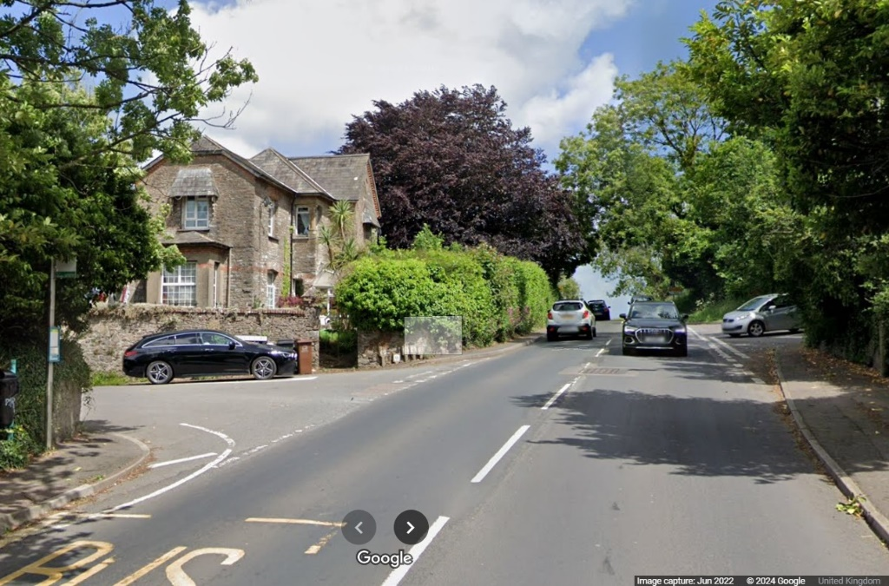



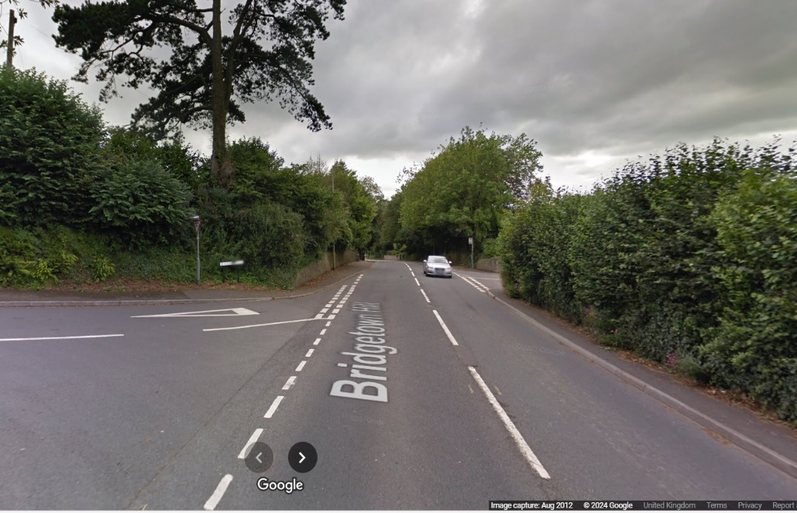



**VE Day May 8th 2025 – Commemoration and Resilience**

If Totnes Town Council are choosing to commemorate the end of WW2, will there be funding available? If there is not an appetite on the council, I believe there might be within the community, and I will ask the District Council to potentially fund a South Hams wide event. The D-Day events in the main were well attended. Again, an educational thrust introducing the politics, espionage, food provision and different uses of wild food (e.g. ground elder used to substitute spinach), what was the Home Front, communications etc. And recent wars considered….what destabilises countries, the environment for example has played a huge role in the onset of the wars that happened/happening in Dafur, Sudan, Syria

This could be done in different areas of the town, or South Hams wide with other villages/towns on board.

The cost of the D-day event was £1,196.50 (the bulk of this was the Hall hire and Band).

I would welcome a decision on this at some point.