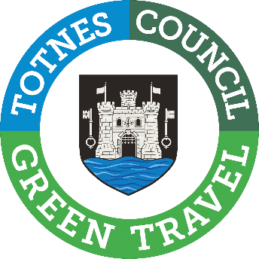

Traffic and Transport Forum Agenda
Wednesday 31 July 2024
6:30pm - 7:25pm
Guildhall, Totnes
Everyone Welcome

1- Introduction - who’s who, Agenda, time limit, changing context

2 - The New Dart Valley Cycle Trail - Update and next steps, by John Forte

3 - Might the affordable ‘good’ be better than the unaffordable ‘perfect’? - Sharing ideas

4 - DCC Update -Plymouth Rd, The Bourtons, liaison with DCC, by Cllr Hodgson

5 - Receipt of any community matters - Please email us before 29 July if you have any matters you wish to raise.

6 - Notes of Forum held 24 April 2024 - Agreement & matters arising not on Agenda. Minutes can be found included in the papers for the Planning meeting held in May. Follow the link to view: https://www.totnestowncouncil.gov.uk/wp-content/uploads/2024/05/Planning-Papers-22-May-24.pdf

After a short break, Steering Group members will reconvene for the Steering Group meeting.

Date of Next Forum Meeting - 30 October 6:30pm

Please arrive by 6:25 for a prompt start at 6:30pm

