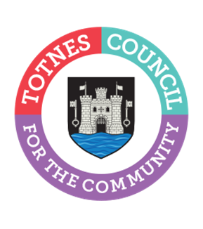

Totnes Town Council Community Funding Policy – Small Grants Application Form

How to use this form: this form can be printed and completed by hand, or can be filled in electronically.

Section 1 – Funding Stream
Please indicate which fund you are applying to:

☐ Community Working Group (£5,000 annual budget)
☐ Economy Working Group – Event Sponsorship (£2,500)
☐ Economy Working Group – Business Support (£2,500)
☐ Environment & Public Realm Working Group (£5,000)

Amount requested (max £1,000): £________

Section 2 – Applicant Details

Name of applicant (individual/group/organisation)

Address (must be within or directly linked to Totnes parish)

Contact details (email/telephone)

Proof of local connection provided (e.g utilities bill): | ☐ Yes

Section 3 – Project Details

Description of activity

Date(s)

Location

Estimated number of Totnes residents benefiting

Which Council priority does this support?

Section 4 – Budget Summary

Total project cost: £_____
Amount requested: £_____
Other income secured: £_____

Please attach a simple breakdown.

Section 5 – Supporting Documents Checklist
The following are required:

For organisations:
☐ Bank statement (dated within 3 months)
☐ Proof of address

For individuals:
☐ Bank statement (dated within 3 months)
☐ Photo ID
☐ Proof of address

These documents will be viewed by officers and councillors but will not be placed in the public domain.

Please note that applications received without these documents cannot be considered

Declaration
I confirm that:

☐ The information provided is accurate
☐ The project benefits Totnes residents
☐ Funds will only be used for the stated purpose

Signature:

Date:

Please return the completed application and supporting documentation for the 2026/27 grant allocations to the contact email addresses as follows:
  - Community Working Group: £5,000 – clerk@totnestowncouncil.gov.uk
  - Economy Working Group: £2,500 Event Sponsorship – economy@totnestowncouncil.gov.uk
  - Economy Working Group: £2,500 Business Support - economy@totnestowncouncil.gov.uk
  - Environment & Public Realm Working Group: £5,000 – administrator@totnestowncouncil.gov.uk

Please cc applications to reception@totnestowncouncil.gov.uk and applications will be redirected if members of staff are out of the office

